# 

# GCP Data engineering course - Exam prep helper

**Goal**

This is a live document and it constantly evolving to be adapted to the new service offering on GCP services, the goal of this document is to concentrate on the topics being covered by the GCP data engineering certification, based on Coursera course content and additional content based on other’s exam experience (mostly globers). The intention is to refresh basic contents before the exam (it is not that easy to have an abstract after doing Coursera course), and having them all together on hand and avoid providing typical url reference in different topics, so lecture is quicker by using just this document (of course I did copy+paste from different sources)

This document is **not intended** to be the **only source of study**, just a helper before the exam. This is just a **base,** more topics can be added as needed.

|  |  |  |  |
| --- | --- | --- | --- |
| **Version History** | | | |
| Version | Date | Author | Description / Update |
| 1.0 | 12/17/2018 | Leandro Stefanutti | Initial Draft |
| 1.1 | 12/18/2018 | Alberto Vicente | Added CAP Theorem |

**GCP Data engineering course - Exam prep helper** **1**

Compute engine 5

Persistent disks 5

Attach disks to instances 7

Images 8

Creating the image 10

Instance templates 11

Preemptible instance 14

Preemptible instance limitations 14

Load balancers 15

Cloud CDN 18

Cloud Storage 20

Basic concepts 20

Permission levels 21

Interaction with GCS 22

Data Encryption Options 24

Transferring data to GC Storage 26

Cloud storage - Pricing 27

Multi-regional vs Regional vs Nearline vs Coldline 29

Store: Cloud Storage as the data lake 29

Cloud SQL 31

Basic concepts 31

Pricing 32

Dataproc 34

Basic concepts 34

Hadoop Cluster setup 35

Submit a dataproc job 36

Pricing 39

Datastore 41

Basic concepts 41

Pricing 44

CAP Theorem 45

BigTable 46

Basic concepts 46

Instances, Clusters, and Nodes 47

Instances 48

Instance types 49

Storage types 49

Application profiles 49

Clusters 50

Nodes 50

Schema design 51

Time series data 53

Performance 54

Pricing 55

BigQuery 57

Basic concepts 57

BigQuery roles 58

Authorized views 59

Bigquery SQL queries 60

Partitioning 61

Partitioning versus sharding (wildcard tables) 61

External data sources 63

Temporary and permanent tables 64

Controlling costs with BQ 64

Load data into BigQuery 64

Performance 66

Pricing 67

Spanner 67

Basic concepts 67

Data Model 68

Pricing 69

Machine Learning concepts 69

Basic concepts 69

Supervised Machine Learning 69

Unsupervised Machine Learning 70

Labels 71

Features 71

Models 73

Regression vs. classification 73

Deep learning 74

Gradient descent 74

Overfitting 76

Feature engineering 77

Logistic regression 80

Neural networks 82

Deep and wide models 84

Tensorflow 86

Basic Concepts 86

Usage 89

MLE 93

Basic Concepts 93

Minimizing skew at scale with tf.Transform and Dataflow 93

Leveraging TensorFlow with tf.Transform on Google Cloud Platform 93

Example of Architecture for ML 95

Interaction with MLE 96

ML APIs 100

Dataflow 104

Basic concepts 104

Pub/Sub 113

Basic concepts 113

DataPrep 115

Basic Concepts 115

IAM and security 118

Service Accounts 118

Best practices 123

Google Functions 124

Google Cron 126

Cloud Stackdriver 127

Cloud Datalab 129

Exam Study Cases 130

## Compute engine

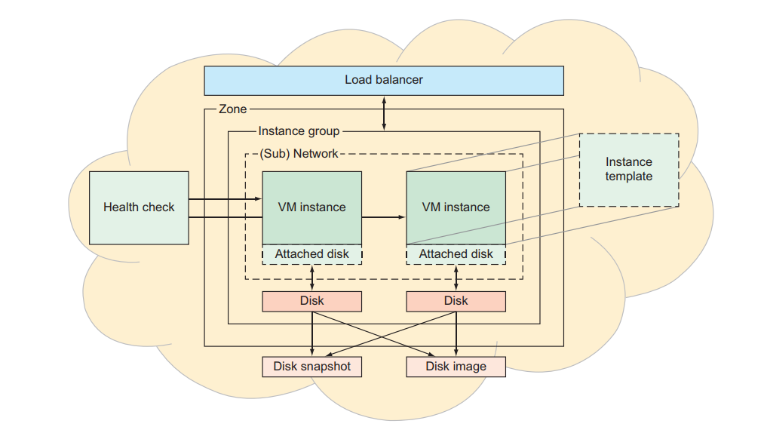

### Persistent disks

At any time, a persistent disk can be in one of three states:

* Unattached —You’ve created the disk, but it’s not mounted on any VMs.
* Attached in read-only mode —The VM can only read from the disk.
* Attached in read-write mode —The VM can both read and write to the disk.

When it comes to choosing a location, remember that to be attached to an instance, a disk must live in the same zone as that instance; otherwise, you would risk latency spikes when accessing data

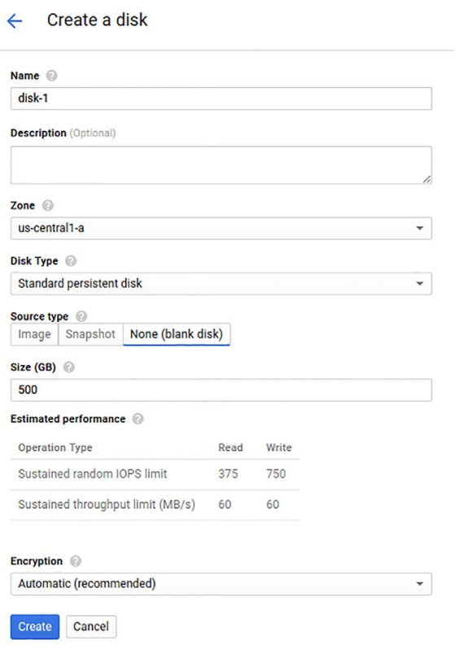

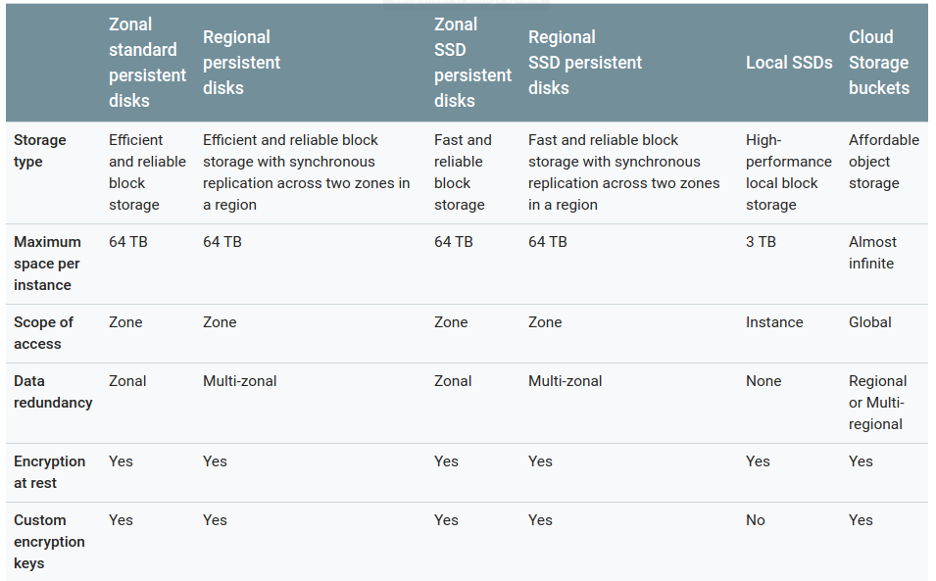

### Attach disks to instances

Disks can be attached to more than 1 instance but just in read-only mode.

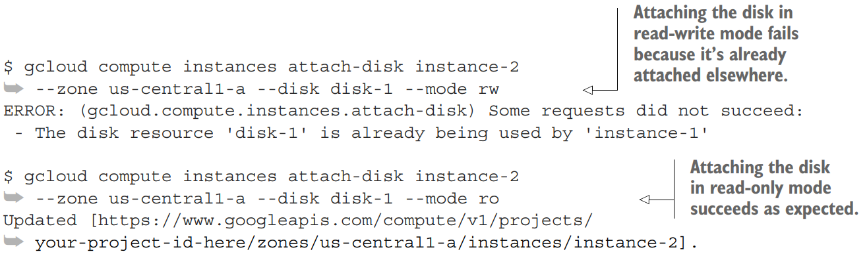

Steps: Attach -> Format -> Mount

Resizing: you can always make a disk larger by increasing the size, but you can’t make a disk smaller. Then you need to execute a command to resize file system, (e.g.: resize2fs)

Snapshots

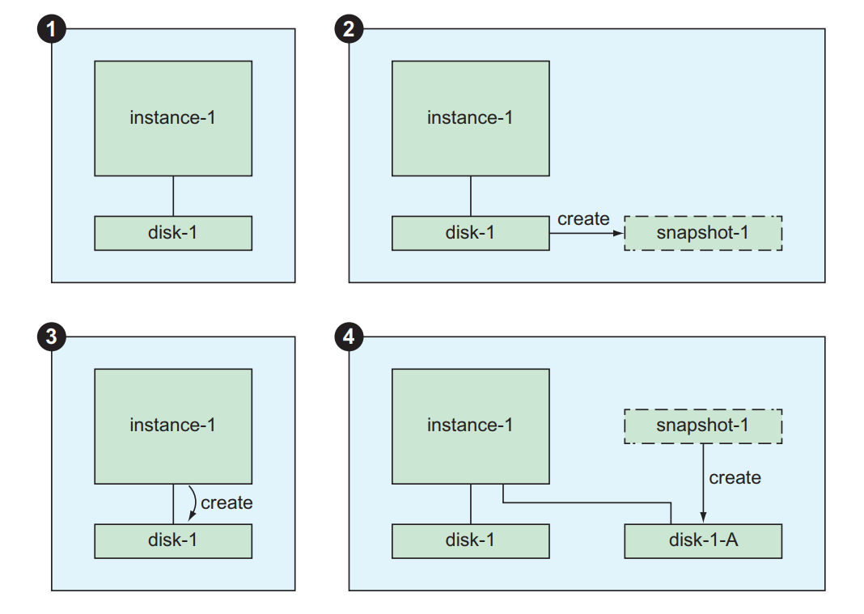

anything running on the machine might continue storing data in memory but not flushing it to the disk. The end result is that to avoid a potentially disastrous snapshot, you should shut

down your applications that are writing data (for example, stop your MySQL server

binary), flush your disk buffers (using the sync command), freeze the disk (using

fsfreeze) and only then take the snapshot:

jjg@instance-1:~$

jjg@instance-1:~$ sudo sync

jjg@instance-1:~$ sudo fs freeze -f /mnt/disks/disk-1

jjg@instance-1:~$

jjg@instance-1:~$ sudo fs freeze -u /mnt/disks/disk-1

### Images

Images are similar to snapshots in that both can be used as the source of content when you create a new disk. The primary difference is that images are meant as starting templates for your disk, whereas snapshots are meant as a form of backup to pinpoint your disk’s content at a particular time

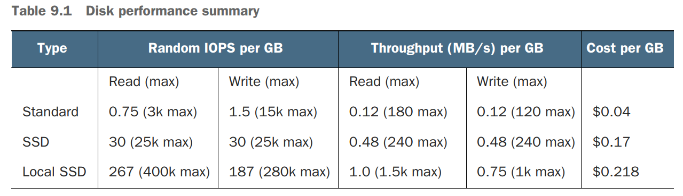

(Local SSD should be considered ephimeral -> when the vm restart, the data goes away)

Local SSDs are suitable only for temporary storage such as caches, processing space, or low value data

Encryption (when create a disk)

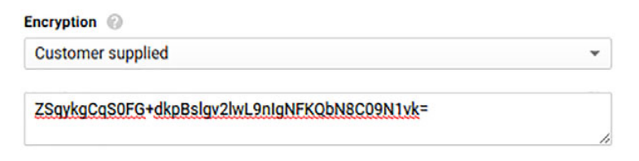

When attaching an encrypted disk you need to provide the encription key

.





Use operating system images to create boot disks for your instances. You can use one of the following image types:

* [**Public images**](https://cloud.google.com/compute/docs/images#os-compute-support) are provided and maintained by Google, open-source communities, and third-party vendors. By default, all projects have access to these images and can use them to [create instances](https://cloud.google.com/compute/docs/instances/creating-and-starting-an-instance#startinginstancwithimage).
* [**Custom images**](https://cloud.google.com/compute/docs/images#custom_images) are available only to your project. You can [create a custom image](https://cloud.google.com/compute/docs/images/create-delete-deprecate-private-images) from boot disks and other images. Then, use the custom image to [create an instance](https://cloud.google.com/compute/docs/instances/creating-and-starting-an-instance#startinginstancwithimage).

You can use most public images at no additional cost, but there are some [premium images](https://cloud.google.com/compute/pricing#premiumimages) that do add additional cost to your instances. Custom images that you import to Compute Engine add no cost to your instances, but do incur an [image storage charge](https://cloud.google.com/compute/pricing#imagestorage) while you keep your custom image in your project.

Some images are capable of running [containers on Compute Engine](https://cloud.google.com/compute/docs/containers).

### Creating the image

You can create disk images from the following sources:

* A persistent disk, even while that disk is attached to an instance.
* A snapshot of a persistent disk
* Another image in your project
* An image that is shared from another project
* A [compressed RAW image](https://cloud.google.com/compute/docs/images/import-existing-image#create_image_file) in Google Cloud Storage

Example: from disk

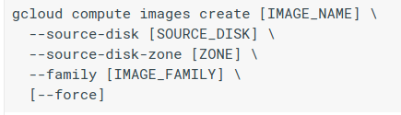

Example: from image

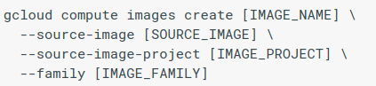

Deprecate



Create instance from an image

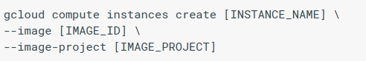

### Instance templates

Instance templates are like the recipe for your instances. They contain all of the information needed to turn on a new VM instance that looks exactly how you want it to. Higher up the chain, an instance group acts as a container for these managed instances and, given a template and some configuration parameters, is the thing that decides whether to turn on more, turn off some, or leave things alone. That could be useful in scenarios where the requested computing power is dynamic.

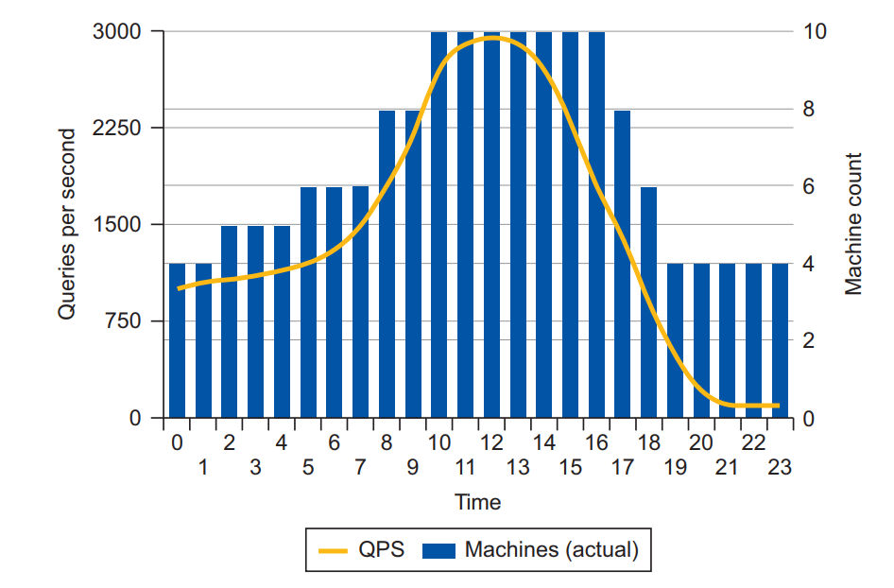

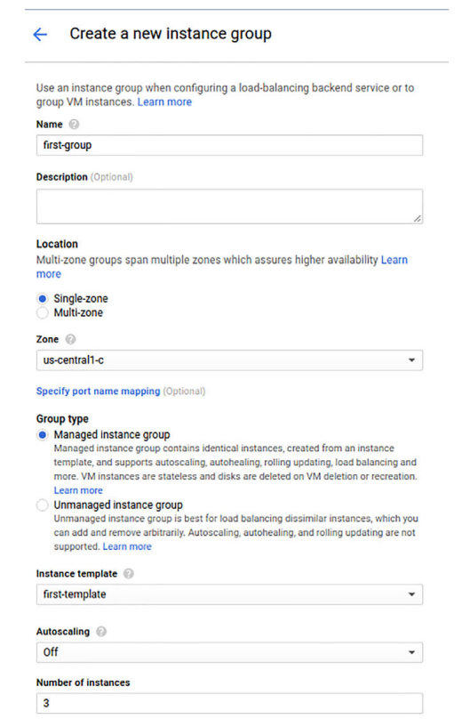

Then you can easily add / remove instances from the group

Rolling updates in a group: You may want to roll updates in the instances of a group, assigning a new template, but you may want to apply the updates to some instances and not all of them at the same time (so the ones with no updates will still be up).

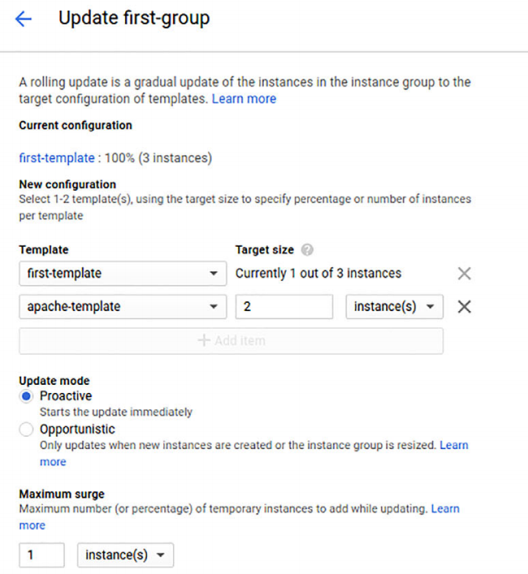

Autoscaling

Cool Down period: minimum amount of time the system will wait until it take a decision on re-scaling.

### Preemptible instance

A preemptible VM is an instance that you can create and run at a much [lower price](https://cloud.google.com/compute/pricing#machinetype) than normal instances. However, Compute Engine might terminate (preempt) these instances if it requires access to those resources for other tasks. Preemptible instances are excess Compute Engine capacity so their availability varies with usage.

If your applications are fault-tolerant and can withstand possible instance preemptions, then preemptible instances can reduce your Compute Engine costs significantly. For example, batch processing jobs can run on preemptible instances. If some of those instances terminate during processing, the job slows but does not completely stop. Preemptible instances complete your batch processing tasks without placing additional workload on your existing instances, and without requiring you to pay full price for additional normal instances.

### Preemptible instance limitations

Preemptible instances function like normal instances, but have the following limitations:

* Compute Engine might terminate preemptible instances at any time due to system events. The probability that Compute Engine will terminate a preemptible instance for a system event is generally low, but might vary from day to day and from zone to zone depending on current conditions.
* Compute Engine always terminates preemptible instances after they run for 24 hours.
* Preemptible instances are finite Compute Engine resources, so they might not always be available.
* Preemptible instances cannot [live migrate](https://cloud.google.com/compute/docs/instances/live-migration#preemptiblemaintenance) or be set to automatically restart when there is a maintenance event.
* Due to the above limitations, preemptible instances are not covered by any Service Level Agreement (and, for clarity, are excluded from the [Google Compute Engine SLA](https://cloud.google.com/compute/sla)).

You can define a graceful script to execute when GCE terminates a preemptible instance.

### Load balancers

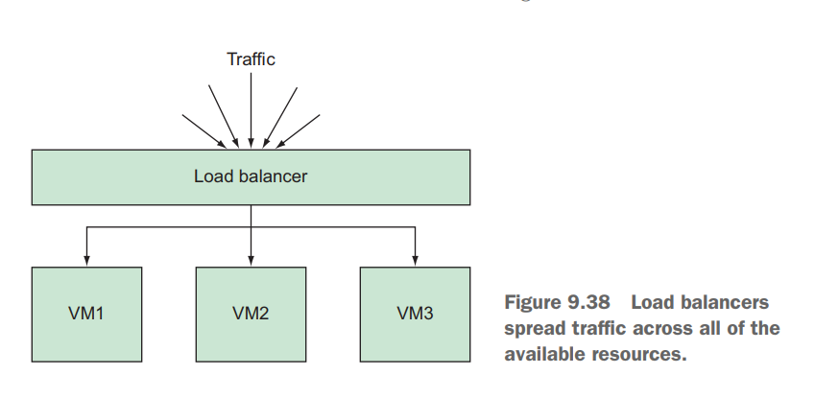

any load balancer will have both frontend and backend configurations.

**Backend configuration**

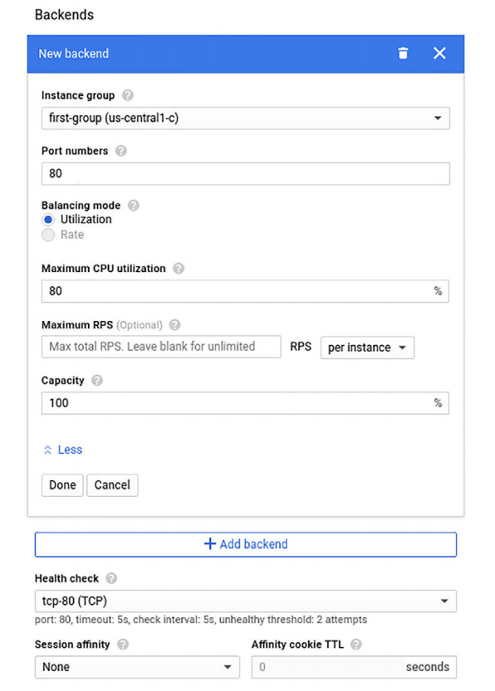

Health check

These health checks can be a simple static response page to show that the web

server is up and running, or something more advanced, like a test of whether the database

connection is working properly. You can create a simple TCP check to see that

port 80 is indeed open

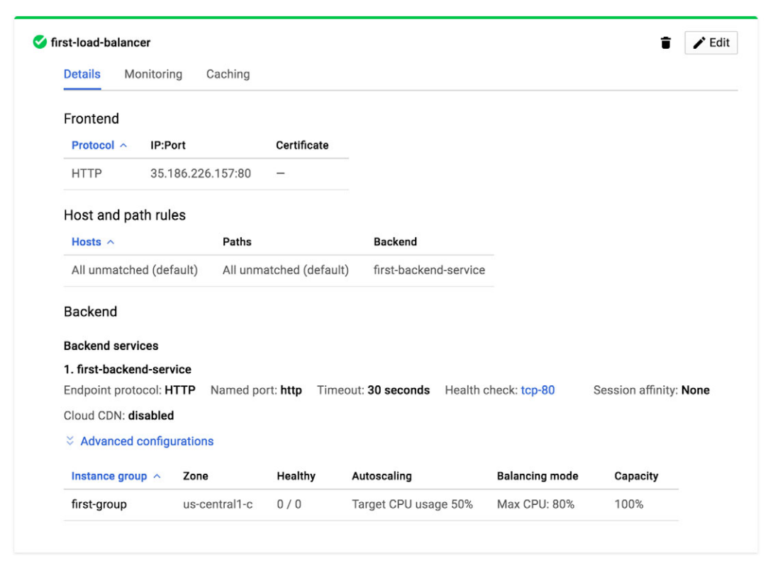

**Frontend configuration**

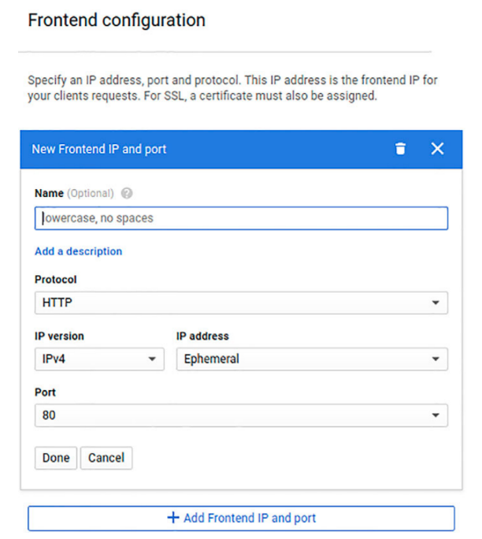

### Cloud CDN

Cloud CDN sits between the load balancer and the various people making requests to the service and attempts to short-circuit requests (by using some caching mechanism). Mostly used for static content, but also applies to dynamic responses. You create it by selecting a load balancer.

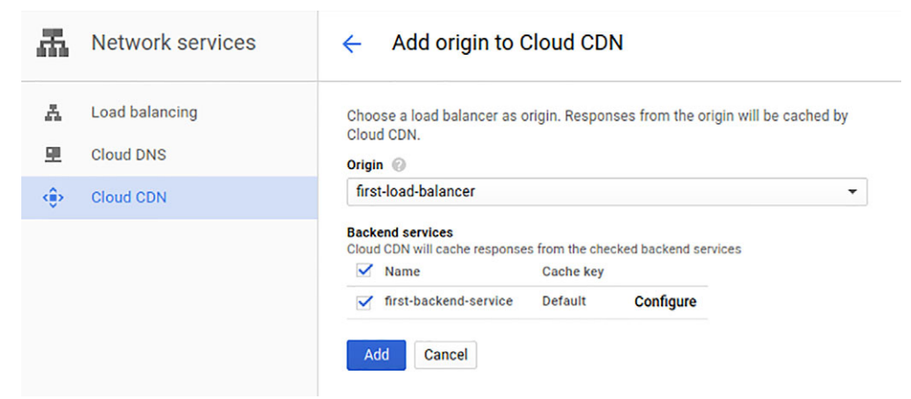

You can define some rules to invalid caching to specific urls, if you will.

**Zones and regions (REGION > zones)**

Certain Compute Engine resources live in regions or zones. A region is a specific geographical location where you can run your resources. Each region has one or more zones. For example, the us-central1 region denotes a region in the Central United States that has zones us-central1-a, us-central1-b, us-central1-c, and us-central1-f.

Resources that live in a zone, such as instances or persistent disks, are referred to as zonal resources. Other resources, like static external IP addresses, are regional. Regional resources can be used by any resources in that region, regardless of zone, while zonal resources can only be used by other resources in the same zone.

For example, disks and instances are both zonal resources. To attach a disk to an instance, both resources must be in the same zone. Similarly, if you want to assign a static IP address to an instance, the instance must be in the same region as t¶he static IP.

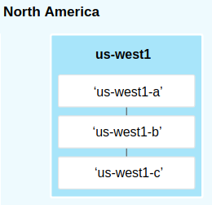

## Cloud Storage

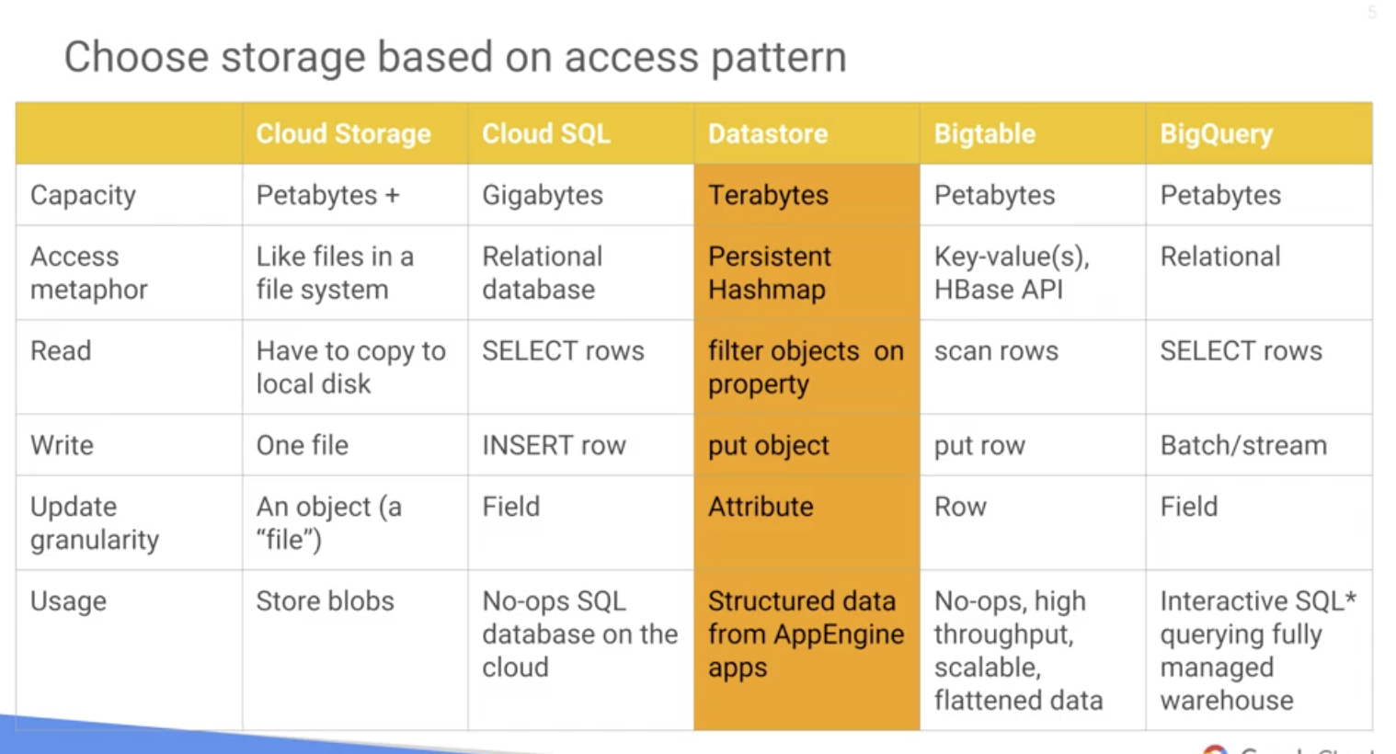

### Basic concepts

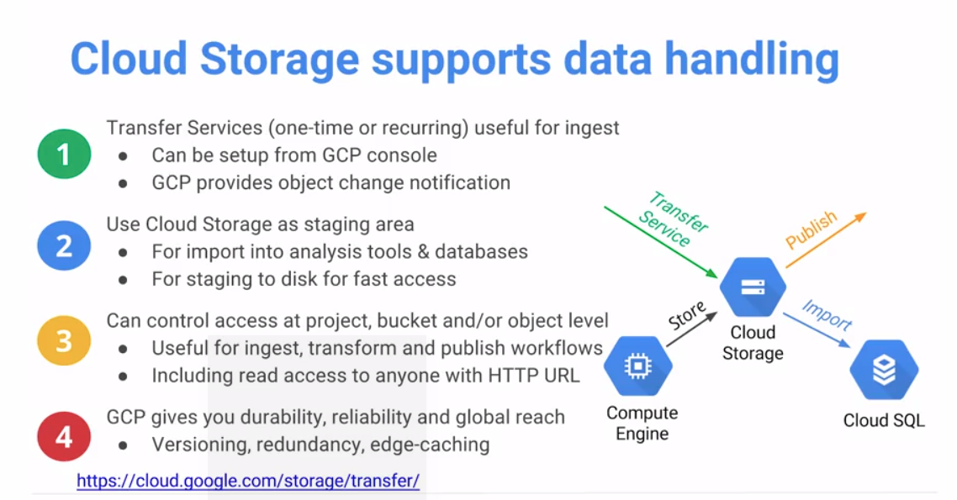

* **Bucket**:Root container for objects, bucket names must be globally-unique. There is only one Cloud Storage namespace, which means every bucket must have a unique name across the entire Cloud Storage namespace
* **Metadata**: controls aspects of how requests are handled, including what type of content your data represents and how your data is **encoded**. Use the GCP Console to set metadata on one object at a time. Use [gsutil setmeta](https://cloud.google.com/storage/docs/gsutil/commands/setmeta) to set metadata on multiple objects simultaneously.
* **Folders**: Cloud Storage system has no notion of folders, folders created in the GCP Console are a convenience to help you organize objects in a bucket, they don't have to be globally unique, they needs to be unique inside a bucket. In reality, all objects exist at the bucket level, and simply include the directory structure in their name.
* **Objects**: individual pieces of data that you store in Cloud Storage (files). Objects have two components: object data and object metadata. Object data is typically a file that you want to store in Cloud Storage. Object metadata is a collection of name-value pairs that describe various object qualities.Objects are **immutable**, which means that an uploaded object cannot change throughout its storage lifetime. An object's storage lifetime is the time between successful object creation (upload) and successful object deletion

### **Permission levels**

A user granted access to a **project:** <https://console.cloud.google.com/>

A user granted access to a **bucket:**

https://console.cloud.google.com/storage/browser/[BUCKET_NAME]/

A user granted access to an **object**

[https://storage.cloud.google.com/[BUCKET_NAME]/OBJECT_NAME]

[**shared publicly**](https://cloud.google.com/storage/docs/access-control/making-data-public). When you share a link publicly, the URL is of the form:https://storage.**googleapis**.com/[BUCKET_NAME]/[OBJECT_NAME]. This public URL does not require a recipient to authenticate with Google and can be used for non-authenticated access to an object.

### **Interaction with GCS**

gsutil command to interact

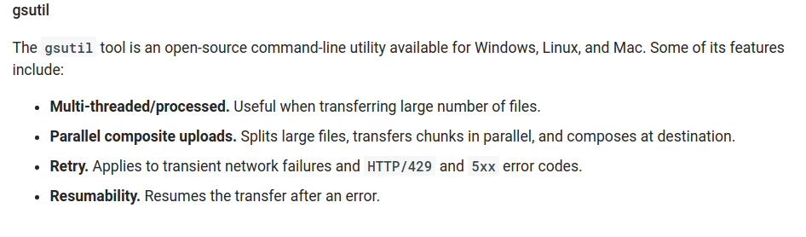



Example

gsutil cp <local-folder> <gs://<target-folder>

-m Multithreaded

-r recursive

Versioning

* Can apply to bucket level
* Not just apply to the content but also metadata (example: ACLs)

Enable versioning

# gsutil versioning get gs://[BUCKET_NAME]

gs://[BUCKET_NAME]: Enabled

# gsutil ls -a gs://[BUCKET_NAME]

gs://[BUCKET_NAME]/[OBJECT_NAME1]#[GENERATION_NUMBER1]  
gs://[BUCKET_NAME]/[OBJECT_NAME1]#[GENERATION_NUMBER2]  
gs://[BUCKET_NAME]/[OBJECT_NAME1]#[GENERATION_NUMBER3]

**Enable Logging**

* First need to create a bucket in which place the logs in (and assign proper permissions)

# gsutil logging set on -b gs://my-example-bucket-logs \

-o example-prefix gs://my-example-bucket

Enabling logging on gs://my-example-bucket/...

**Sliced objects downloads**

gsutil uses HTTP Range GET requests to perform "sliced" downloads in parallel when downloading large objects from Google Cloud Storage. This means that disk space for the temporary download destination file will be pre-allocated and byte ranges (slices) within the file will be downloaded in parallel. Once all slices have completed downloading, the temporary file will be renamed to the destination file. No additional local disk space is required for this operation.

**Parallel composite uploads**

gsutil can automatically use [object composition](https://cloud.google.com/storage/docs/composite-objects) to perform uploads in parallel for large, local files being uploaded to Google Cloud Storage. If enabled (see below), a large file will be split into component pieces that are uploaded in parallel

gsutil -o GSUtil:parallel_composite_upload_threshold=150M cp bigfile gs://your-bucket

**Resumable uploads**

gsutil automatically performs a resumable upload whenever you use the cp command to upload an object that is larger than 8 MiB. You do not need to specify any special command line options to make this happen. If your upload is interrupted you can restart the upload by running the same cp command that you ran to start the upload. Until the upload has completed successfully

### **Data Encryption Options**

Cloud Storage always encrypts your data on the server side, before it is written to disk, at no additional charge. Besides this default behavior, there are additional ways to encrypt your data when using Cloud Storage. Below is a summary of the encryption options available to you:

* *Server-side encryption*: encryption that occurs **after** Cloud Storage receives your data, but before the data is written to disk and stored.
  + [*Google-managed encryption keys*](https://cloud.google.com/storage/docs/encryption/default-keys): Cloud Storage uses its server-side encryption keys to encrypt your data. This is the default for Cloud Storage encryption.To protect your data as it travels over the Internet during read and write operations, use Transport Layer Security, commonly known as TLS or HTTPS.
  + [*Customer-supplied encryption keys*](https://cloud.google.com/storage/docs/encryption/customer-supplied-keys): You can create and manage your own encryption keys for server-side encryption, which replace the Google-managed encryption keys.
  + [*Customer-managed encryption keys*](https://cloud.google.com/storage/docs/encryption/customer-managed-keys): You can generate and manage your encryption keys using Cloud Key Management Service. These replace the Google-managed encryption keys.
* [*Client-side encryption*](https://cloud.google.com/storage/docs/encryption/client-side-keys): encryption that occurs **before** data is sent to Cloud Storage. Such data arrives at Cloud Storage already encrypted but also undergoes server-side encryption.

**Warning:** If you use customer-supplied encryption keys or client-side encryption, you must securely manage your keys and ensure that they are not lost. If you lose your keys, you are no longer able to read your data, and you continue to be charged for storage of your objects until you delete them.

# 

**Customer-Supplied Encryption Keys**

As an alternative to a [Google-managed server-side encryption key](https://cloud.google.com/storage/docs/encryption/default-keys), you can choose to provide your own AES-256 key, encoded in [standard Base64](https://tools.ietf.org/html/rfc4648#section-4). This key is known as a *customer-supplied encryption key*. If you provide a customer-supplied encryption key, Cloud Storage does not permanently store your key on Google's servers or otherwise manage your key. Instead, you provide your key for each Cloud Storage operation, and your key is purged from Google's servers after the operation is complete. Cloud Storage stores only a cryptographic hash of the key so that future requests can be validated against the hash. Your key cannot be recovered from this hash, and the hash cannot be used to decrypt your data.

When you apply a customer-supplied encryption key to an object, the object, its CRC32C checksum, and its MD5 hash are encrypted using the encryption key. The encryption key is then required to read any of these pieces of information. The remaining [metadata](https://cloud.google.com/storage/docs/metadata) for the object, including the object's name, is encrypted using standard server-side keys. This allows you to [read and update metadata](https://cloud.google.com/storage/docs/viewing-editing-metadata), as well as list and delete objects, without needing the customer-supplied encryption key. However, to perform any of these actions, you must have sufficient [permissions](https://cloud.google.com/storage/docs/access-control/index) to do so.

For example, if an object is encrypted with a customer-supplied encryption key, you must use the key to perform operations on the object such as downloading or moving it. If you attempt to read the object's metadata without providing the key, you receive metadata such as the object name and Content-Type, but not the object's CRC32C checksum or MD5 hash. If you do supply your key with the request for the object metadata, the object's CRC32C checksum and MD5 hash are included with the metadata.

**Note:** Because metadata can be read regardless of encryption method, do not include sensitive information in your object and bucket metadata or names.

If you are performing a compose operation on objects encrypted by customer-supplied encryption keys, the component objects must be encrypted by the same key, and you need to provide the key with the compose request. The resulting composite object is encrypted by the same key.

To protect your data as it travels over the Internet during read and write operations, use Transport Layer Security, commonly known as TLS or HTTPS. TLS is required when you provide an encryption key. If you accidentally use your encryption key over an unencrypted (HTTP) connection, it is possible for an attacker to intercept your key. Because of this possibility, the Cloud Storage API returns an error message warning you that your key may be compromised. If this occurs, you should immediately [rotate your keys](https://cloud.google.com/storage/docs/encryption/using-customer-supplied-keys#rotating).

### Transferring data to GC Storage

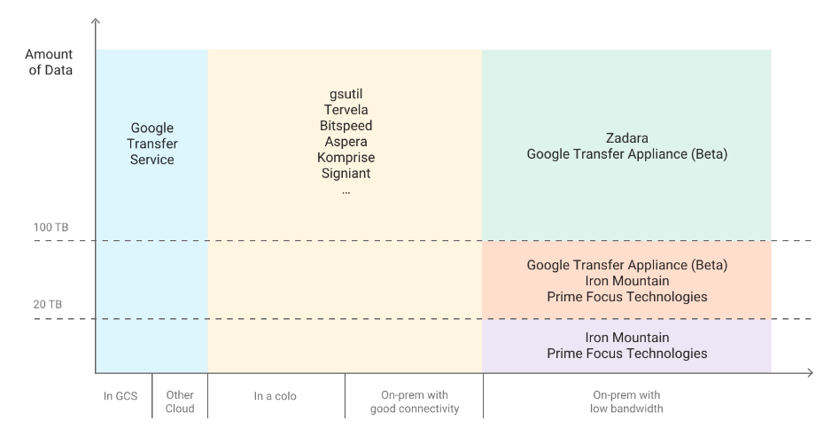

**Google Transfer Appliance**

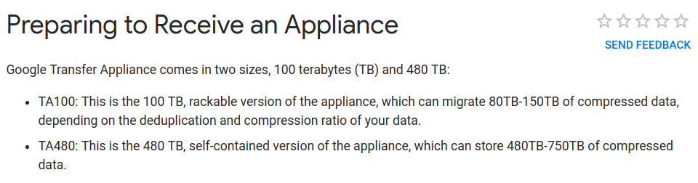

Step 1: Request a Transfer Appliance

Step 2: Fill appliance with up to a PB of data

Step 3: Ship the appliance back to Google

Step 4: Google uploads data to Cloud

Step 5: Access and place your data

**Google Transfer service**

Storage Transfer Service performs a data transfer with a *transfer operation*. Transfer operations are scheduled and configured through a *transfer job*. Storage Transfer Service has options that make data transfers and synchronization between data sources and data sinks easier. For example, you can:

* Schedule one-time transfer operations or recurring transfer operations.
* Delete existing objects in the destination bucket if they don't have a corresponding object in the source.
* Delete source objects after transferring them.
* Schedule periodic synchronization from data source to data sink with advanced filters based on file creation dates, file-name filters, and the times of day you prefer to import data.

You need to configure a job

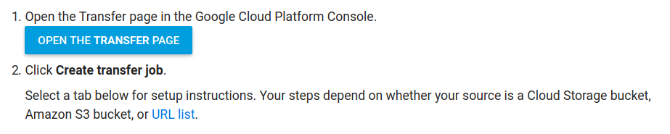

### Cloud storage - Pricing

Price composition:

* Storage
* Network
* Operations

Example

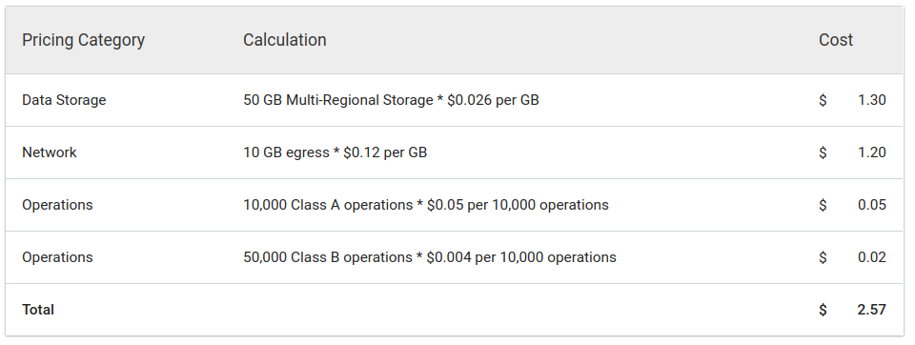

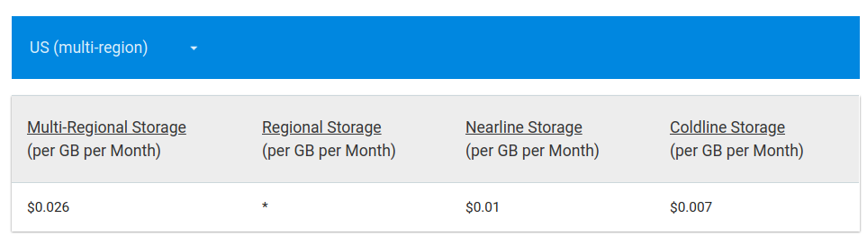

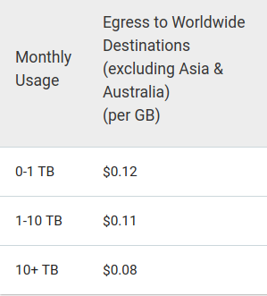

### Multi-regional vs Regional vs Nearline vs Coldline

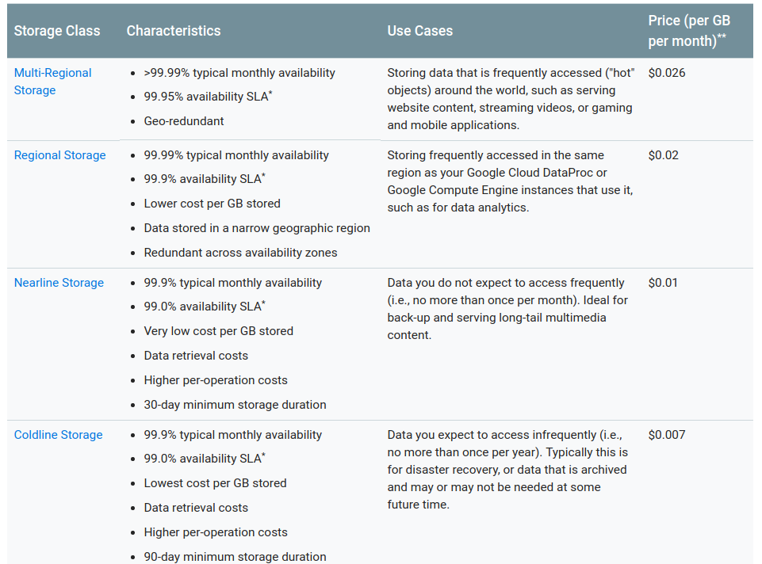

### Store: Cloud Storage as the data lake

[Cloud Storage](https://cloud.google.com/storage/) is well suited to serve as the central storage repository for many reasons.

**Performance and durability**: With Cloud Storage, you can start with a few small files and grow your data lake to exabytes in size. Cloud Storage supports [high-volume ingestion](https://cloud.google.com/solutions/architecture/optimized-large-scale-analytics-ingestion) of new data and high-volume consumption of stored data in combination with other services such as [Cloud Pub/Sub](https://cloud.google.com/pubsub/). While performance is critical for a data lake, durability is even more important, and Cloud Storage is designed for 99.999999999% annual durability.

**Strong consistency**: One key characteristic that sets Cloud Storage apart from many other object stores is its support for[strong consistency](https://cloud.google.com/storage/docs/consistency) in scenarios such as read-after-write operations, listing buckets and objects, and granting access to resources. Without this consistency, you must implement complex, time-consuming workarounds to determine when data is available for processing.

**Cost efficiency**: Cloud Storage provides a number of [storage classes](https://cloud.google.com/storage/features/) at multiple prices to suit different access patterns and availability needs, and to offer the flexibility to balance cost and frequency of data access. Without sacrificing performance, you can access data from these various storage classes by using a consistent API. For instance, you can archive infrequently used data to [Cloud Storage Nearline or Cloud Storage Coldline](https://cloud.google.com/storage/archival/) using a [lifecycle policy](https://cloud.google.com/storage/docs/lifecycle), and then access it later, maybe to gather training data for machine learning, with subsecond latency.

**Flexible processing**: Cloud Storage provides native integration with a number of powerful GCP services, such as[BigQuery](https://cloud.google.com/bigquery/), [Cloud Dataproc](https://cloud.google.com/dataproc/) (Hadoop ecosystem), [Cloud Dataflow](https://cloud.google.com/dataflow/) for serverless analytics, [Cloud Video Intelligence API](https://cloud.google.com/video-intelligence/) and[Cloud Vision API](https://cloud.google.com/vision/), and [Cloud Machine Learning Engine](https://cloud.google.com/ml-engine/), giving you the flexibility to choose the right tool to analyze your data.

**Central repository**: By offering a central location for storing and accessing data across teams and departments, Cloud Storage helps you avoid data silos that have to be kept in sync.

**Security**: Because data lakes are designed to store all types of data, enterprises expect strong access control capabilities to help ensure that their data doesn't fall into the wrong hands. Cloud Storage offers a [number of mechanisms](https://cloud.google.com/storage/docs/access-control/) to implement fine-grained access control over your data assets.

## 

## 

## Cloud SQL

### Basic concepts

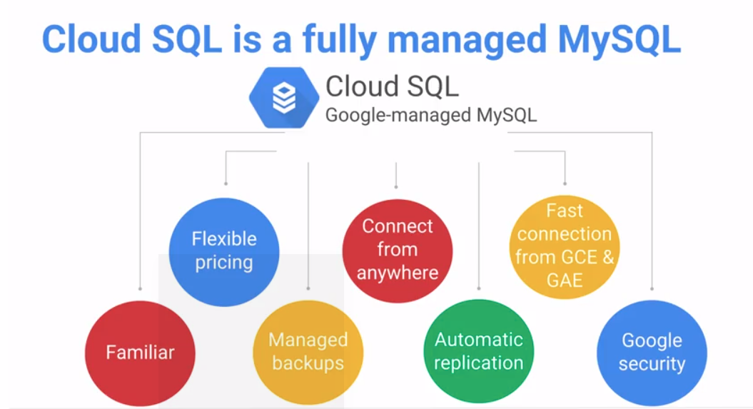

Now they offer both: MySQL and PostgreSQL

It can import scripts or data from Cloud Storage

Need to define an access network so we can access from console. (Option Access control -> Authorized networks)

From cloud shell:

mysql --host=<hostname> --user=<user> --password

Maximum storage capacity: **10 Tb**

### Pricing

Mysql

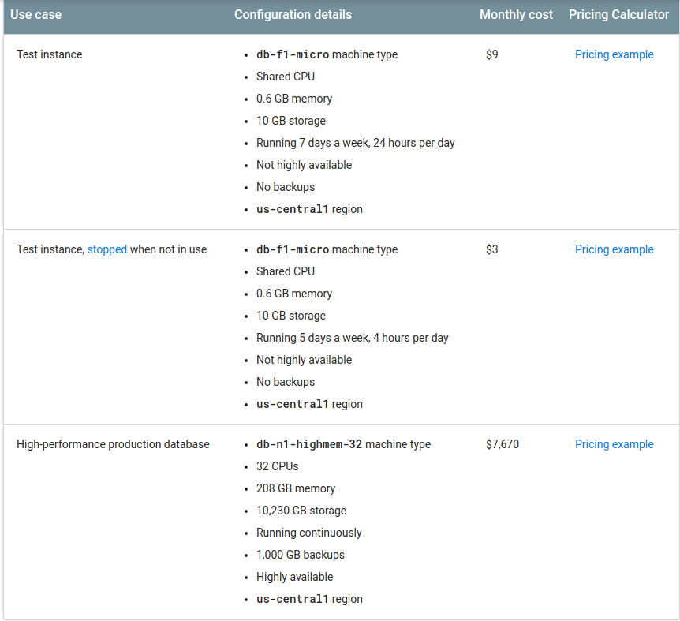

PostgreSQL

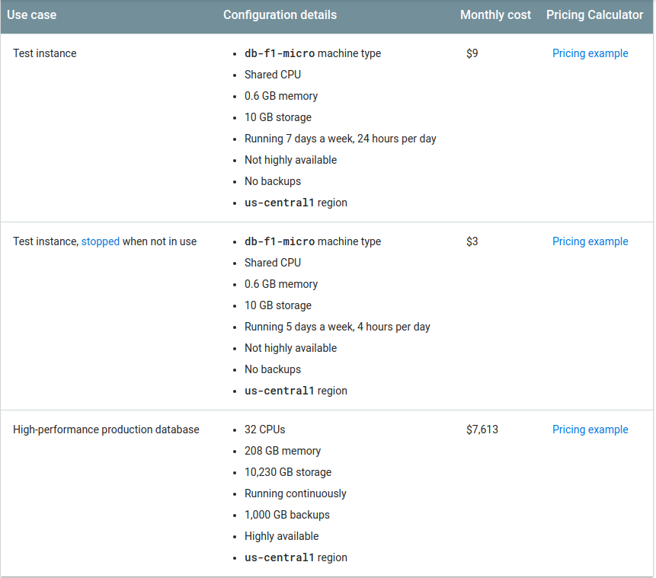

## 

## Dataproc

### Basic concepts

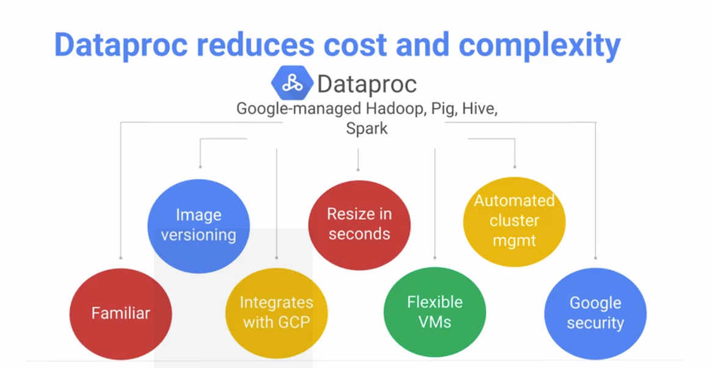

GCP integration: if you store data on HDFS, data will be stored in dataproc cluster itself. You have the chance to store in Cloud Storage, so your Dataproc cluster remains stateless, you can drop the cluster if you will, and use Dataproc cluster as you need ($$$).

Dataproc also works very well with flexible VMs (preemptible machines)

Get all the advantages of running on the Google Cloud, in terms of security, in terms of automated cluster management, in terms of image versioning. To make sure that all of your versions of Hadoop and Pig etc, they all work very well together.

Example:

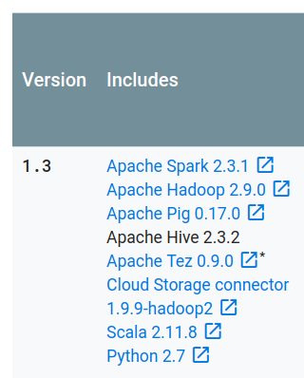

Helps to implement Hadoop open source stack:

* Pig for data transformation
* Hive for data querying at big scale
* Spark open source computing framework, with streaming, sql and ML libraries.

### Hadoop Cluster setup

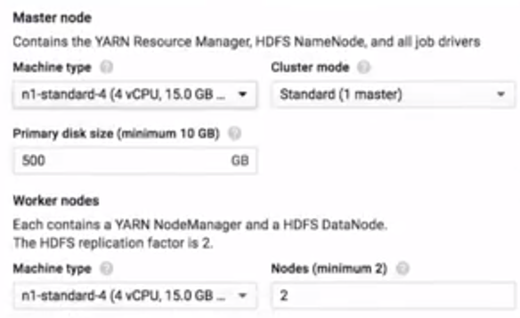

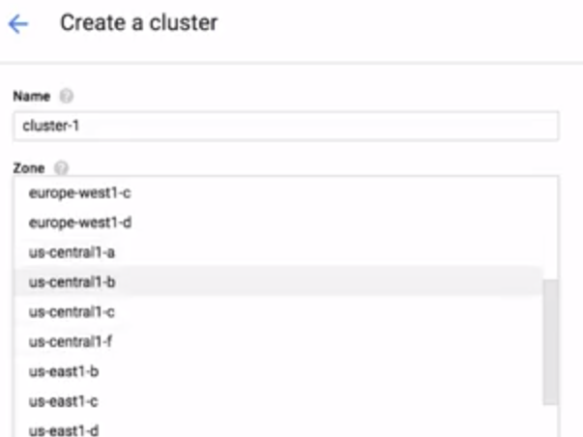

Zone selection is important since it should be closer from the data the cluster is consuming from.

Cluster configuration:

1- Single node (experimental)

2- Standard (1 master)

3- HA (3 masters) If a master fails, other master will keep the data and keep cluster running.

It can add preemptible nodes

You can also select different set of versions, for instance 1.0 will use the following versions for Spark, Hadoop, Pig and Hive:

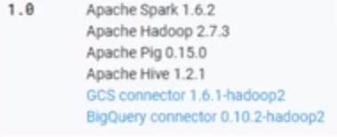

Command line

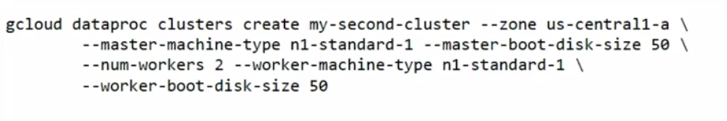

By default, usual web ports (e.g. 50070) are being blocked, so we need to create a firewall rule to access to those ports from browser

We can customize the size of memory or number of nodes for each worker.

You can ssh on the master node, or do ssh into the cluster to do quick experimentation (try some spark command lines, verify the data is in, or how long some steps would take)

Spark on HDFS will make some dependencies on compute and storage: (if a node goes down, all data in that node should be somewhere else).

So you can write in Google Storage instead of HDFS so data is persistent there. Once the cluster finishes, you can remove the cluster. You can also use preemptible nodes to run jobs.

So temporary storage still will be HDFS, but final storage will be GS, making the cluster stateless.

### Submit a dataproc job

Example by using python job

gcloud dataproc jobs submit pyspark \  
 --cluster **cluster-name** --region **region** \  
 gs://dataproc-examples-2f10d78d114f6aaec76462e3c310f31f/src/pyspark/hello-world/hello-world.py

Dataproc it is pre-installed with standard versions of HDFS, Spark. In order to install anything else on dataproc nodes we should:

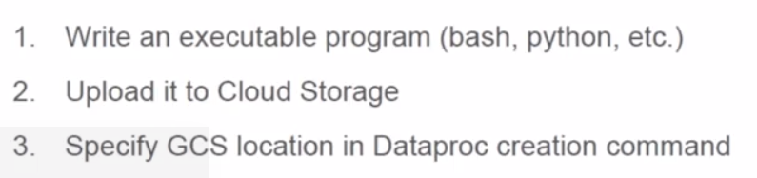

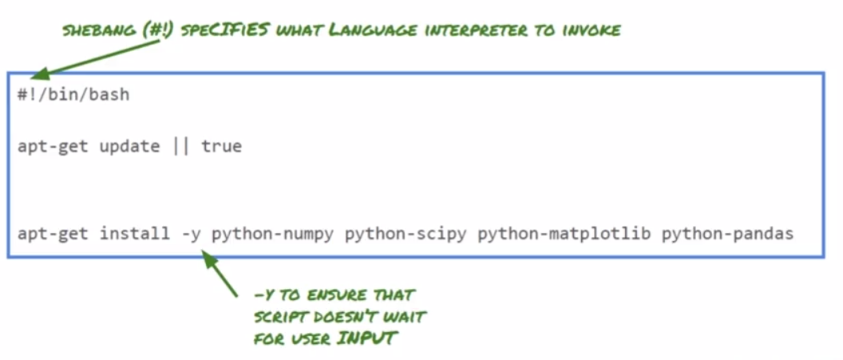

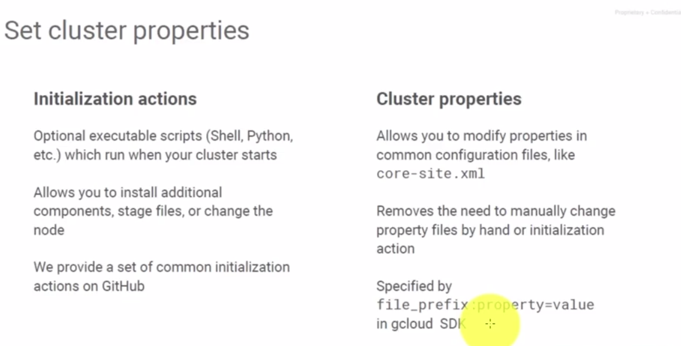

Example of initialization script

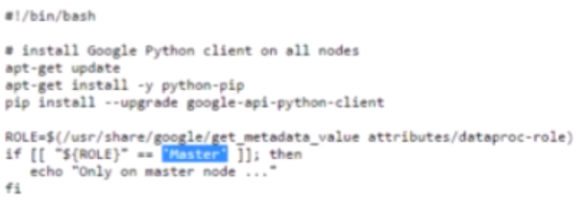

This script will be stored in gs, and then we can use the complete script path “Initialization script” by when Dataproc cluster is created. There are standard scripts we can download from Google Github, for instance Datalab can be installed in Dataproc nodes.

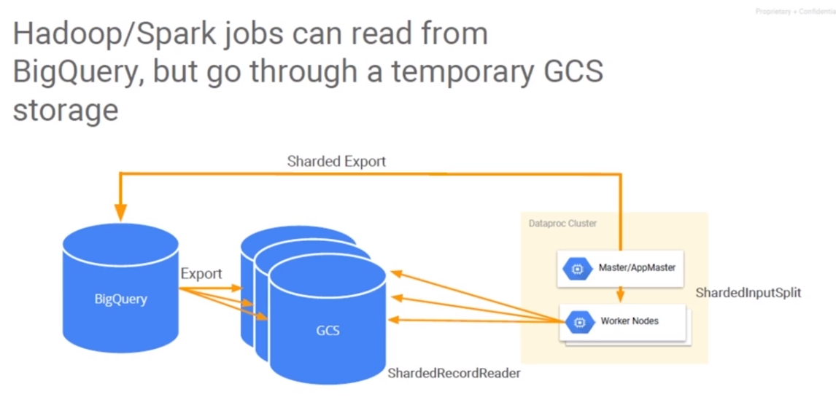





1. Setup connector read from BQ
2. Load data into GCS from BQ as a RRD, sharded in different buckets (e.g. one per worker)
3. Run main spark job as normal
4. Output to sharded files into GCS (sharded per worker so there is no bottleneck on a single GCS bucket from all workers)
5. Then we can call “bq load” so output data is available in BQ

### Pricing

Most important thing to take into account pricing will depend on **amount of processing hours**

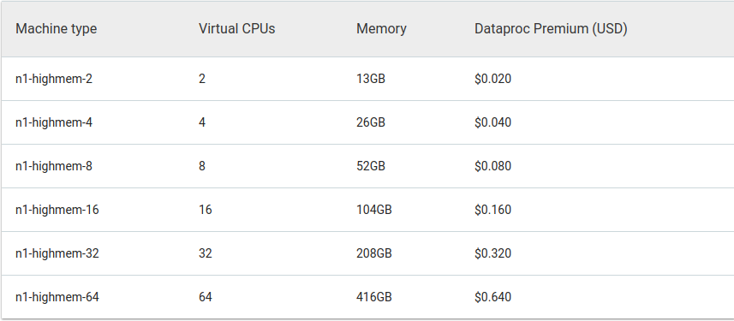

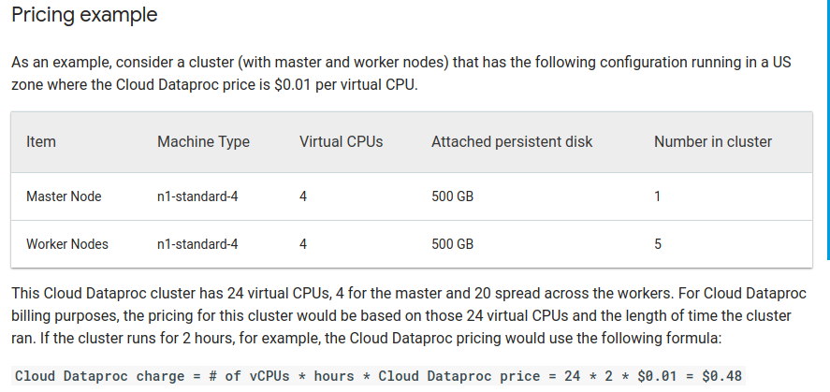

## 

## Datastore

### Basic concepts

## 

NoSQL document database.

- Great fit for product catalogs (real-time inventory) and user profiles/preferences.

- Autoscaling, high performance.

- Ease of application development: maps naturally to object-oriented and scripting languages.

- SQL-like query language (GQL).

Limitations

- Not a good fit for highly-relational data (no joins, no inequality filtering on multiple properties, no subqueries).

- Not an effective storage solution for analytic data (no aggregations).

## 

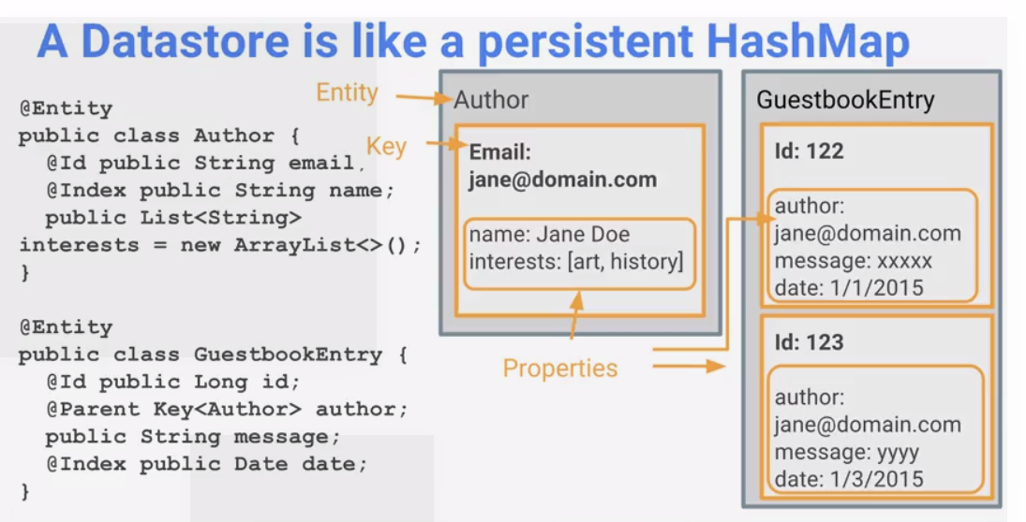

**Entities**

The primary storage concept in Cloud Datastore is an entity, which is Datastore’s take on a document. From a technical perspective, an entity is nothing more than a collection of properties and values combined with a unique identifier called a key.

An entity can have properties of all the basics, also known as primitives: Integer, boolean, string, floating-point, etc.

Advanced types:

Lists, which allow you to have a list of strings

Keys, which point to other entities

Embedded entities, which act as subentities

**Entity group**

Entities can define a parent key. Example: companyId (from Company entity) is a parent key for Employee entity. Datastore ensure that entity groups are stored closer (for data locality)

**Operations**

Operations in Cloud Datastore are pretty simple: they’re the things you can do to an

entity. The basic operations are

get—Retrieve an entity by its key.

put—Save or update an entity by its key.

delete—Delete an entity by its key.

**Indexes**

In order to query entities by certain property/ies, Datastore **requires** that there is always an index to rely on.

* Simple indexes: Datastore creates an index for each property by default
* Composite indexes: whenever we want to query by more than one property at the same time. Those are NOT created by default,
* Indexes are useful for filtering, sorting and filtering + (then) sorting.
* Excluded properties: If you know that a property never will be used by an index, you can exclude from indexing (“exclude from indexes”)

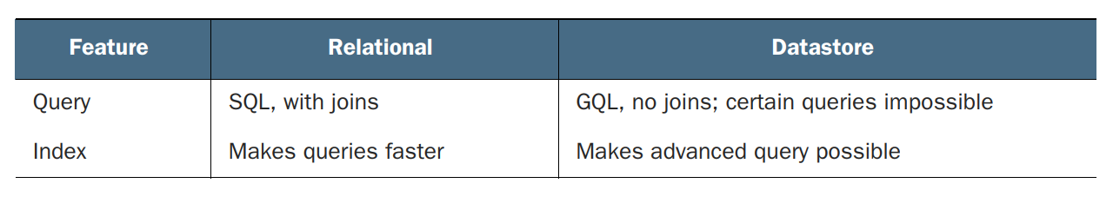

**Consistency**

Two-phase commit: Commit in two phases: a preparation phase and a commit phase. In the preparation phase, you send a request to a set of replicas, describing a change and asking the replicas to get ready to apply it. Once all of the replicas confirm that they’ve prepared the change, you send a second request instructing all replicas to apply that change. In the case of Datastore, this second (commit) phase is done **asynchronously**, where some of those changes may hang around in the prepared but not yet applied state. **Eventual consistency**, which means that eventually your indexes will be up to date (consistent) with the data you have stored in your entities.

However, queries inside a **single entity group** are **strongly consistent** (not eventually consistent). An entity group, defined by keys sharing the same parent key, is how you tell Datastore to put entities near each other. If you want to query over a bunch of entities that all have the same parent key, your query will be strongly consistent.

**Export**

* Export: a GC Storage can be configured to do the export.
* Remember eventual consistency to do export. The only way to avoid missing updates is to stop writings before the export (you can disable writes to your Datastore instance via

the Cloud Console, using the Admin tab in the Datastore section)

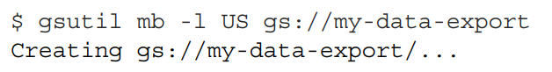

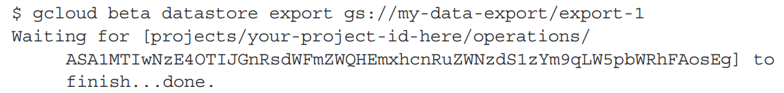

**Import**

if you had made changes to any of the entities (or deleted any entities),  
those entities would be reverted to how they were at the time of the export. But if you  
had created new entities, they’d be left entirely alone, because an import doesn’t  
affect entities it hasn’t seen before.

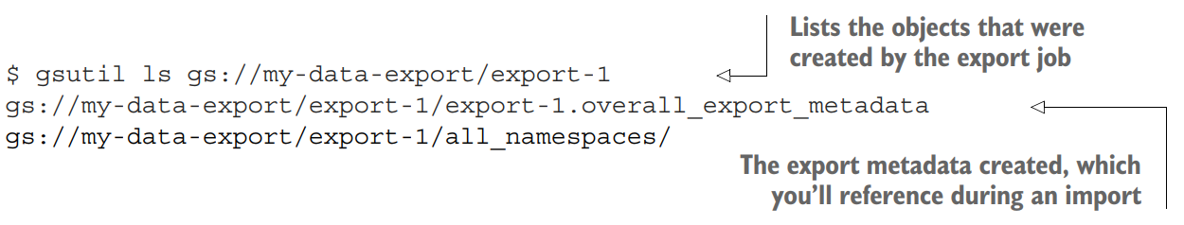

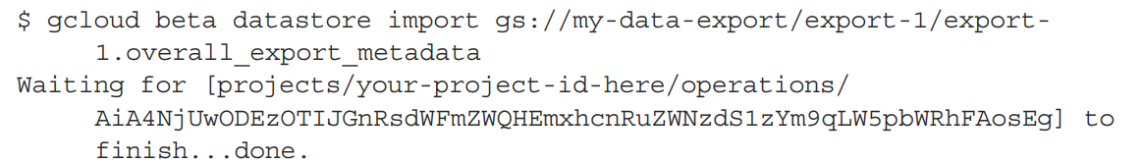

**Locations**

- Decision is permanent for the instance (and also for App Engine).

- Multi-region location:

- Multi-region and multi-zone replication.

- Maximizes availability and durability (withstands loss of entire regions).

- Uptime percentage SLA: 99.95%.

- Regional location:

- Multi-zone replication.

- Lower write latency.

- Uptime percentage SLA: 99.9%.

### Pricing

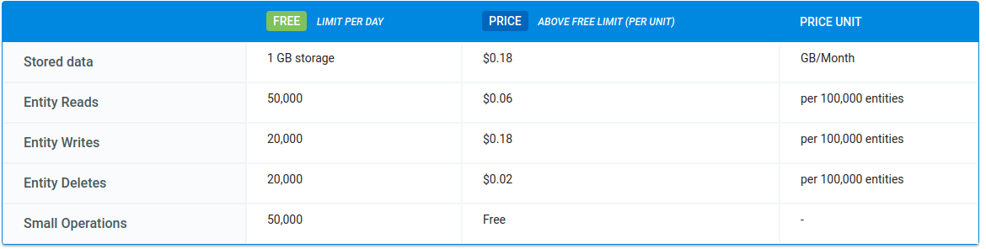

## CAP Theorem

In theoretical computer science, the **CAP theorem**, states that it is impossible for a [distributed data store](https://en.wikipedia.org/wiki/Distributed_data_store) to simultaneously provide more than two out of the following three guarantees:

* [*Consistency*](https://en.wikipedia.org/wiki/Consistency_(database_systems)): Every read receives the most recent write or an error
* [*Availability*](https://en.wikipedia.org/wiki/Availability): Every request receives a (non-error) response – without the guarantee that it contains the most recent write
* [*Partition tolerance*](https://en.wikipedia.org/wiki/Network_partitioning): The system continues to operate despite an arbitrary number of messages being dropped (or delayed) by the network between nodes

In particular, the CAP theorem implies that in the presence of a network partition, one has to choose between consistency and availability. Note that consistency as defined in the CAP theorem is quite different from the consistency guaranteed in [ACID](https://en.wikipedia.org/wiki/ACID) [database transactions](https://en.wikipedia.org/wiki/Database_transaction).

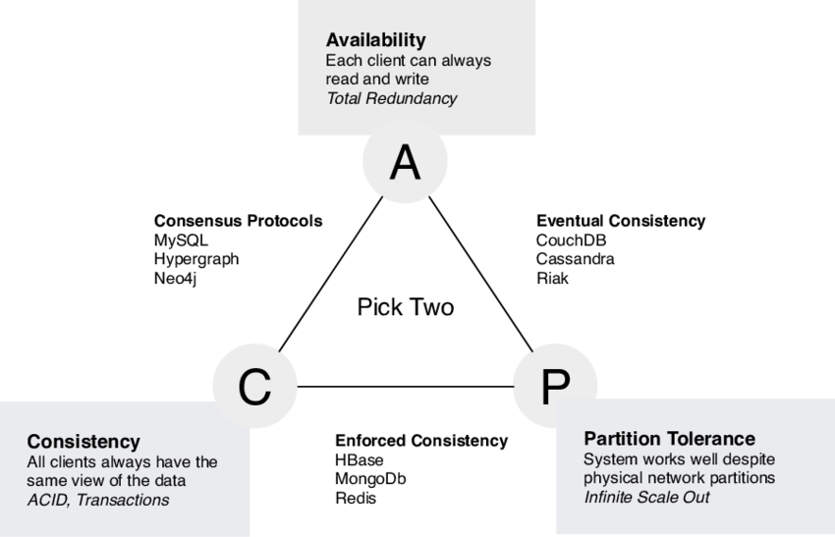

## 

## BigTable

### Basic concepts

Ideal for non-structured key/value data.

- Great fit for time-series data.

- Very low latency (typically < 10 milliseconds).

- High read and write throughput.

- Able to store terabytes or even petabytes of data.

- Compatible with HBase API.

Limitations

- Not supported: SQL queries, joins, multi-row transactions.

- Not a good solution for storing less than 1 TB of data

- As a best practice, store a maximum of 10 MB in a single cell and **100 MB in a single row.**

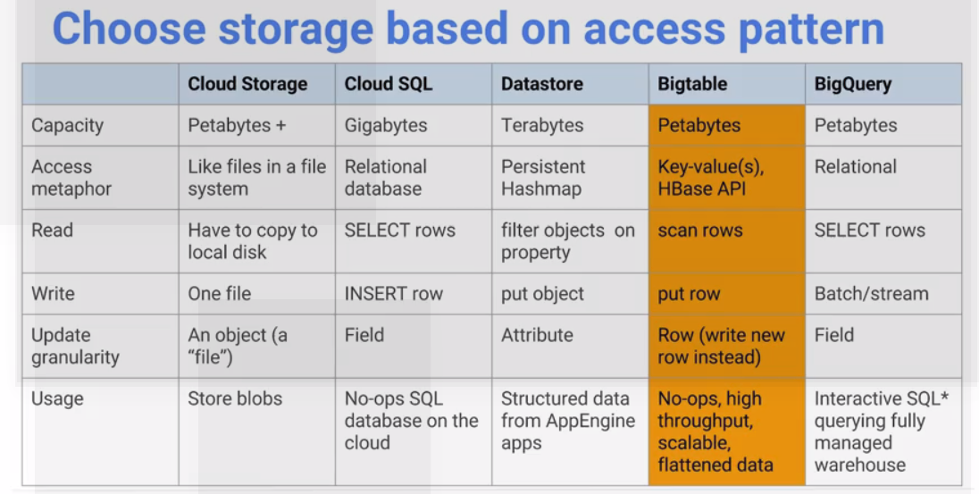

Flattened data, not hierarchical, so you need to model key-values and access by key.

Defined as “a sparse, distributed, persistent, multi-dimensional **sorted** **map**” think about the **“sorted map”** by when design row key

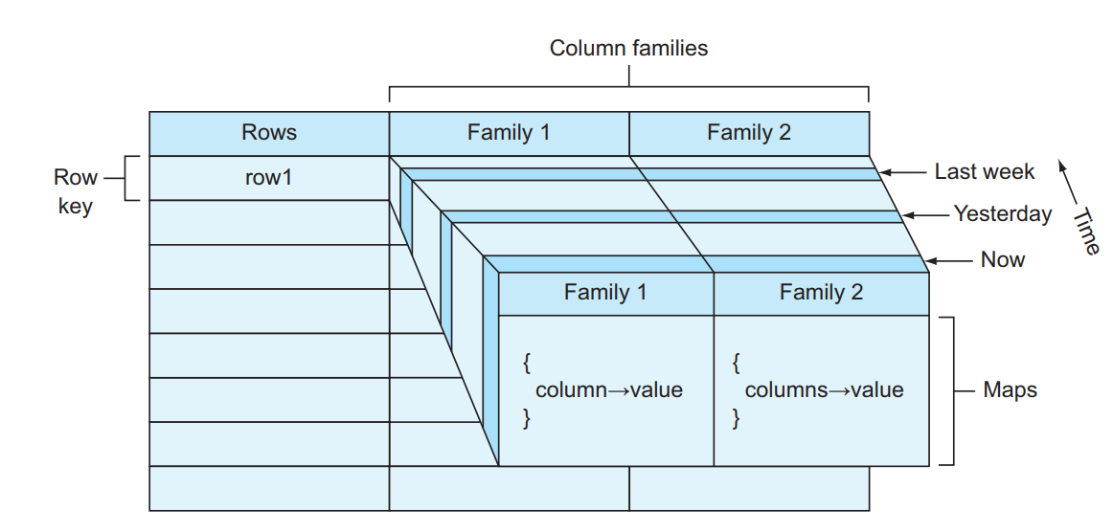

Key will be distributed in different bucket, we need to avoid hot-spots.

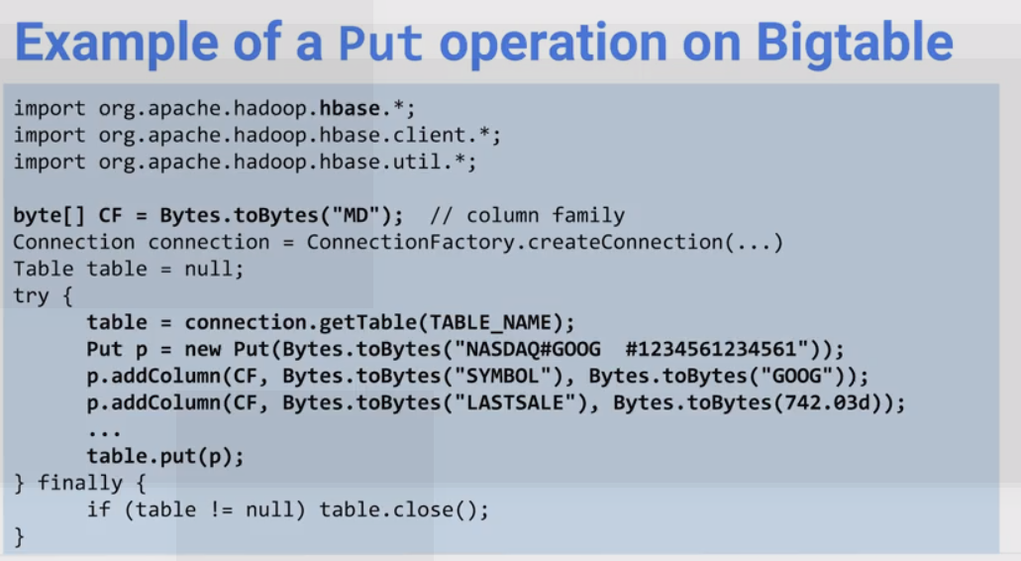

### Instances, Clusters, and Nodes

To use Cloud Bigtable, you create *instances*, which contain 1 or 2 *clusters* that your applications can connect to. Each cluster contains *nodes*, the compute units that manage your data and perform maintenance tasks.

This page provides more information about Cloud Bigtable instances, clusters, and nodes.

* To learn how to create an instance, see [Creating an Instance](https://cloud.google.com/bigtable/docs/creating-instance).
* To learn how to manage an instance's clusters, see [Adding and deleting clusters](https://cloud.google.com/bigtable/docs/modifying-instance#clusters).
* To learn how to monitor an instance and its clusters, see [Monitoring an Instance](https://cloud.google.com/bigtable/docs/monitoring-instance).
* To learn how to update the number of nodes in a cluster, see [Adding and removing nodes](https://cloud.google.com/bigtable/docs/modifying-instance#nodes).

Before you read this page, you should be familiar with the [overview of Cloud Bigtable](https://cloud.google.com/bigtable/docs/overview).

### **Instances**

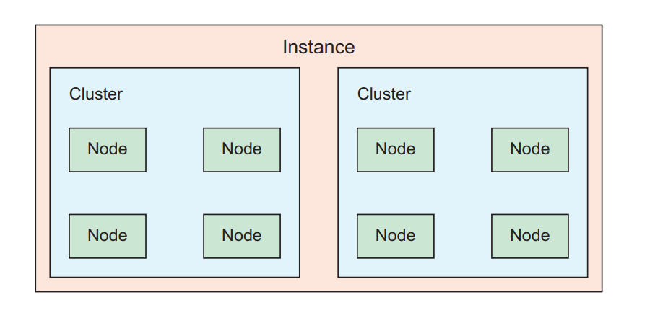

A Cloud Bigtable instance is mostly just a container for your [clusters](https://cloud.google.com/bigtable/docs/instances-clusters-nodes#clusters) and [nodes](https://cloud.google.com/bigtable/docs/instances-clusters-nodes#nodes), which do all of the real work. However, an instance has a few important properties that you need to know about:

* The *instance type* (production or development)
* The *storage type* (SSD or HDD)
* The *application profiles*, for instances that use replication

The following sections describe these properties.

### Instance types

When you [create an instance](https://cloud.google.com/bigtable/docs/creating-instance), you must choose what type of instance to create:

* **Production**: A standard instance with either 1 or 2 clusters, as well as 3 or more nodes in each cluster. You cannot downgrade a production instance to a development instance.
* **Development**: A low-cost instance for development and testing, with performance limited to the equivalent of a 1-node cluster. There are no monitoring or throughput guarantees; replication is not available; and the [SLA](https://cloud.google.com/bigtable/sla) does not apply. You can upgrade a development instance to a production instance at any time.

### Storage types

When you [create an instance](https://cloud.google.com/bigtable/docs/creating-instance), you must also choose whether the instance's clusters will store data on solid-state drives (SSD) or hard disk drives (HDD). SSD is often, but not always, the most efficient and cost-effective choice.

The choice between SSD and HDD is permanent, and every cluster in your instance must use the same type of storage, so make sure you pick the right storage type for your use case. See [Choosing Between SSD and HDD Storage](https://cloud.google.com/bigtable/docs/choosing-ssd-hdd) for more information to help you decide.

### Application profilesited States. The company began accepting property facultative business in 1961, and has continued since, to underwrite property business by appointment on behalf of insurance and reinsurance companies domestic and Lloyds. This record makes Burt and Scheld one of the oldest continuous facultative underwriting organizations in the United States.

After you [create a production instance](https://cloud.google.com/bigtable/docs/creating-instance), Cloud Bigtable uses the instance to store [application profiles](https://cloud.google.com/bigtable/docs/app-profiles), or app profiles. For instances that use replication, app profiles control how your applications connect to the instance's clusters. If your instance doesn't use replication, you can still use app profiles to provide separate identifiers for each of your applications, or each function within an application; you can then [view separate charts for each app profile in the GCP Console](https://cloud.google.com/bigtable/docs/monitoring-instance#console-monitoring-resources).

App profiles are basically defined by setting:

* Routing policy:
  + **Single-cluster routing** routes all requests to 1 cluster in your instance.
  + **Multi-cluster routing** tells Cloud Bigtable that it can route each request to any available cluster.
* Single-row transactions:
  + Allow to disable a single-row transaction for instance with 2 clusters

### Clusters

A cluster represents the actual Cloud Bigtable service. Each cluster belongs to a single Cloud Bigtable instance, and an instance can have up to 2 clusters. When your application sends requests to a Cloud Bigtable instance, those requests are actually handled by one of the clusters in the instance.

Each cluster is located in a single zone. An instance's clusters must be in unique zones that are within the same region. For example, if the first cluster is in us-east1-b, then us-east1-c is a valid zone for the second cluster. For a list of zones and regions where Cloud Bigtable is available, see [Cloud Bigtable Locations](https://cloud.google.com/bigtable/docs/locations).

Cloud Bigtable instances with only 1 cluster do not use [replication](https://cloud.google.com/bigtable/docs/replication-overview). If you add a second cluster to a production instance, then Cloud Bigtable automatically starts replicating your data by keeping separate copies of the data in each of the clusters' zones and synchronizing updates between the copies. You can choose which cluster your applications connect to, which makes it possible to isolate different types of traffic from one another, or you can let Cloud Bigtable balance traffic between clusters. If a cluster becomes unavailable, you can fail over from one cluster to another. To learn more about how replication works, see [Overview of Replication](https://cloud.google.com/bigtable/docs/replication-overview).

### Nodes

Each cluster in a production instance has 3 or more nodes, which are compute resources that Cloud Bigtable uses to manage your data.

Behind the scenes, Cloud Bigtable splits all of the data from your tables into smaller *tablets*, which are stored on disk, separate from the nodes. Each node is responsible for keeping track of specific tablets on disk; handling incoming reads and writes for its tablets; and performing maintenance tasks on its tablets, such as periodic [compactions](https://cloud.google.com/bigtable/docs/overview#compactions). For more details about how Cloud Bigtable stores and manages data, see [Cloud Bigtable architecture](https://cloud.google.com/bigtable/docs/overview#architecture).

A cluster must have enough nodes to support its current workload and the amount of data it stores. Otherwise, the cluster might not be able to handle incoming requests, and latency could go up. You should [monitor your clusters' CPU and disk usage](https://cloud.google.com/bigtable/docs/monitoring-instance#cpu-and-disk), and [add nodes](https://cloud.google.com/bigtable/docs/modifying-instance#nodes) if you exceed the recommendations and limits listed below.

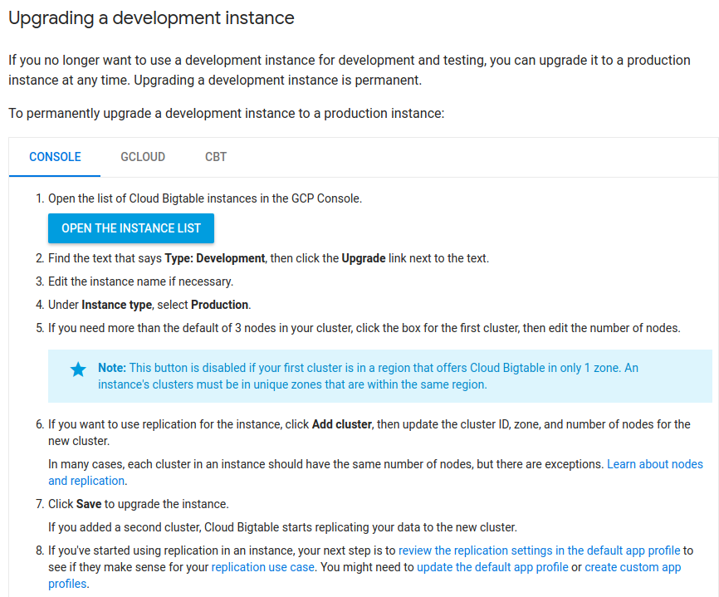

### Schema design

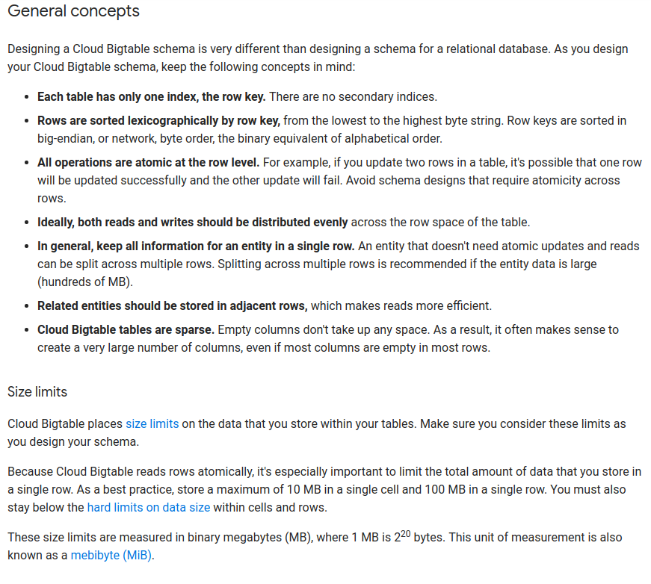

### Time series data

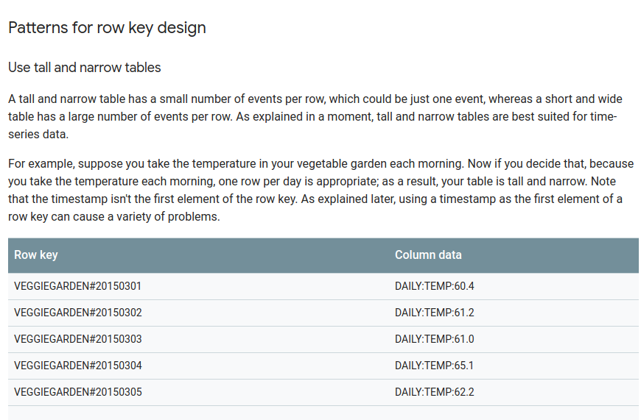

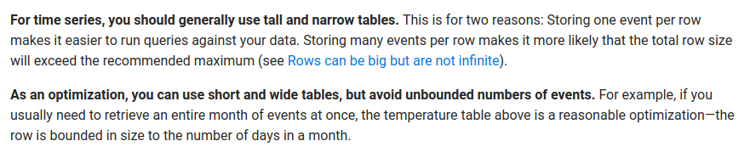

### Performance

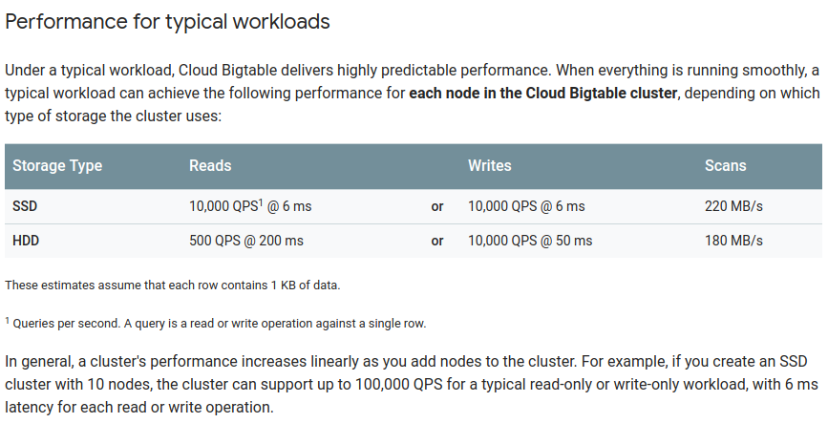

HDD vs SDD

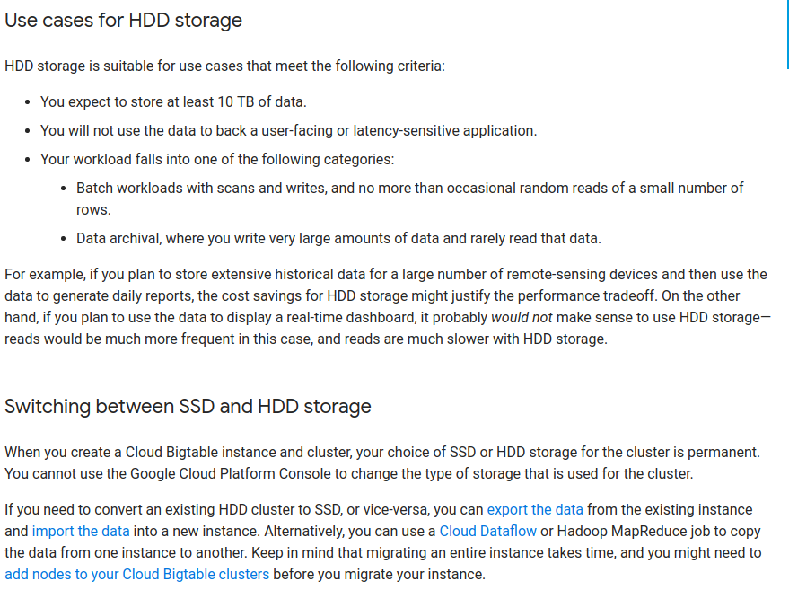

Cbt tool

The cbt tool is a command-line interface for performing several different operations on Cloud Bigtable. It is written in Go using the Go client library for Cloud Bigtable. Source code for the cbt tool is available in the GitHub repository GoogleCloudPlatform/google-cloud-go. This repository is a mirror of code.googlesource.com/gocloud

### Pricing

Instance

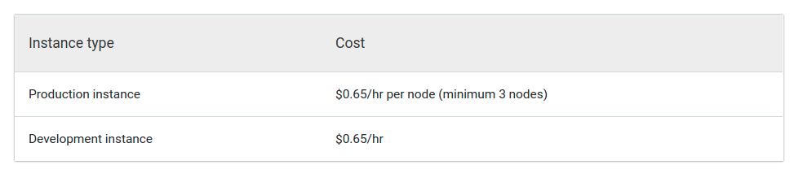

Storage

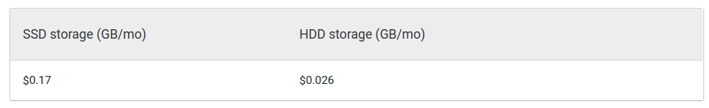

Network

(really cheap)

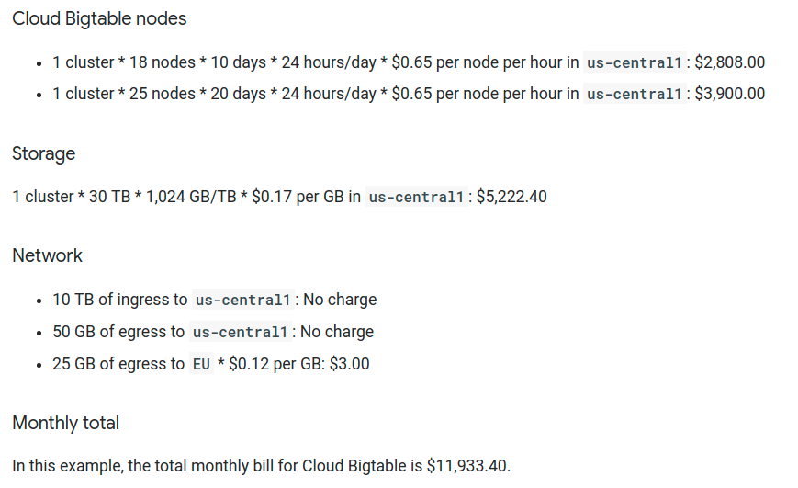

## 

## BigQuery

### Basic concepts

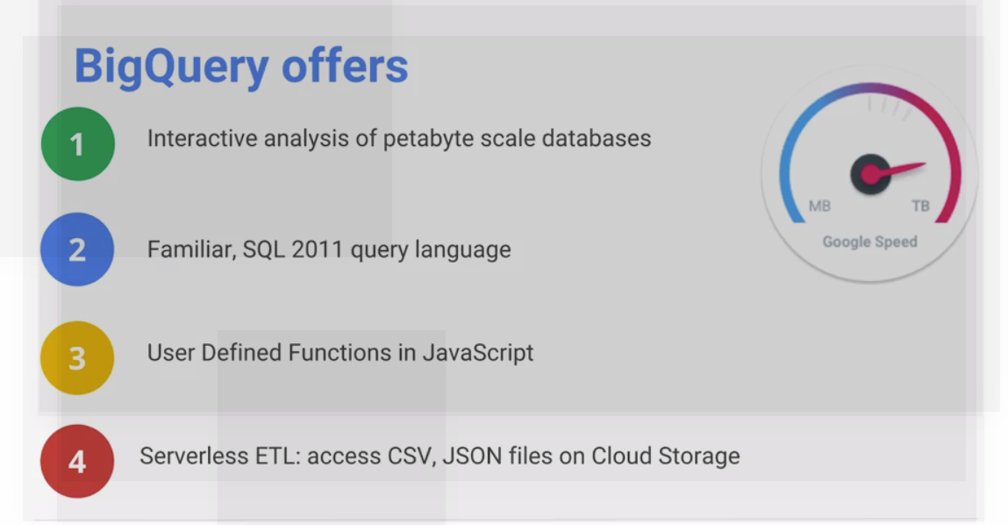

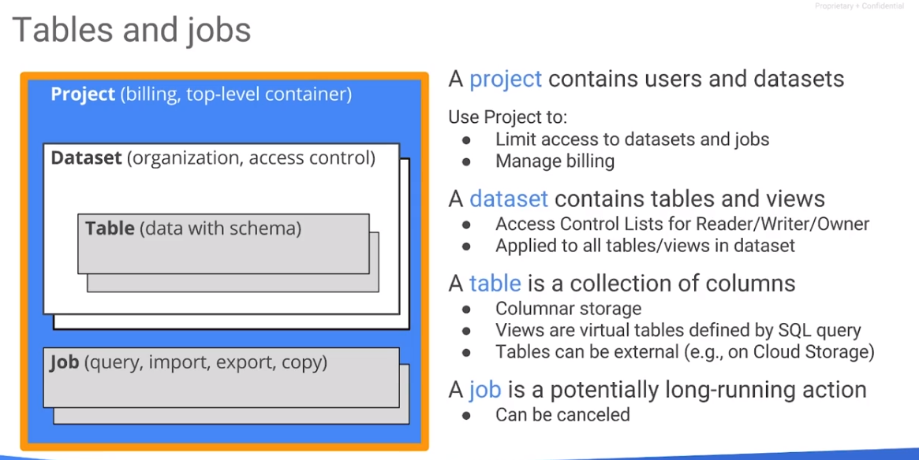

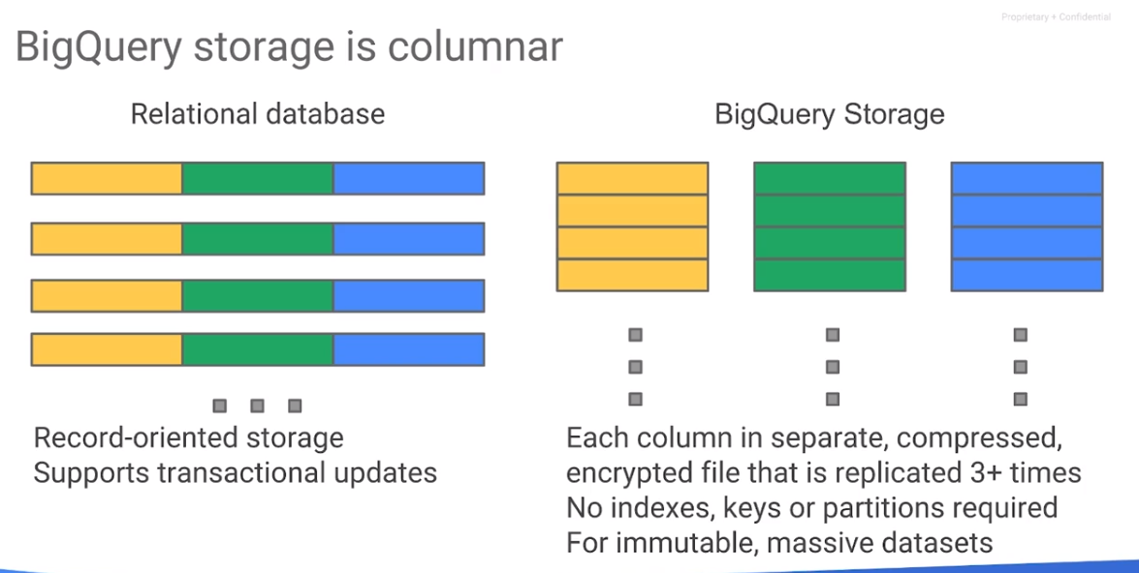

Unlike in a traditional relational database, BigQuery rows typically don’t have a unique identifier column, primarily because BigQuery isn’t meant for transactional queries where a unique ID is required to address a single row

Import: It can take a CSV, new-line separated Json. It can “autodetect” the table schema if we desire.

Export: In Cloud Storage as comma-separated (csv), new-line separated JSON, or Avro

### **BigQuery roles**

roles/bigquery.**jobUser**: run, list, cancel jobs (Project level)

roles/bigquery.**user:** jobUser permissions + create new datasets (Project level). The bigquery.user role does not give users permission to query data, view table data, or view table schema details for datasets the user **did not create**.

roles/bigquery.**metadataViewer:** Query table and schema metadata (Project level)

roles/bigquery.**dataViewer:** read metadata + data from tables. (Dataset level)

roles/bigquery.**dataEditor:** read and edit (even drop) tables (Dataset level. If it is granted at project level it can create datasets)

roles/bigquery.**dataOwner:** dataEditor + update/delete datasets. (Dataset level)

roles/bigquery.admin: Admin permission. Project level.

### **Authorized views**

Suppose we have a table in which you don’t want to share all columns to a certain group of users. This is a typical case for authorized views. Scenario: you already have a dataset (let’s called “source” dataset) with a table on it, just a few columns need to be visible for certain users. In most relational databases you just create a view and assign just permissions to use that view. However (looks like) the deeper level of permissions to objects in BigQuery is dataset (not individual tables / views). So you will have to create a separated dataset with the new view inside.

These are the steps to create authorized views

* Create a separate dataset to store the view
* Create the view in the new dataset
* Assign access controls to the project (such as bigquery.user role)
* Assign access controls to the dataset containing the view (Share dataset option, assign READER access)
* Authorize the view to access the source dataset



(and select the target view ;) )

### 

### **Bigquery SQL queries**

## 

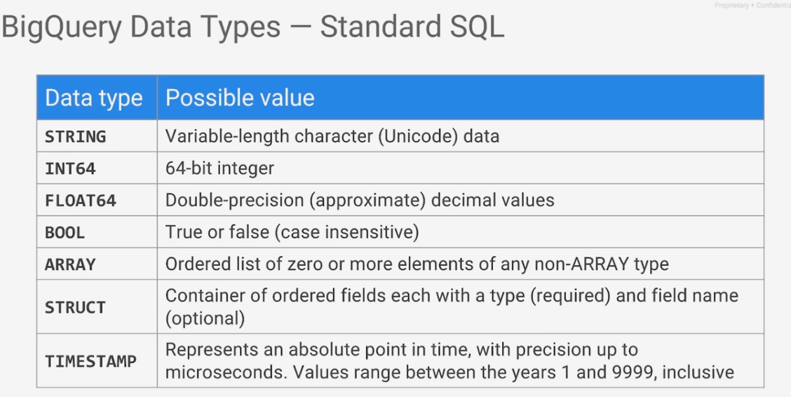

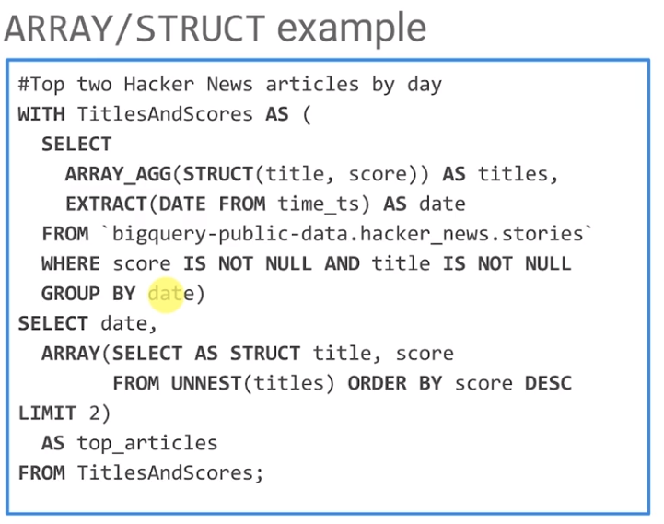

### Partitioning

There are two types of table partitioning in BigQuery:

* **Tables partitioned by ingestion time**: Tables partitioned based on the data's ingestion (load) date or arrival date. Include a pseudo column named _PARTITIONTIME that contains a date-based timestamp for data that is loaded into the table
* **Partitioned tables**: Tables that are partitioned based on a [TIMESTAMP](https://cloud.google.com/bigquery/docs/reference/standard-sql/data-types#timestamp-type) or [DATE](https://cloud.google.com/bigquery/docs/reference/standard-sql/data-types#date-type) column.

### Partitioning versus sharding (wildcard tables)

As an alternative to partitioned tables, you can shard tables using a time-based naming approach such as [PREFIX]_YYYYMMDD. This is referred to as creating date-sharded tables. Using either standard SQL or legacy SQL, you can specify a query with a UNION operator to limit the tables scanned by the query.

_TABLE_SUFFIX pseudocolumn is used to reference the suffix when you use wildcard tables.

Example:

Tables: blogs_20181120, blogs_20181121

**SELECT** **COUNT**(**DISTINCT** user_id)  
-- Notice the usage of the wildcard  
**FROM** `project.dataset.blogs_*`  
**WHERE** _TABLE_SUFFIX = "20181120"

Partitioned tables perform better than tables sharded by date.

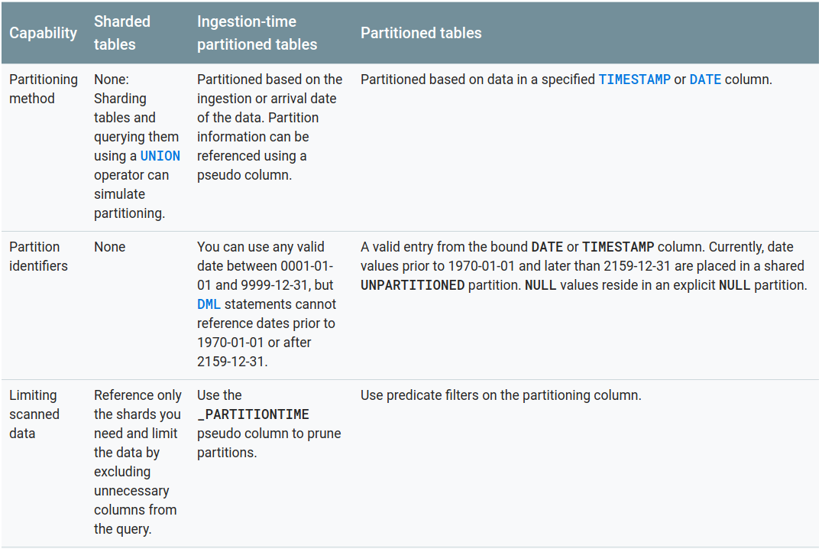

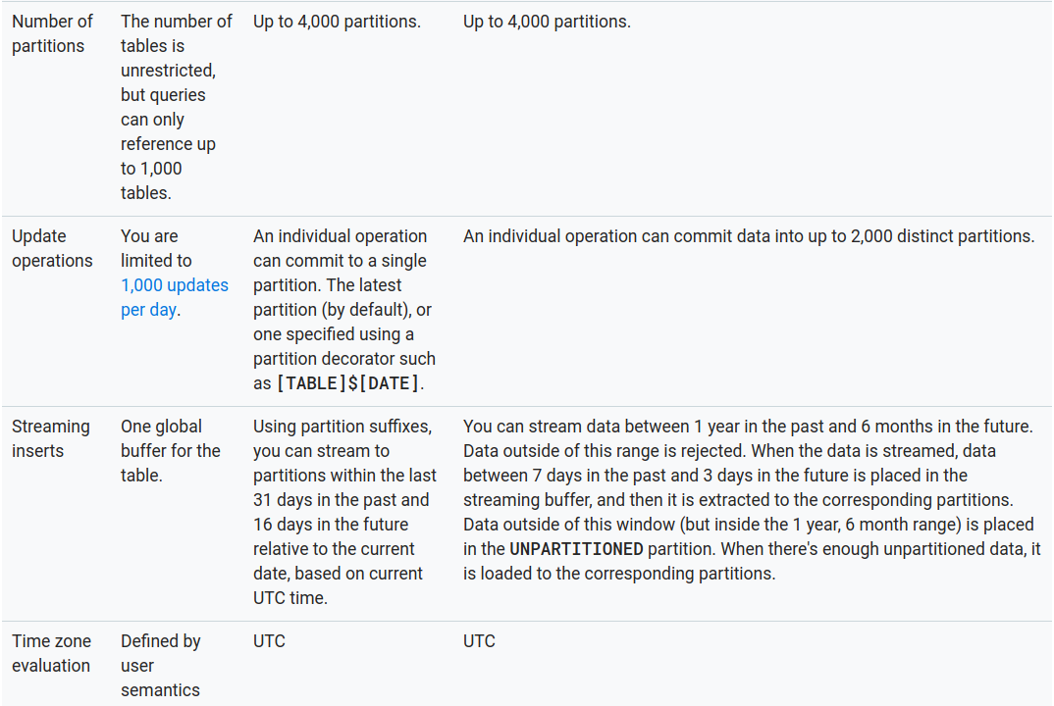

### External data sources

An external data source (also known as a federated data source) is a data source that you can query directly even though the data is not stored in BigQuery. Instead of loading or streaming the data, you create a table that references the external data source.

BigQuery offers support for querying data directly from:

* [Google Cloud Bigtable](https://cloud.google.com/bigquery/external-data-bigtable)
* [Google Cloud Storage](https://cloud.google.com/bigquery/external-data-cloud-storage)
* [Google Drive](https://cloud.google.com/bigquery/external-data-drive)

Limitations

* No consistency
* Lower performance
* Cannot export
* Cannot use wildcard
* No cached results

### Temporary and permanent tables

BigQuery saves all query results to a table, which can be either permanent or temporary:

A **temporary** table is a randomly named table saved in a special dataset. Temporary tables are used to cache query results. A temporary table has a lifetime of approximately 24 hours. Temporary tables are not available for sharing, and are not visible using any of the standard list or other table manipulation methods. You are not charged for storing temporary tables.

A **permanent** table can be a new or existing table in any dataset to which you have access. If you write query results to a new table, you are charged for storing the data. When you write query results to a permanent table, the tables you're querying must be in the **same location** as the dataset that contains the destination table.

When running a query in UI, it shows if the results are coming from cache or not.

### Controlling costs with BQ

* Avoid SELECT *
* Sample data using preview options
* Price your queries before running them (--dry_run option)
* Using the query validator (to verify the number of bytes to read), also the price calculator
* Limit query costs by restricting the number of bytes billed (Setting “Maximum bytes billed”)
* LIMIT doesn’t affect cost
* View costs using a dashboard and query your audit logs
* Partition data by date
* Materialize query results in stages
* Consider the cost of large result sets
* Use streaming inserts with caution
* Use the expiration settings to remove unneeded tables and partitions
* Take advantage of long-term storage: If you have a table that is not edited for 90 consecutive days, the price of storage for that table automatically drops by 50 percent to $0.01 per GB, per month.

### Load data into BigQuery

1. Load jobs:

* By using Bigquery API (in python ,java) , console or bq command line tool (bq load <target> <source> <schema>) Load job completion is ACID (all records or nothing)
* Sources:

**Cloud Storage:**

CSV

JSON (newline delimited only)

Avro

Parquet

ORC

Cloud Datastore exports

Cloud Firestore exports

**Readable data source (such as your local machine):**

CSV

JSON (newline delimited only)

Avro

Parquet

ORC

* CSV and JSON can be compressed (GZIP)
* Limitations
  + Upto 10,000 files per job
  + Upto 1Tb of input data
  + Uncompressed data: upto 1Gb
* Some nice options

**--[no]allow_jagged_rows:** Whether to allow missing trailing optional columns in CSV import data.

**--[no]allow_quoted_newlines**: Whether to allow quoted newlines in CSV import data.

**--[no]autodetect:** Enable auto detection of schema and options for formats that are not self describing like CSV and JSON.

2) Streaming inserts:

* “At least once”: meaning that there may be duplicates on each row, then need a way to identify row id and do validations to avoid dups.
* “insertId” is the field that the service will use to avoid dups
* Streaming buffer: The buffer that retains recently inserted rows, and is optimized for high-throughput writes rather than columnar access.
* Instant availability reader: Allows the query engine to read records directly from the streaming buffer.
* However, no UPDATE and DELETE operations are supported in a table with a streaming buffer

**Bigquery transfer service** : paíd, managed, monthly service to push data into bigquery. Sources:

* Campaign manager
* Cloud storage
* Ad manager
* Google ads
* Google play
* Youtube channel
* Youtube content owner

### Performance

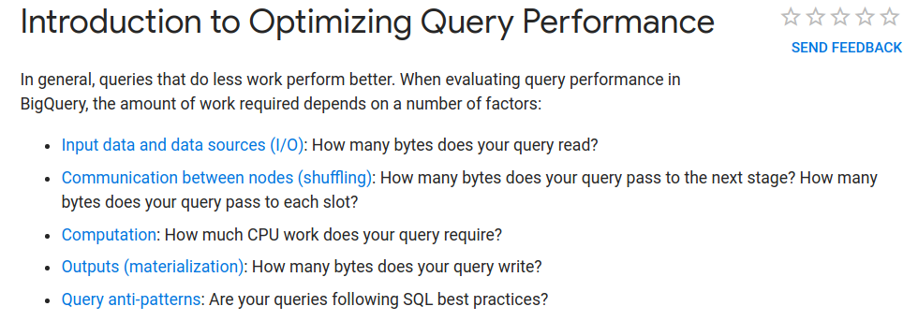

Communication between slots

* Reduce data before using a JOIN
* Do not treat WITH clauses as prepared statements (it is just for readability)
* Avoid tables sharded by date. Partitioned tables performs better than date-named tables
* Avoid oversharding

Computation

* Avoid repeatedly transforming data via SQL queries (pre-process data when possible)
* Avoid JavaScript user-defined functions
* Use approximate aggregation functions
* Order query operations to maximize performance (for instance: Use ORDER BY only in the outermost query)
* Optimize your join patterns. For queries that join data from multiple tables: start with the largest table
* Prune partitioned queries: When querying a time-partitioned table, use the _PARTITIONTIME pseudo column to filter the partitions

SQL anti-patterns

* Avoid self joins, use windows functions instead
* Data skew: avoid unbalanced partitions.
* Cross joins: avoid joins with more output records than input records
* DMLs: Avoid DML that affect just 1 row at time, verify the chance to do massive updates in just one sentence.

### Pricing

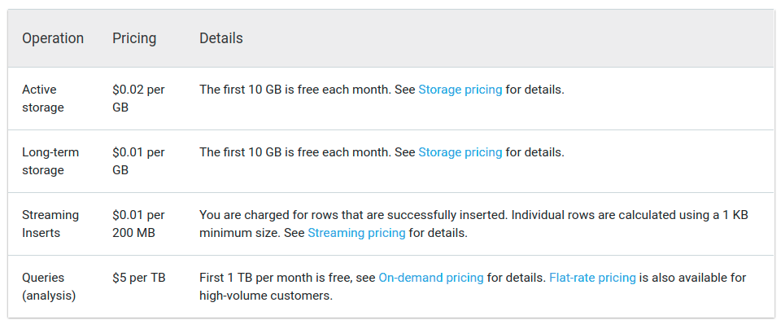

## Spanner

### Basic concepts

Cloud Spanner offers:

* **Strong consistency**, including strongly consistent secondary indexes.
* **SQL support**, with ALTER statements for schema changes.
* **Managed instances with high availability** through transparent, synchronous, built-in data replication.

What it's good for

Cloud Spanner is ideal for relational, structured, and semi-structured data that requires high availability, strong consistency, and **transactional** reads and writes.

Replica Types

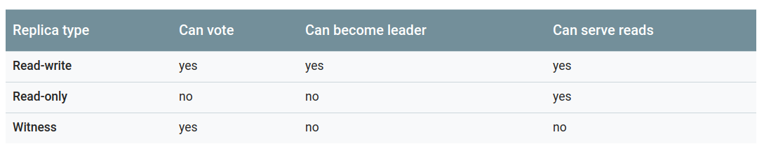

Read-only and Witness are only used for multi-regional replication.

Node count

In addition to choosing where your data is stored when you create an instance, you must also choose the node count, or the number of nodes to allocate to that instance. Your choice of node count determines the amount of serving and storage resources that are available to the databases in that instance. Each node provides up to 2 TiB of storage.

A minimum of **3 nodes** is recommended for **production** environments. This guidance applies to regional and multi-region configurations.

Nodes vs replicas

If you need to scale up the serving and storage resources in your instance, add more nodes to that instance. Note that adding a node does not increase the number of replicas (which are fixed for a given configuration), but rather increases the resources each replica has in the instance. Adding nodes gives each replica more CPU and RAM, which increases the replica's throughput (that is, more reads and writes per second can occur). Effectively, the number of Cloud Spanner servers in each of the instance's replicas is the same as the node count of the instance. Thus, the total number of servers in a Cloud Spanner instance is the number of nodes the instance has multiplied by the number of replicas in the instance

### Data Model

Parent-child table relationships

You can define multiple tables in a database, and **you can optionally define parent-child relationships between tables if you want Cloud Spanner to physically co-locate their rows for efficient retrieval**.

Cloud Spanner stores rows in sorted order by primary key values (so be careful to PK selection to avoid hot spots, usually a hash/UUID value is selected), with child rows inserted between parent rows that share the same primary key prefix. This insertion of child rows between parent rows along the primary key dimension is called interleaving, and child tables are also called **interleaved tables**.

Schema Design - Anti-patterns

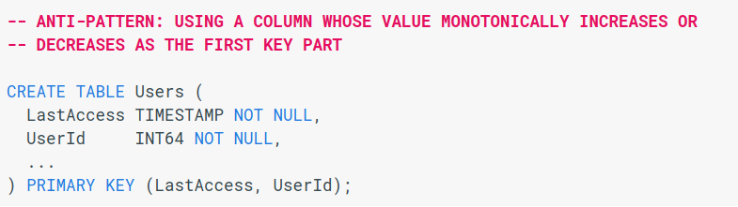

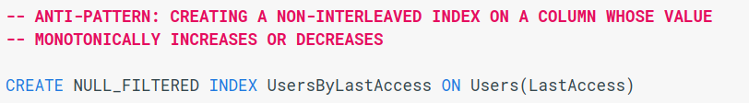

**Interleaved Indexes**

Like interleaved tables, entries in an interleaved indexes are stored with the corresponding row of the parent table

### Pricing

Pricing considers:

* Regional vs Multi-regional configuration
* Hours per node
* Storage per Gb per month

## Machine Learning concepts

### Basic concepts

#### Supervised Machine Learning

Supervised learning is where you have input variables (x) and an output variable (Y) and you use an algorithm to learn the mapping function from the input to the output.

Y = f(X)

The goal is to approximate the mapping function so well that when you have new input data (x) that you can predict the output variables (Y) for that data.

It is called supervised learning because the process of an algorithm learning from the training dataset can be thought of as a teacher supervising the learning process. We know the correct answers, the algorithm iteratively makes predictions on the training data and is corrected by the teacher. Learning stops when the algorithm achieves an acceptable level of performance.

Supervised learning problems can be further grouped into regression and classification problems.

Some popular examples of supervised machine learning algorithms are:

Linear regression for regression problems.

Random forest for classification and regression problems.

Support vector machines for classification problems.

#### Unsupervised Machine Learning

Unsupervised learning is where you only have input data (X) and no corresponding output variables.

The goal for unsupervised learning is to model the underlying structure or distribution in the data in order to learn more about the data.

These are called unsupervised learning because unlike supervised learning above there is no correct answers and there is no teacher. Algorithms are left to their own devises to discover and present the interesting structure in the data.

Unsupervised learning problems can be further grouped into clustering and association problems.

**Clustering**: A clustering problem is where you want to discover the inherent groupings in the data, such as grouping customers by purchasing behavior.

**Association**: An association rule learning problem is where you want to discover rules that describe large portions of your data, such as people that buy X also tend to buy Y.

Some popular examples of unsupervised learning algorithms are:

k-means for clustering problems.

Apriori algorithm for association rule learning problems.

#### Labels

A **label** is the thing we're predicting—the y variable in simple linear regression. The label could be the future price of wheat, the kind of animal shown in a picture, the meaning of an audio clip, or just about anything.

#### Features

A **feature** is an input variable—the x variable in simple linear regression. A simple machine learning project might use a single feature, while a more sophisticated machine learning project could use millions of features, specified as:

x1,x2,...xN

In the spam detector example, the features could include the following:

* words in the email text
* sender's address
* time of day the email was sent
* email contains the phrase "one weird trick."

Examples

An **example** is a particular instance of data, **x**. (We put **x** in boldface to indicate that it is a vector.) We break examples into two categories:

* labeled examples
* unlabeled examples

A **labeled example** includes both feature(s) and the label. That is:

labeled examples: {features, label}: (x, y)

Use labeled examples to **train** the model. In our spam detector example, the labeled examples would be individual emails that users have explicitly marked as "spam" or "not spam."

For example, the following table shows 5 labeled examples from a [data set](https://developers.google.com/machine-learning/crash-course/california-housing-data-description) containing information about housing prices in California:

|  |  |  |  |
| --- | --- | --- | --- |
| **housingMedianAge**  **(feature)** | **totalRooms**  **(feature)** | **totalBedrooms**  **(feature)** | **medianHouseValue**  **(label)** |
| 15 | 5612 | 1283 | 66900 |
| 19 | 7650 | 1901 | 80100 |
| 17 | 720 | 174 | 85700 |
| 14 | 1501 | 337 | 73400 |
| 20 | 1454 | 326 | 65500 |

An **unlabeled example** contains features but not the label. That is:

unlabeled examples: {features, ?}: (x, ?)

Here are 3 unlabeled examples from the same housing dataset, which exclude medianHouseValue:

|  |  |  |
| --- | --- | --- |
| **housingMedianAge**  **(feature)** | **totalRooms**  **(feature)** | **totalBedrooms**  **(feature)** |
| 42 | 1686 | 361 |
| 34 | 1226 | 180 |
| 33 | 1077 | 271 |

Once we've trained our model with labeled examples, we use that model to predict the label on unlabeled examples. In the spam detector, unlabeled examples are new emails that humans haven't yet labeled.

#### Models

A model defines the relationship between features and label. For example, a spam detection model might associate certain features strongly with "spam". Let's highlight two phases of a model's life:

* **Training** means creating or **learning** the model. That is, you show the model labeled examples and enable the model to gradually learn the relationships between features and label.
* **Inference** means applying the trained model to unlabeled examples. That is, you use the trained model to make useful predictions (y'). For example, during inference, you can predict medianHouseValue for new unlabeled examples.

#### Regression vs. classification

A **regression** model predicts continuous values. For example, regression models make predictions that answer questions like the following:

* What is the value of a house in California?
* What is the probability that a user will click on this ad?

A **classification** model predicts discrete values. For example, classification models make predictions that answer questions like the following:

* Is a given email message spam or not spam?
* Is this an image of a dog, a cat, or a hamster?

**Training** a model simply means learning (determining) good values for all the weights and the bias from labeled examples. In supervised learning, a machine learning algorithm builds a model by examining many examples and attempting to find a model that minimizes loss; this process is called **empirical risk minimization**.

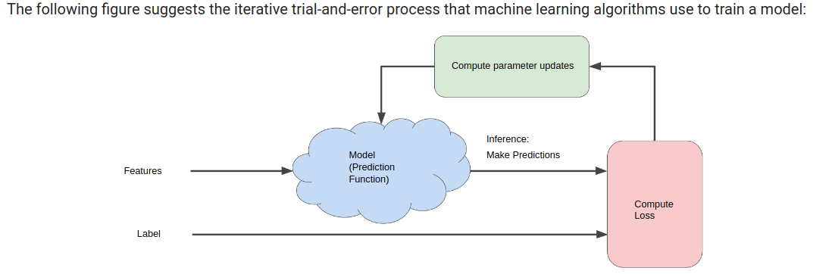

Loss is the penalty for a bad prediction. That is, **loss** is a number indicating how bad the model's prediction was on a single example. If the model's prediction is perfect, the loss is zero; otherwise, the loss is greater. The goal of training a model is to find a set of weights and biases that have *low* loss, on average, across all examples.

#### Deep learning

Deep learning (also known as deep structured learning or hierarchical learning) is part of a broader family of machine learning methods based on learning data representations, as opposed to task-specific algorithms. Learning can be supervised, semi-supervised or unsupervised

Deep learning is a class of machine learning algorithms that:

* use a cascade of multiple layers of nonlinear processing units for feature extraction and transformation. Each successive layer uses the output from the previous layer as input.
* learn in supervised (e.g., classification) and/or unsupervised (e.g., pattern analysis) manners.
* learn multiple levels of representations that correspond to different levels of abstraction; the levels form a hierarchy of concepts.

#### Gradient descent



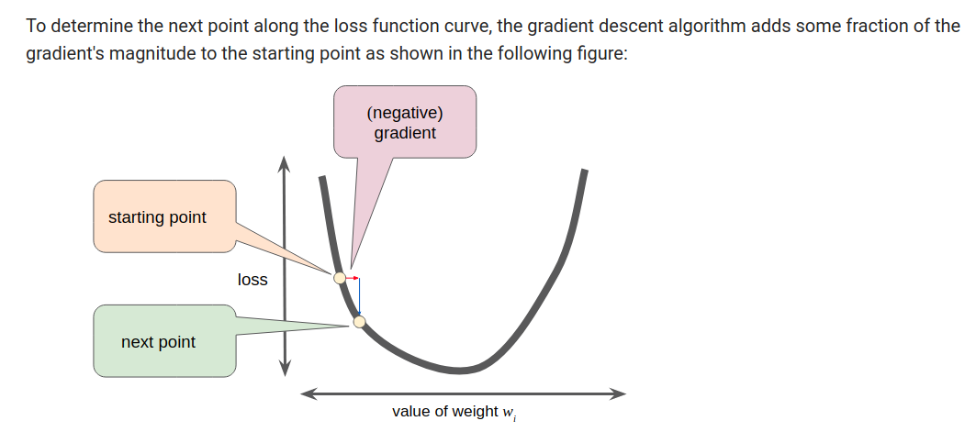

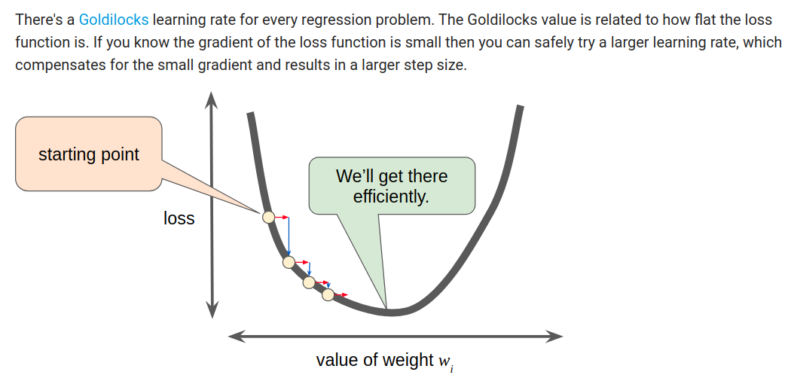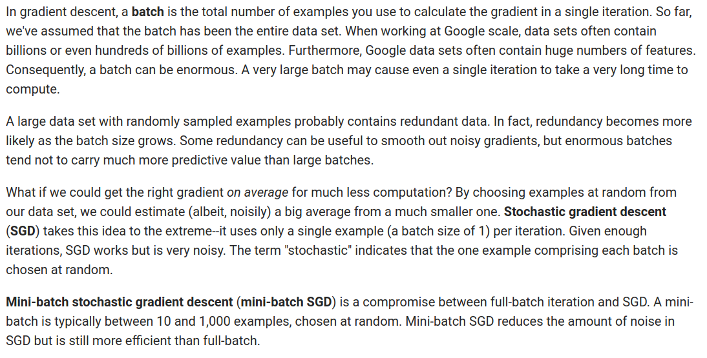

Epoch: . The epoch on the other hand is one traversal through the **entire** training dataset. It consists of going through multiple batches. In our example we said that if we had 100,000 samples in our training dataset and each batch was 100, then an epoch consists of 1,000 batches or 1,000 steps

A machine learning model aims to make good predictions on new, previously unseen data. But if you are building a model from your data set, how would you get the previously unseen data? Well, one way is to divide your data set into two subsets:

* training set—a subset to train a model.
* test set—a subset to test the model.

Example: 80% training set - 20% of test set.

#### **Overfitting**

occurs when a model tries to fit the training data so closely that it does not generalize well to new data.

How to avoid overfitting:

* Data augmentation: more data in training set
* Regularization: L1 and L2 (That can be set as hyperparameter)
* Early stopping: Select a sub-set of training data, if performance is getting worse, stop.
* Dropout: dropout is usually preferred when we have a large neural network structure in order to introduce more randomness.

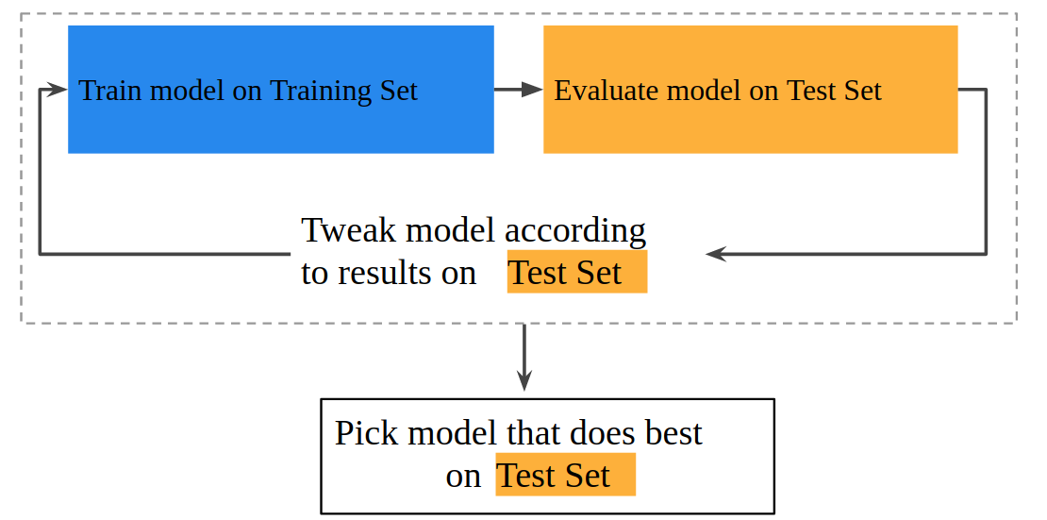

#### Feature engineering

Means transforming raw data into a feature vector. Expect to spend significant time doing feature engineering.

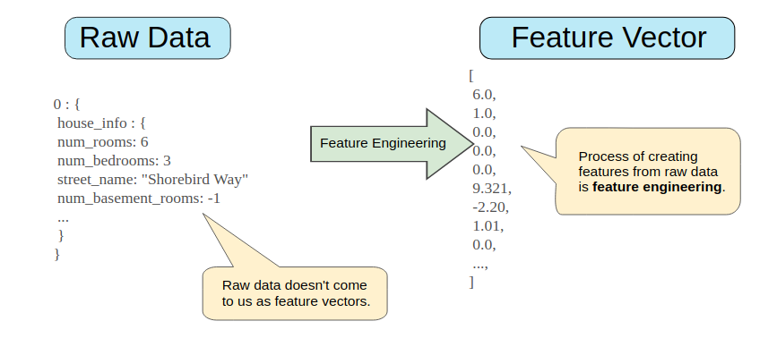

* Mapping **numeric values.** Example num_rooms 6 -> 6.0
* Mapping **categorical values** - Categorical features have a discrete set of possible values. For example, there might be a feature called street_name with options that include:

{'Charleston Road', 'North Shoreline Boulevard', 'Shorebird Way', 'Rengstorff Avenue'}

Be careful to assign numeric values for each (these could be interpreted as a weight when calculating the loss in linear regression). It is better to assign vectors: for instance binary vectors

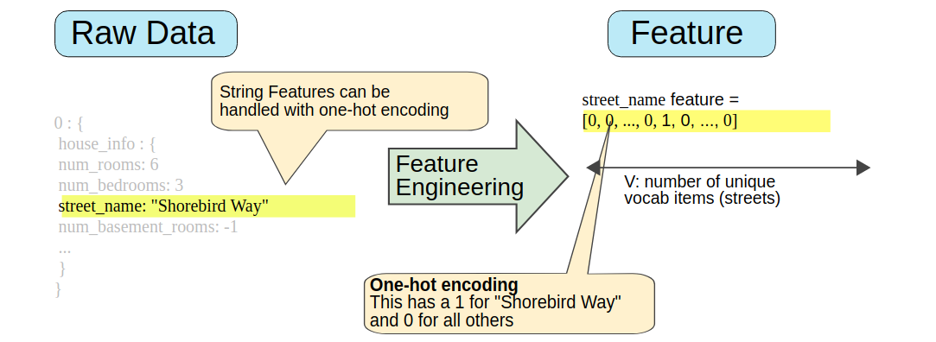

Sparse Representation

Suppose that you had 1,000,000 different street names in your data set that you wanted to include as values for street_name. Explicitly creating a binary vector of 1,000,000 elements where only 1 or 2 elements are true is a very inefficient representation in terms of both storage and computation time when processing these vectors. In this situation, a common approach is to use a [sparse representation](https://developers.google.com/machine-learning/glossary#sparse_representation) in which only nonzero values are stored. In sparse representations, an independent model weight is still learned for each feature value, as described above.

**One-hot encoding** vector: all 0’s and just one 1.

Binned vectors: we can distribute ranges of a floating values into bins. E.g.: latitud, longitud.

**Scaling feature values**

Scaling means converting floating-point feature values from their natural range (for example, 100 to 900) into a standard range (for example, 0 to 1 or -1 to +1). If a feature set consists of only a single feature, then scaling provides little to no practical benefit. If, however, a feature set consists of multiple features, then feature scaling provides the following benefits:

* Helps gradient descent converge more quickly.
* Helps avoid the "NaN trap," in which one number in the model becomes a NaN (e.g., when a value exceeds the floating-point precision limit during training), and—due to math operations—every other number in the model also eventually becomes a NaN.
* Helps the model learn appropriate weights for each feature. Without feature scaling, the model will pay too much attention to the features having a wider range.

**Cross features**

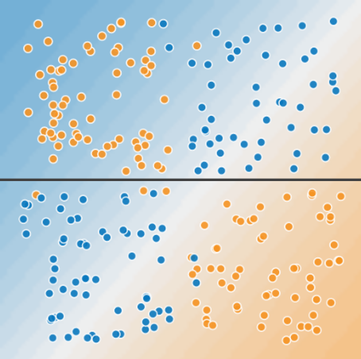

Figure 3. A single line can't separate the two classes.

To solve the nonlinear problem shown in Figure 2, create a feature cross. A feature cross is a synthetic feature that encodes nonlinearity in the feature space by multiplying two or more input features together. (The term *cross* comes from [*cross product*](https://wikipedia.org/wiki/Cross_product).) Let's create a feature cross named x3 by crossing x1 and x2:

x3=x1x2

We treat this newly minted x3 feature cross just like any other feature.

Example of crossed features could be: date-time (used together), to measure traffic: it is not the same Saturday-7pm than Monday-7pm.

**Bucketizing**

Example: Latitude for houses: real value and too many different values. You basically say, I wanted to bucketize column, parsing in the original real-valued column,and parsing in the boundaries. How do I get the boundaries? In this case, I'm asking NumPy, np is NumPy, to equally divide values between 32 and 42, divide them equally into n buckets.

**Pre-processing**

The pre-processing is where we create a **vocabulary**, we do our feature crosses, we do our scaling, we do our bucketizing.

#### Logistic regression

Many problems require a **probability** estimate as **output**. Logistic regression is an extremely efficient mechanism for calculating probabilities. Practically speaking, you can use the returned probability in either of the following two ways:

* "As is" Example. P( bark | night)
* Converted to a binary category. Example: “spam | not spam”

**Classification metrics:**

Cross-entropy: Cross-entropy is commonly used to quantify the difference between two probability distributions (in ML we compare the estimated probability vs the “true” probability). Usually the "true" distribution (the one that your machine learning algorithm is trying to match) is expressed in terms of a one-hot distribution. Cross-entropy describes the **loss** between two probability distributions, cross-entropy loss function can be used as part of **gradient descent**.

Confusion matrix: can be used to get following metrics, where we put rows with the predicted qty and columns with the actual qty

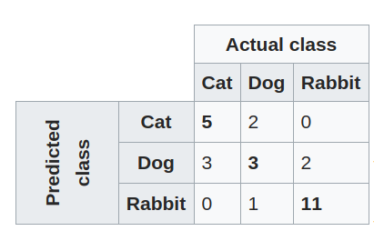

TP: true positives. TN: True negatives. FP. False positives. FN: False negatives

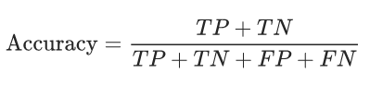

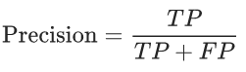

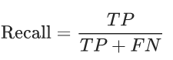

If you are developing a classification model, cross entropy is going to be the error that you're going to use to do the **optimization**, but precision and recall, are the measures of skill that you will use to describe your **dataset**

#### Neural networks

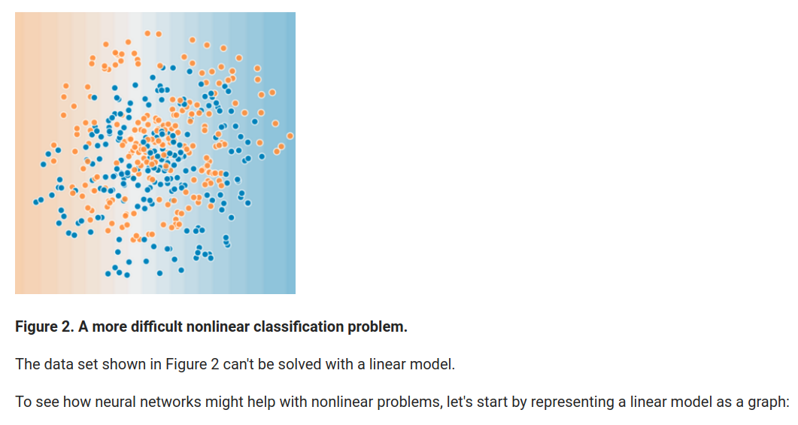

**Hidden layers**

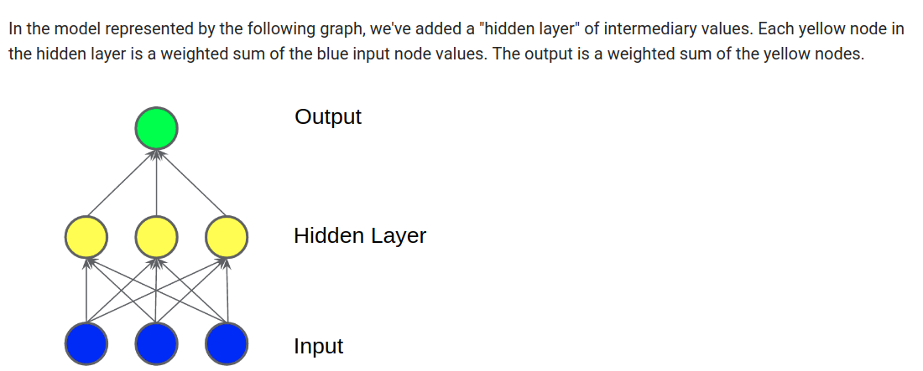

Still a linear model

Activation functions

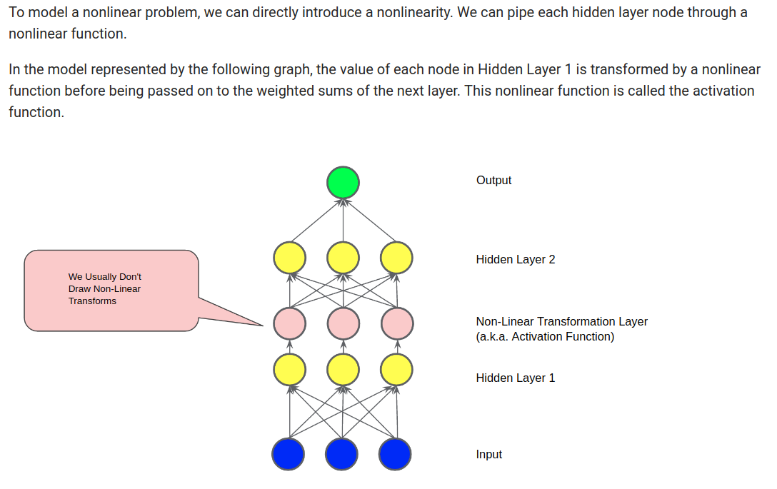

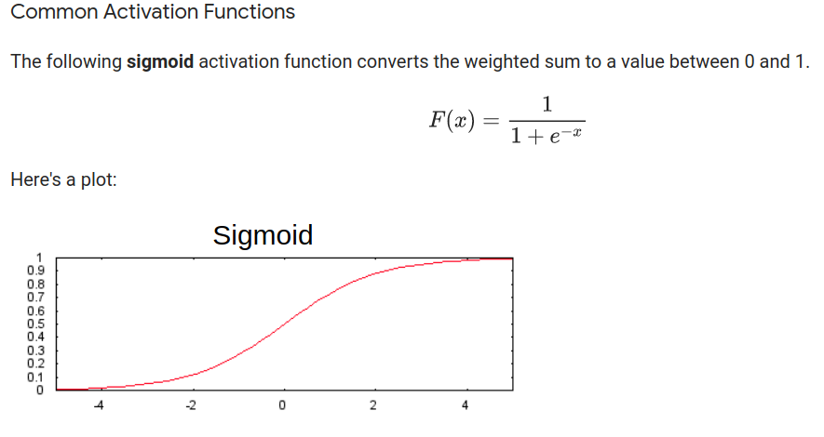

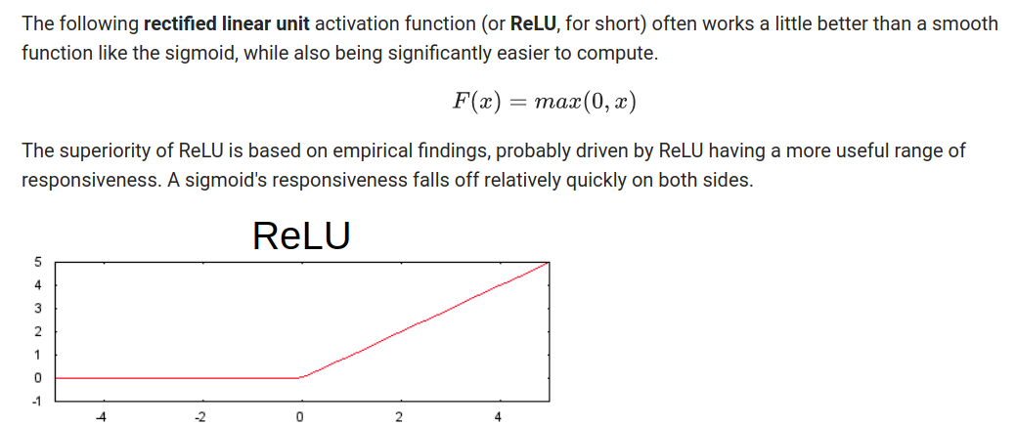

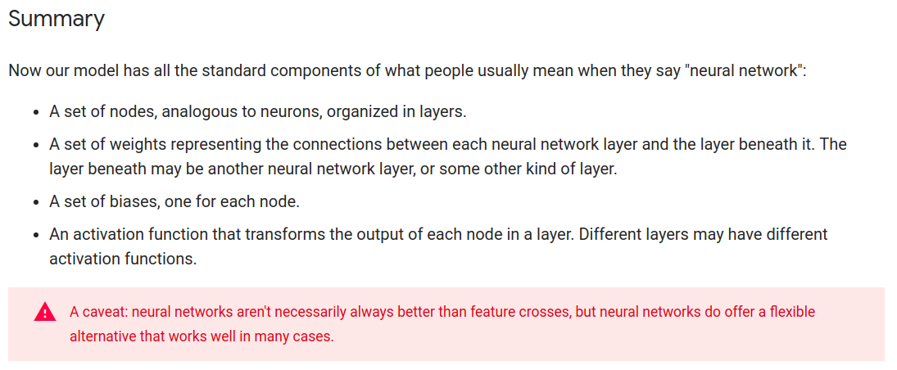

#### Deep and wide models

Google context

“The human brain is a sophisticated learning machine, forming rules by **memorizing** everyday events (“sparrows can fly” and “pigeons can fly”) and **generalizing** those learnings to apply to things we haven't seen before (“animals with wings can fly”). Perhaps more powerfully, memorization also allows us to further refine our generalized rules with exceptions (“penguins can't fly”). As we were exploring how to advance machine intelligence, we asked ourselves the question—can we teach computers to learn like humans do, by combining the power of memorization and generalization?

It's not an easy question to answer, but by jointly training a wide linear model (for memorization) alongside a deep neural network (for generalization), one can combine the strengths of both to bring us one step closer. “

The following illustration outlines the three major model types: wide, deep, and wide and deep:

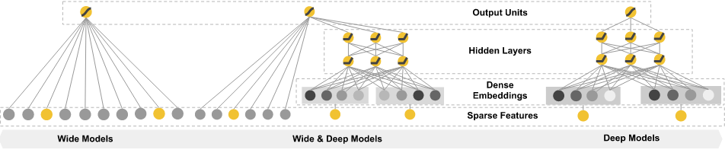

A ***wide model*** is generally useful for training based on **categorical** features. In the Natality dataset, the following features work well with a wide model:

* is_male, plurality

To apply numeric features to the wide model, you must convert them to categorical features by splitting the continuous value into buckets of value ranges (that is, *bucketizing* them). You apply this technique to the following features in this case:

* mother_age, gestation_weeks

Feature crossing generates a new feature by concatenating the pair of features (is_male, plurality) and using this concatenation as an input so that the model learns that, for example, twin boys tend to have a higher weight than twin girls. You can apply feature crossing directly to categorical features, and you can apply it to numeric features when the numeric features are discretized into buckets first.

A ***deep*** *model* is most appropriate for **numeric** features. The following features in the baby weight prediction problem match this criterion:

* mother_age, gestation_weeks

You can implement *embedding layers* in a deep model, too. An [embedding layer](https://www.tensorflow.org/versions/master/programmers_guide/embedding) transforms a large number of categorical features into a lower-dimensional numeric feature.

The drawback is that feature crossing greatly increases the total number of features, which increases the risk of overfitting if supplied to a deep network. You can mitigate this risk by using an embedding layer.

In the Natality dataset, you take the numeric columns, discretize them into buckets, generate additional categorical features through feature crossing, and then apply an embedding layer. This embedding layer is an additional input to the deep model.

## Tensorflow

### Basic Concepts

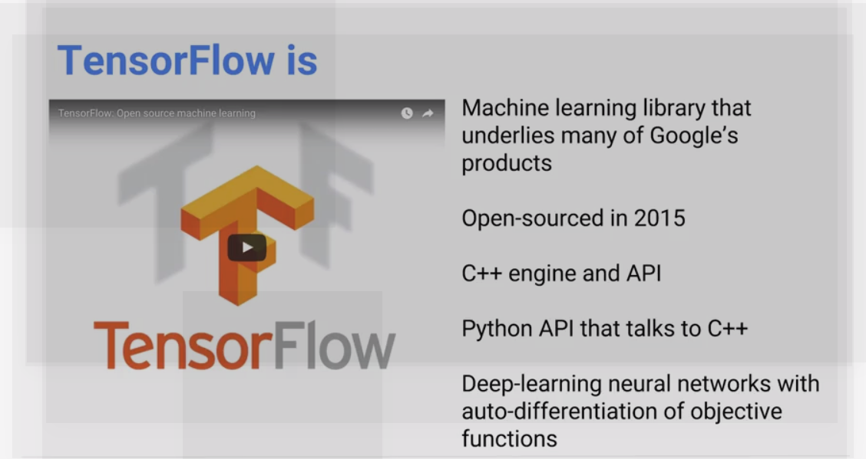

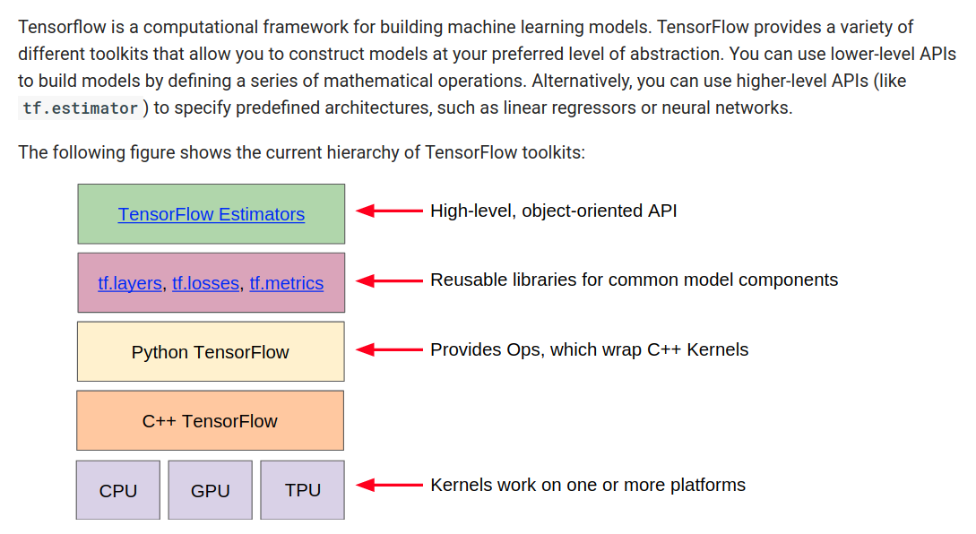

**Tensorflow libraries and methods**

Tf functions for Feature Engineering

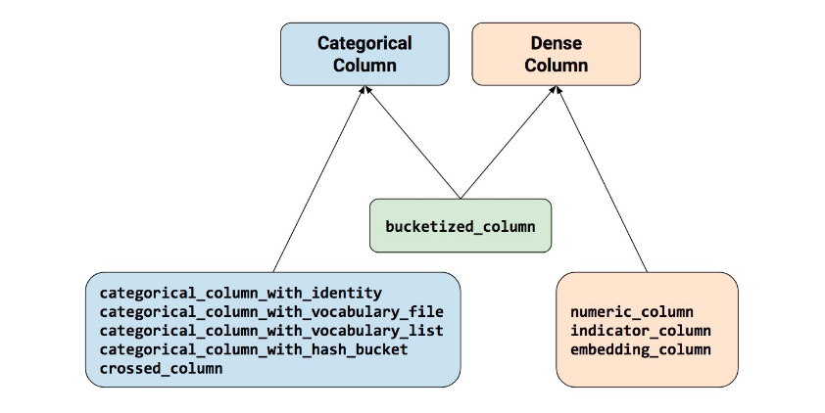

sparse_column_with_hash_bucket (sparse columns but lots of different values that we even don’t know), sparse_column with_keys (few different values that we know -e.g.: “sex”).

Estimators

As the following list indicates, not all Estimators permit all types of feature_columns argument(s):

* [tf.estimator.LinearClassifier](https://www.tensorflow.org/api_docs/python/tf/estimator/LinearClassifier) and [tf.estimator.LinearRegressor](https://www.tensorflow.org/api_docs/python/tf/estimator/LinearRegressor): Accept all types of feature column.
* [tf.estimator.DNNClassifier](https://www.tensorflow.org/api_docs/python/tf/estimator/DNNClassifier) and [tf.estimator.DNNRegressor](https://www.tensorflow.org/api_docs/python/tf/estimator/DNNRegressor): Only accept dense columns. Other column types must be wrapped in either an indicator_column or embedding_column.
* [tf.estimator.DNNLinearCombinedClassifier](https://www.tensorflow.org/api_docs/python/tf/estimator/DNNLinearCombinedClassifier) and [tf.estimator.DNNLinearCombinedRegressor](https://www.tensorflow.org/api_docs/python/tf/estimator/DNNLinearCombinedRegressor):
  + The linear_feature_columns argument accepts any feature column type.
  + The dnn_feature_columns argument only accepts dense columns.

**Tensor processing unit (TPU)**

In May 2016, Google announced its Tensor processing unit (TPU), an application-specific integrated circuit (a hardware chip) built specifically for machine learning and tailored for TensorFlow. TPU is a programmable AI accelerator designed to provide high throughput of low-precision arithmetic (e.g., 8-bit), and oriented toward using or running models rather than training them. Google announced they had been running TPUs inside their data centers for more than a year, and had found them to deliver an order of magnitude better-optimized performance per watt for machine learning

<https://developers.google.com/machine-learning/crash-course>

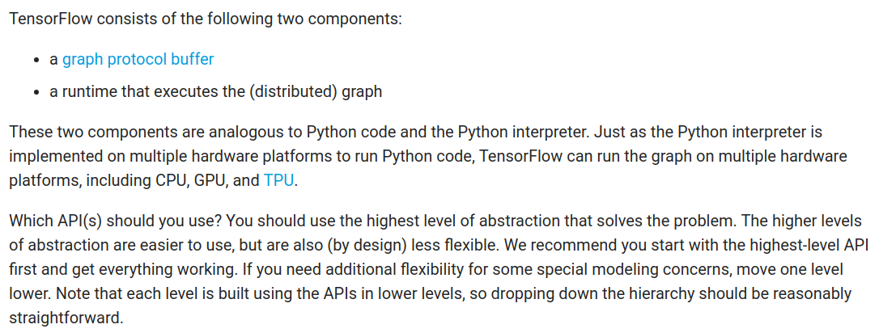

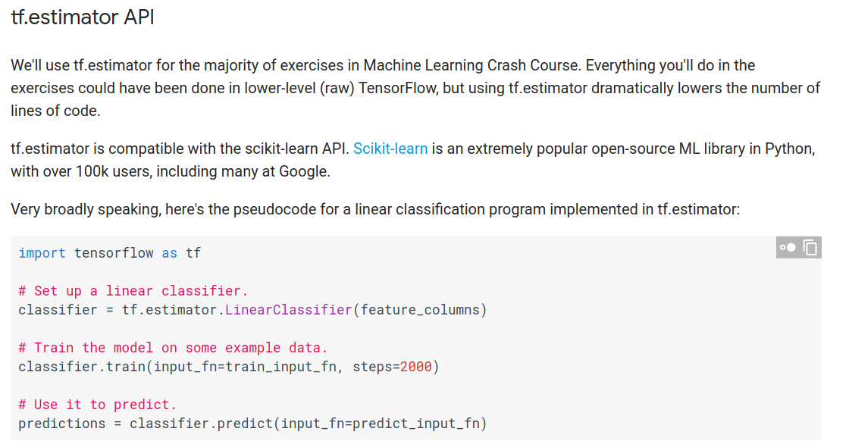

Eager mode

TensorFlow's eager execution is an imperative programming environment that evaluates operations immediately, without building graphs: operations return concrete values instead of constructing a computational graph to run later. So the evaluation is immediate and it's not lazy (default)

### Usage

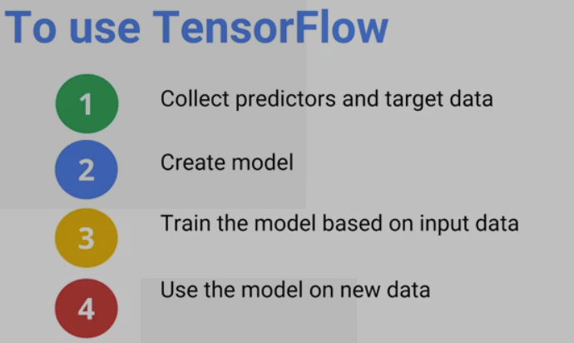

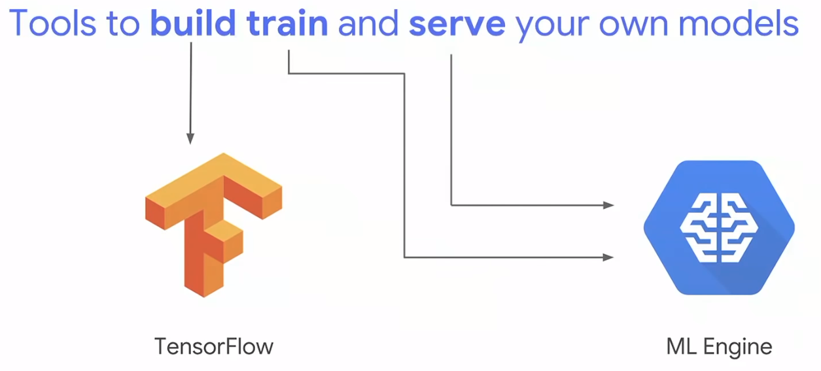

Predictors: variables that we use to make a prediction (day of week, temperature).

Target data: values of variables we are trying to guess (number of taxi rides).

Collect:

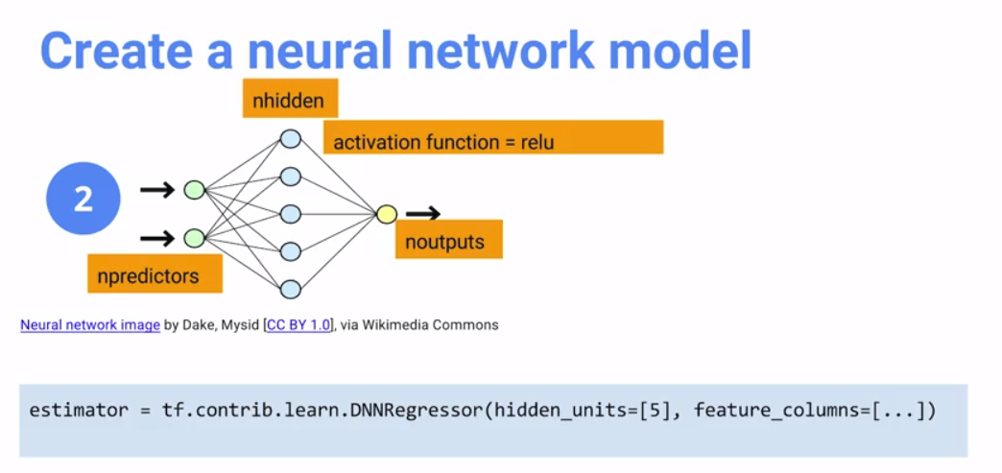

All predictors should be numerical data, not categorical. If we have categorical data, we need to encode it.

Nhidden: number of hidden cells we are going to use.

Regression model: we are predicting a number (real number), classification problem we are predicting a category.

Train the model:

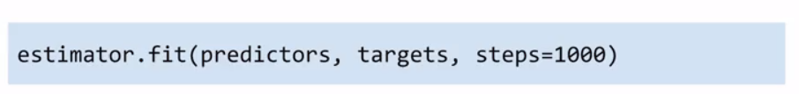

Run predictions:

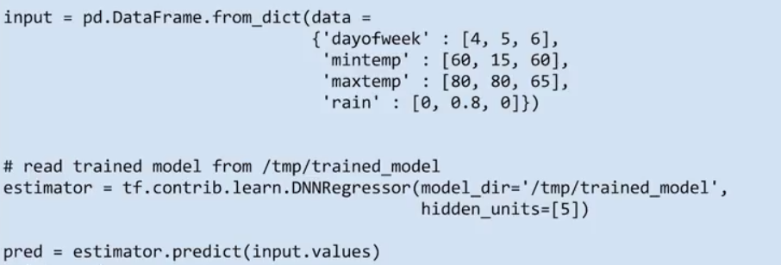

Created a dictionary with the predictor values we have as input.

Use the trained model and predict.

Remember 5 steps for source code

1- Get source data: training and evaluation

2- Model (Most complex part)

3- Train

4- Evaluate

5- Predict

1- Get source data

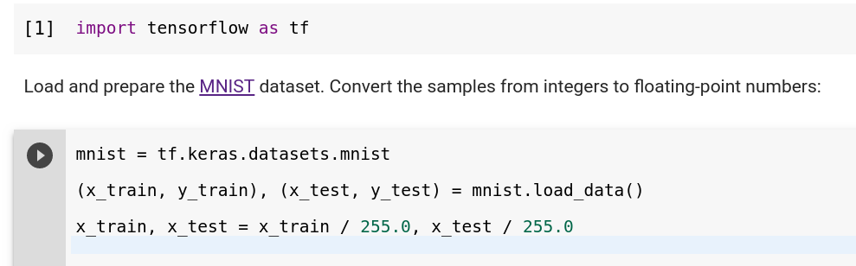

2- Model

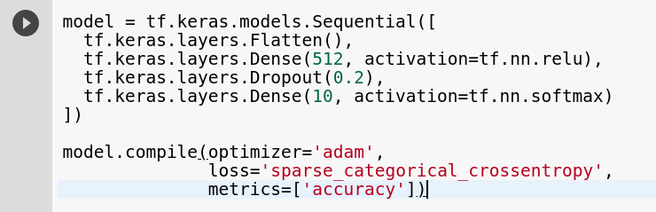

3- Train, 4-Evaluate

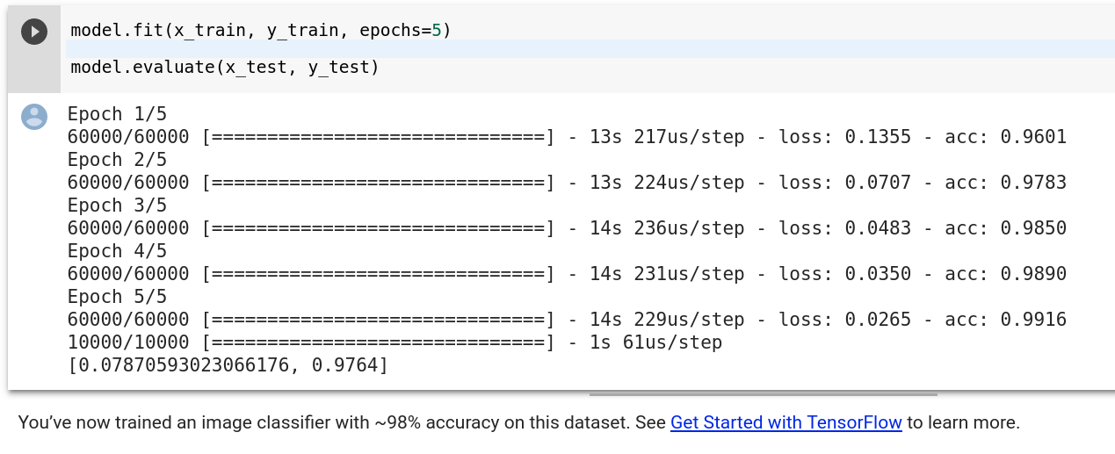

## MLE

### Basic Concepts

Larger newer networks you also have a huge computer problem. And that the scale at which Google operates, very deep networks, to use TensorFlow processing units, we do distributer training and we can do no-ops. So cloud ML gives you all these things if you have a data set that's large enough to solve the problem.

### Minimizing skew at scale with tf.Transform and Dataflow

Developers often write preprocessing code for training. Sometimes, they adapt this code to run in a distributed environment, but they also write similar but different code for incoming data for the prediction. This approach can cause two main problems:

* Two codebases need to be maintained, possibly by different teams.
* More importantly, it can create a skew between training and inference.

[tf.Transform](https://github.com/tensorflow/transform) solves both problems by letting you write common code for both training and prediction. It can also use Apache Beam to run the code in a distributed environment.

### Leveraging TensorFlow with tf.Transform on Google Cloud Platform

While some of the features mentioned previously are part of TensorFlow—therefore, open source—ML Engine offers key advantages when running TensorFlow:

* Running machine learning tasks in a serverless environment
* Facilitating hyperparameter tuning
* Hosting models as a RESTful API accessible from heterogenous clients (not only Python)

The following diagram illustrates the approach to leveraging TensorFlow.

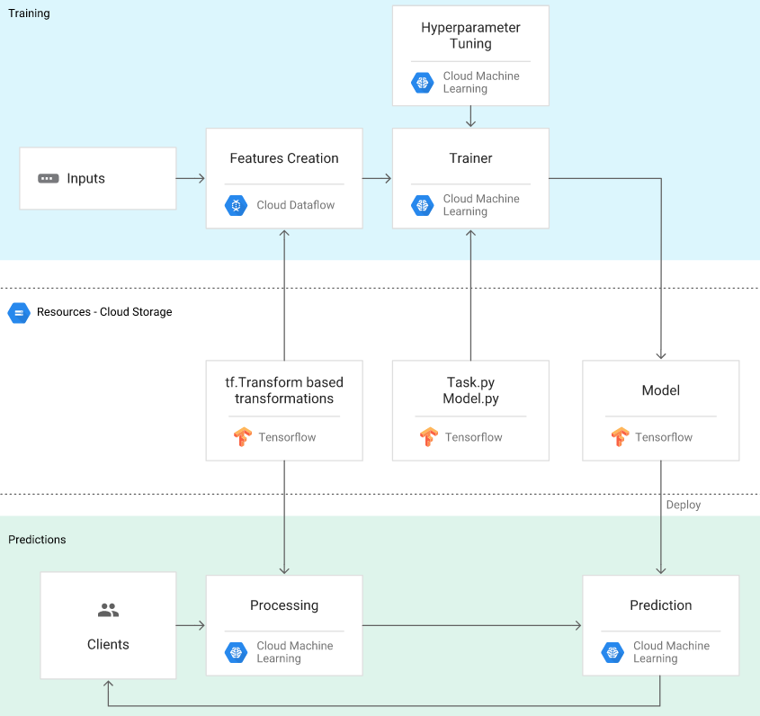

Note that by leveraging tf.Transform—a TensorFlow library—you limit potential skew between training and prediction as they can use the same code base. (Discretizing and feature crossing, are examples of pre-processing that is done in TensorFlow itself.)

## Example of Architecture for ML

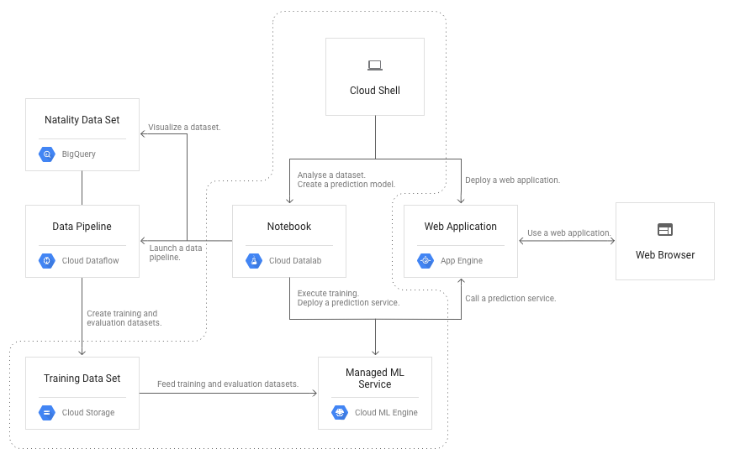

From <https://cloud.google.com/solutions/machine-learning/ml-on-structured-data-model-2>

### Interaction with MLE

1- List the models and versions

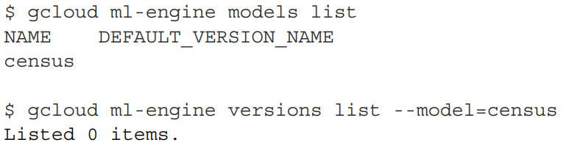

2- Use Cloud Storage to store training and evaluation data

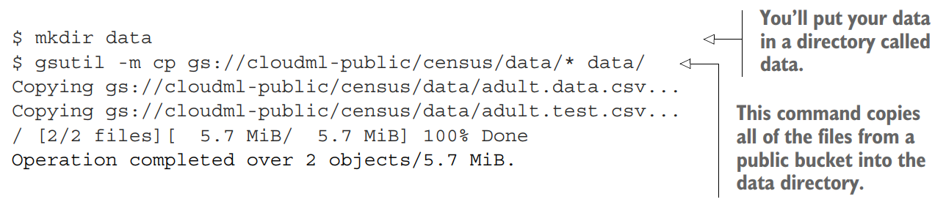

3- Create job source code

Example:

estimator = tf.estimator.DNNLinearCombinedRegressor(

model_dir=output_dir,

linear_feature_columns=wide,

dnn_feature_columns=deep,

dnn_hidden_units=[64, 32])

This can be executed in Datalab, make sure that dataset is small enough (since it won’t be running in a distributed environment).

In order to execute in ML engine, you need to build a python project according to a suggested project structure, and use gcloud command to upload the package and send the training job

4- Submit training job

gcloud ml-engine jobs submit training $JOB_NAME \

--staging-bucket $PACKAGE_STAGING_PATH \

--package-path /Users/mlguy/models/faces/trainer \

--module-name $MAIN_TRAINER_MODULE \

--packages dep1.tar.gz,dep2.whl \

--region us-central1 \

-- \

--user_first_arg=first_arg_value \

--user_second_arg=second_arg_value

The directory path containing the model output looks like $OUTDIR/export/exporter/1492051542987/, where $OUTDIR is the storage path specified by the --output_dir option in the previous step

Another example of running a training job:

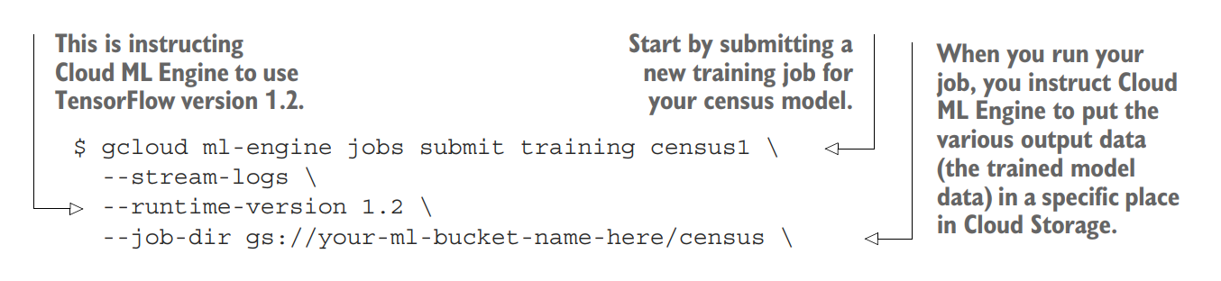

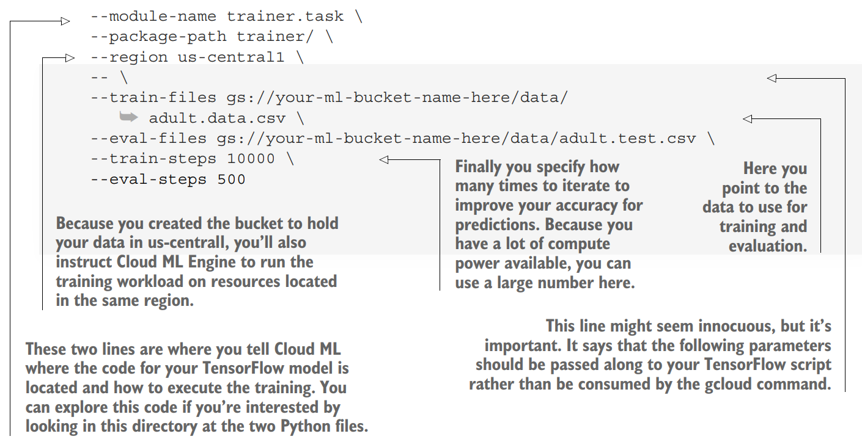

Verify export folder as part of the output

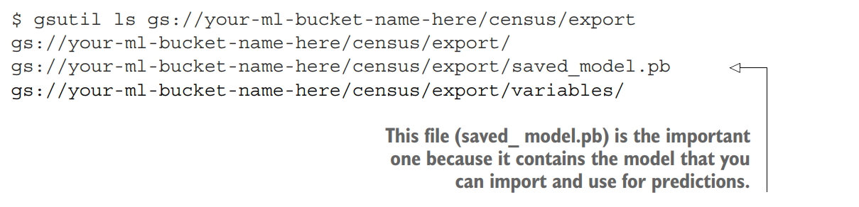

You can create a model “version” based on it. Ensure that the file size of your SavedModel is under the Cloud ML Engine default limit of 250 MB by exporting a graph specifically for prediction.

5- Making predictions

From gcloud command line:

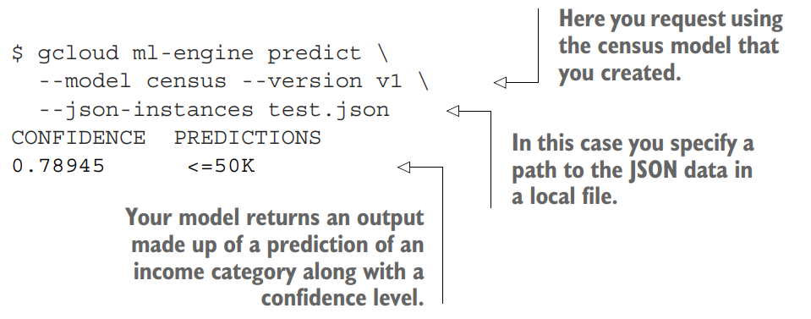

By using prediction API

The following [main.py](https://github.com/GoogleCloudPlatform/training-data-analyst/blob/master/blogs/babyweight/application/main.py) code snippet sends a request to the prediction API service hosted on Cloud ML Engine.

Note that the line numbers are identical to the GitHub code repository:

32: credentials = GoogleCredentials.get_application_default()  
 33: api = discovery.build('ml', 'v1', credentials=credentials)  
 34: project = app_identity.get_application_id()  
 35: model_name = os.getenv('MODEL_NAME', 'babyweight')  
  
 41: def get_prediction(features):  
 42: input_data = {'instances': [features]}  
 43: parent = 'projects/%s/models/%s' % (project, model_name)  
 44: prediction = api.projects().predict(body=input_data, name=parent).execute()  
 45: return prediction['predictions'][0]['outputs']

MLE jobs - other parameters

When creating a training job on ML Engine, you have the option to specify something called a **scale tier**, which is a predefined configuration of computing resources that are likely to do a good job of handling your **training workload**.

BASIC, which is a single worker server that trains a model

BASIC_GPU, which is a single worker server that comes with a GPU attached

STANDARD_1, which uses lots of worker servers but has a single parameter server

PREMIUM_1, which uses lots of workers and lots of parameter servers to coordinate

the shared model state

You can also specify “CUSTOM”, and determine the number and machine type of worker server, and parameter server.

Reference:

* **Parameter server node**. Update parameters with gradient vectors from worker and chief work nodes.
* **Worker node**. Calculate a gradient vector from the training dataset.
* **Chief worker node**. Coordinate the operations of multiple workers, in addition to working as one of the worker nodes.

In case of **prediction workload,** you can specify the max number of workers. That will be related to the amount of data to predict (not the amount of data already trained).

## 

## ML APIs

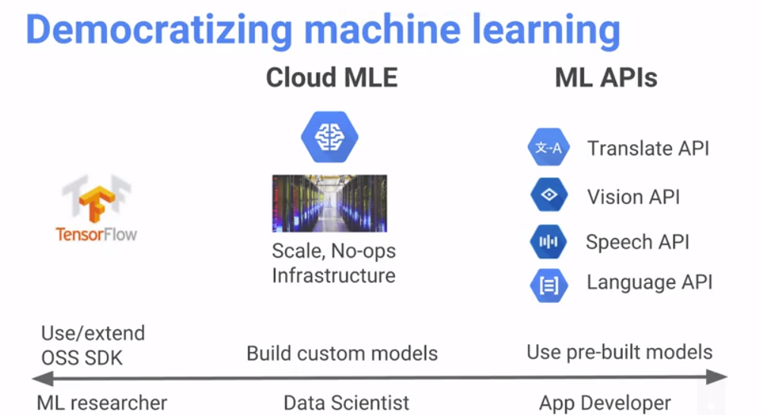

Sentiment analysis with Languague API: allows us to detect polarity (positive or negative feelings on text). Magnitude is how strong the sentiment is: from 0 to 1.

Speech API: from audio, it recognizes it and give us a JSON result, with a confidence (0 to 1).

All of them are available as HTTP REST APIs.

**Translate AP**I: We specify some parameters, such as origin text and target language

**Vision API**: We Need to upload an image into GCS. It will return a JSON document with lots of attributes and percentage of probability on each one: such as: male/female, smiling, adult, etc

Label detection

Detect broad sets of categories within an image, ranging from modes of transportation to animals.

Web detection

Search the internet for similar images.

Optical character recognition(OCR)

Detect and extract text within an image, with support for a broad range of languages, along with support for automatic language identification. You can upload PDF and TIFF files as well as images such as PNG and GIF files. See the full list of supported files [here](https://cloud.google.com/vision/docs/supported-files).

Handwriting recognition (Beta)

Using the Vision API, you can recognize human handwriting in addition to machine-printed text.

Logo detection

Detect popular product logos within an image.

Object localizer (Beta)

In addition to identifying an object in an image, the Vision API can now also identify where in the image that object is and how many of that type of object are in the image.

Integrated REST API

Access the Cloud Vision API via REST API to request one or more annotation types per image. Images can be uploaded in the request or integrated with [Google Cloud Storage](https://cloud.google.com/storage/).

Landmark detection

Detect popular natural and man-made structures within an image.

Face detection

Detect multiple faces within an image, along with the associated key facial attributes like emotional state or wearing headwear. Facial recognition is not supported.

Content moderation

Detect explicit content like adult content or violent content within an image.

ML Kit integration

Integrate with ML Kit, a mobile SDK that makes it easy to apply Google's machine learning technology to Android and iOS apps in a powerful yet easy-to-use package.

Product search (Beta)

Recognize products from your catalog within web and mobile photos, and implement visual search experiences that enable your apps to recognize products in your images.

Image attributes

Detect general attributes of the image, such as dominant colors and appropriate crop hints.

**Speech AP**I: We just provide an audio file and get a text from audio speech.

Text-to-Speech: Cloud Text-to-Speech enables developers to synthesize natural-sounding speech with 32 voices, available in multiple languages and variants

Speech-to-text: Cloud Speech-to-Text enables developers to convert audio to text by applying neural network models in an easy-to-use API. The API recognizes 120 languages and variants, to support your global user bas

**Language API:**

* **Sentiment analysis** inspects the given text and identifies the prevailing emotional opinion within the text, especially to determine a writer's attitude as positive, negative, or neutral. Sentiment analysis is performed through the analyzeSentiment method.
* **Entity analysis** inspects the given text for known entities (Proper nouns such as public figures, landmarks, and so on. Common nouns such as restaurant, stadium, and so on.) and returns information about those entities. Entity analysis is performed with the analyzeEntities method.
* **Entity sentiment analysis** inspects the given text for known entities (proper nouns and common nouns), returns information about those entities, and identifies the prevailing emotional opinion of the entity within the text, especially to determine a writer's attitude toward the entity as positive, negative, or neutral. Entity analysis is performed with the analyzeEntitySentiment method.
* **Syntactic analysis** extracts linguistic information, breaking up the given text into a series of sentences and tokens (generally, word boundaries), providing further analysis on those tokens. Syntactic Analysis is performed with the analyzeSyntax method.
* **Content classification** analyzes text content and returns a content category for the content. Content classification is performed by using the classifyText method

**Cloud Video Intelligence API**

Cloud Video Intelligence API makes videos searchable and discoverable by extracting metadata, identifying key nouns, and annotating the content of the video. By calling an easy-to-use REST API, you can now search every moment of every video file in your catalog and find each occurrence of key nouns as well as its significance. Separate signal from noise by retrieving relevant information by video, shot, or frame.

**Dialogflow Enterprise Edition**

Conversational experiences across devices and platforms

Dialogflow Enterprise Edition is an end-to-end development suite for building conversational interfaces for websites, mobile applications, popular messaging platforms, and IoT devices. You can use it to build interfaces (e.g., chatbots) that are capable of natural and rich interactions between your users and your business. It is powered by machine learning to recognize the intent and context of what a user says, allowing your conversational interface to provide highly efficient and accurate responses.

Source code examples

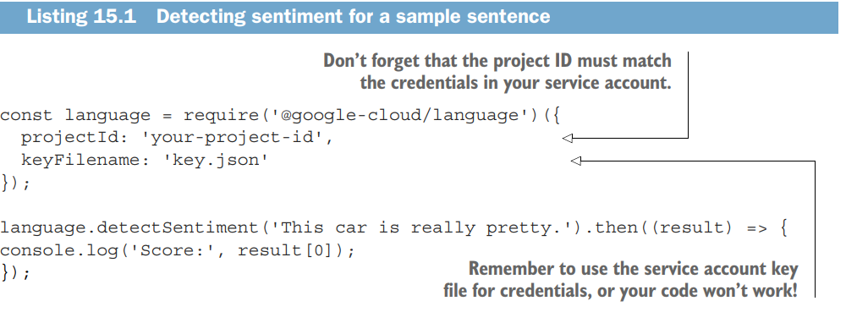

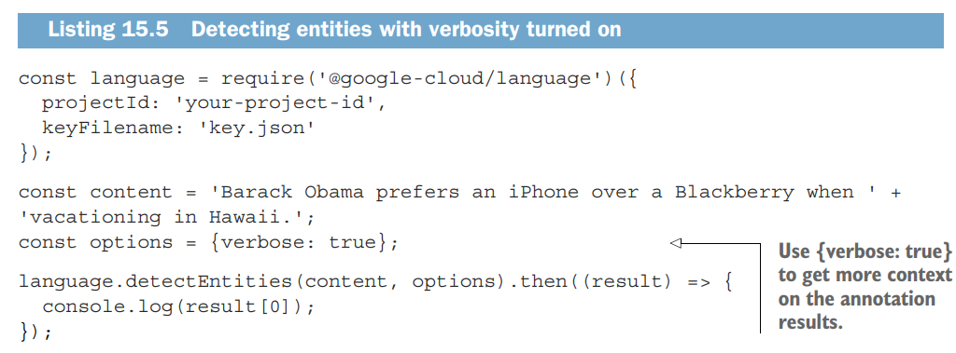

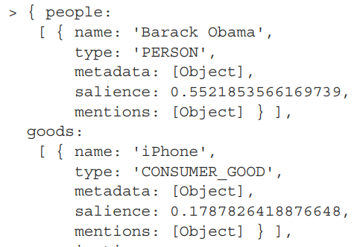

## 

## Dataflow

### Basic concepts

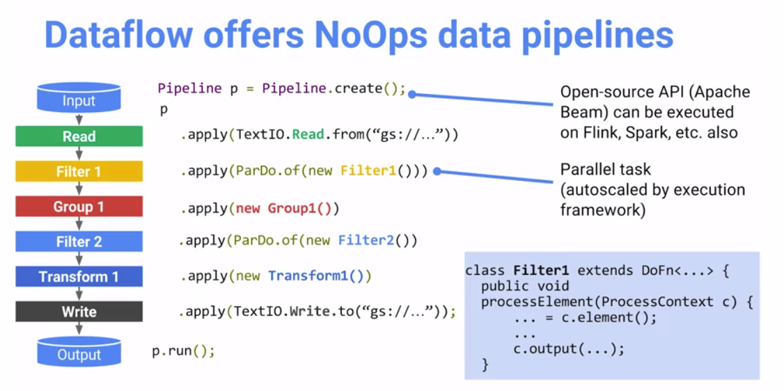

* Pipeline: A Pipeline encapsulates your entire data processing task, from start to finish
* PCollection: A PCollection represents a distributed data set that your Beam pipeline operates on. The data set can be ***bounded***, meaning it comes from a fixed source like a file, or ***unbounded***, meaning it comes from a continuously updating source via a subscription or other mechanism
* PTransform: A PTransform represents a data processing operation, or a step, in your pipeline. Every PTransform takes one or more PCollection objects as input, performs a processing function that you provide on the elements of that PCollection, and produces zero or more output PCollection objects.
* I/O transforms: Beam comes with a number of “IOs” - library PTransforms that read or write data to various external storage systems.

ParDo is a Beam transform for generic parallel processing. The ParDo processing paradigm is similar to the “Map” phase of a Map/Shuffle/Reduce-style algorithm: a ParDo transform considers each element in the input PCollection, performs some processing function (your user code) on that element, and emits zero, one, or multiple elements to an output PCollection.

* **Filtering a data set.** You can use ParDo to consider each element in a PCollection and either output that element to a new collection, or discard it.
* **Formatting or type-converting each element in a data set.** If your input PCollection contains elements that are of a different type or format than you want, you can use ParDo to perform a conversion on each element and output the result to a new PCollection.
* **Extracting parts of each element in a data set.** If you have a PCollection of records with multiple fields, for example, you can use a ParDo to parse out just the fields you want to consider into a new PCollection.
* **Performing computations on each element in a data set.** You can use ParDo to perform simple or complex computations on every element, or certain elements, of a PCollection and output the results as a new PCollection.

*// The input PCollection of Strings.*  
PCollection**<**String**>** words **=** **...;**  
  
*// The DoFn to perform on each element in the input PCollection.*  
**static** **class** **ComputeWordLengthFn** **extends** DoFn**<**String**,** Integer**>** **{** **...** **}**  
  
*// Apply a ParDo to the PCollection "words" to compute lengths for each word.*  
PCollection**<**Integer**>** wordLengths **=** words**.**apply**(**  
 ParDo  
 **.**of**(new** ComputeWordLengthFn**()));** *// The DoFn to perform on each element, which*

GroupByKey

GroupByKey is a Beam transform for processing collections of key/value pairs. It’s a parallel reduction operation, analogous to the Shuffle phase of a Map/Shuffle/Reduce-style algorithm. The input to GroupByKey is a collection of key/value pairs that represents a multimap, where the collection contains multiple pairs that have the same key, but different values. Given such a collection, you use GroupByKey to collect all of the values associated with each unique key.

GroupByKey gathers up all the values with the same key and outputs a new pair consisting of the unique key and a collection of all of the values that were associated with that key in the input collection.

If you are using unbounded PCollections, you must use either non-global windowing or an aggregation trigger in order to perform a GroupByKey or CoGroupByKey. This is because a bounded GroupByKey or CoGroupByKey must wait for all the data with a certain key to be collected, but with unbounded collections, the data is unlimited. Windowing and/or triggers allow grouping to operate on logical, finite bundles of data within the unbounded data streams.

CoGroupByKey

CoGroupByKey performs a relational join of two or more key/value PCollections that have the same key type.

Combine

Combine is a Beam transform for combining collections of elements or values in your data. Combine has variants that work on entire PCollections, and some that combine the values for each key in PCollections of key/value pairs.

When you apply a Combine transform, you must provide the function that contains the logic for combining the elements or values. The combining function should be commutative and associative, as the function is not necessarily invoked exactly once on all values with a given key. Need to define createAccumulator, addInput, mergeAccumulator and extractOutput methods.

**public** **class** **AverageFn** **extends** CombineFn**<**Integer**,** AverageFn**.**Accum**,** Double**>** **{**  
 **public** **static** **class** **Accum** **{**  
 **int** sum **=** 0**;**  
 **int** count **=** 0**;**  
 **}**  
  
 @Override  
 **public** Accum **createAccumulator()** **{** **return** **new** Accum**();** **}**  
  
 @Override  
 **public** Accum **addInput(**Accum accum**,** Integer input**)** **{**  
 accum**.**sum **+=** input**;**  
 accum**.**count**++;**  
 **return** accum**;**  
 **}**  
  
 @Override  
 **public** Accum **mergeAccumulators(**Iterable**<**Accum**>** accums**)** **{**  
 Accum merged **=** createAccumulator**();**  
 **for** **(**Accum accum **:** accums**)** **{**  
 merged**.**sum **+=** accum**.**sum**;**  
 merged**.**count **+=** accum**.**count**;**  
 **}**  
 **return** merged**;**  
 **}**  
  
 @Override  
 **public** Double **extractOutput(**Accum accum**)** **{**  
 **return** **((double)** accum**.**sum**)** **/** accum**.**count**;**  
 **}**  
**}**

Flatten

Flatten and is a Beam transform for PCollection objects that store the same data type. Flatten merges multiple PCollection objects into a single logical PCollection.

Partition

Partition is a Beam transform for PCollection objects that store the same data type. Partition splits a single PCollection into a fixed number of smaller collections.

**Requirements for writing user code for Beam transforms**

Your function object must be serializable.

Your function object must be thread-compatible, and be aware that the Beam SDKs are not thread-safe.

In addition, it’s recommended that you make your function object idempotent.

Any function object you provide to a transform must be **fully serializable.** This is because a copy of the function needs to be serialized and transmitted to a remote worker in your processing cluster.

Side inputs

In addition to the main input PCollection, you can provide additional inputs to a ParDo transform in the form of side inputs. A side input is an additional input that your DoFn can access each time it processes an element in the input PCollection

Side inputs and windowing

A windowed PCollection may be infinite and thus cannot be compressed into a single value (or single collection class). When you create a PCollectionView of a windowed PCollection, the PCollectionView represents a single entity per window (one singleton per window, one list per window, etc.).

Additional outputs

While ParDo always produces a main output PCollection (as the return value from apply), you can also have your ParDo produce any number of additional output PCollections. If you choose to have multiple outputs, your ParDo returns all of the output PCollections (including the main output) bundled together.

Composite transforms

Transforms can have a nested structure, where a complex transform performs multiple simpler transforms (such as more than one ParDo, Combine, GroupByKey, or even other composite transforms). These transforms are called composite transforms. Nesting multiple transforms inside a single composite transform can make your code more modular and easier to understand

Windowing

Windowing subdivides a PCollection according to the timestamps of its individual elements. Transforms that aggregate multiple elements, such as GroupByKey and Combine, work implicitly on a per-window basis — they process each PCollection as a succession of multiple, finite windows, though the entire collection itself may be of unbounded size.

A related concept, called triggers, determines **when** to emit the results of aggregation as unbounded data arrives. You can use triggers to refine the windowing strategy for your PCollection. Triggers allow you to deal with late-arriving data or to provide early results. See the triggers section for more information.

After you set the windowing function for a PCollection, the elements’ windows are used the next time you apply a grouping transform to that PCollection. Window grouping occurs on an as-needed basis. If you set a windowing function using the Window transform, each element is assigned to a window, but the windows are not considered until GroupByKey or Combine aggregates across a window and key. This can have different effects on your pipeline. Consider the example pipeline in the figure below:

Diagram of pipeline applying windowing

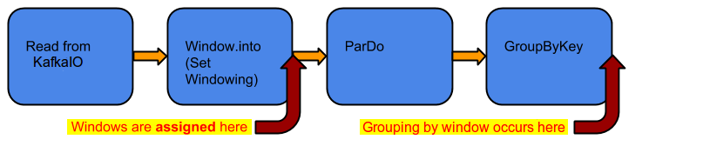

You can define different kinds of windows to divide the elements of your PCollection. Beam provides several windowing functions, including:

* Fixed Time Windows
* Sliding Time Windows
* Per-Session Windows
* Single Global Window
* Calendar-based Windows (not supported by the Beam SDK for Python)

Fixed

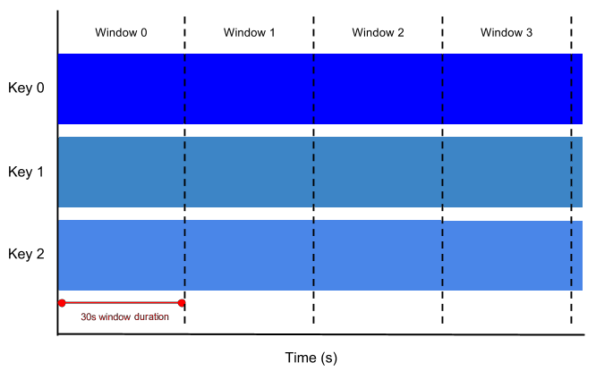

**Sliced**

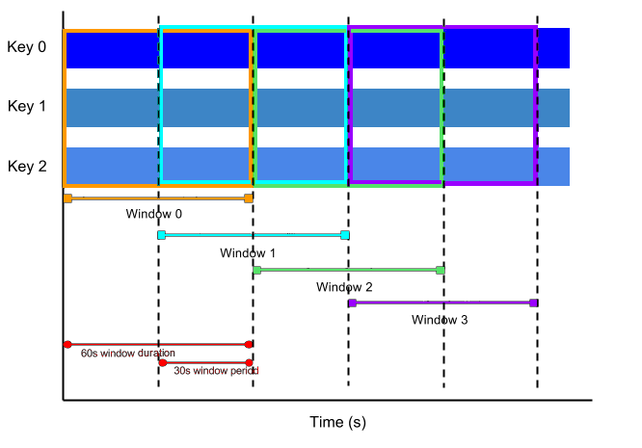

Session

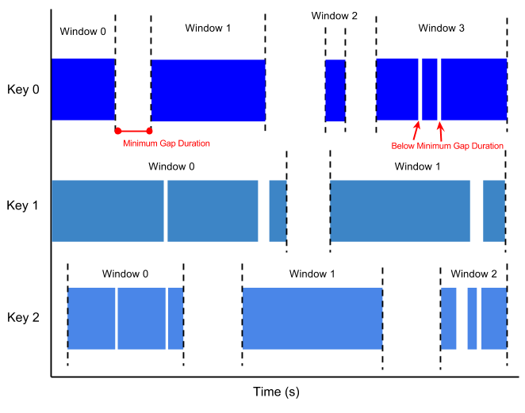

Watermarks and late data

In any data processing system, there is a certain amount of lag between the time a data event occurs (the “event time”, determined by the timestamp on the data element itself) and the time the actual data element gets processed at any stage in your pipeline (the “processing time”, determined by the clock on the system processing the element). In addition, there are no guarantees that data events will appear in your pipeline in the same order that they were generated.

For example, let’s say we have a PCollection that’s using fixed-time windowing, with windows that are five minutes long. For each window, Beam must collect all the data with an event time timestamp in the given window range (between 0:00 and 4:59 in the first window, for instance). Data with timestamps outside that range (data from 5:00 or later) belong to a different window.

However, data isn’t always guaranteed to arrive in a pipeline in time order, or to always arrive at predictable intervals. Beam tracks a watermark, which is the system’s notion of when all data in a certain window can be expected to have arrived in the pipeline. Data that arrives with a timestamp after the watermark is considered late data.

PCollection**<**String**>** items **=** **...;**  
 PCollection**<**String**>** fixedWindowedItems **=** items**.**apply**(**  
 Window**.<**String**>**into**(**FixedWindows**.**of**(**Duration**.**standardMinutes**(**1**)))**  
 **.**withAllowedLateness**(**Duration**.**standardDays**(**2**)));**

Triggers

When collecting and grouping data into windows, Beam uses triggers to determine when to emit the aggregated results of each window (referred to as a pane). If you use Beam’s default windowing configuration and default trigger, Beam outputs the aggregated result when it estimates all data has arrived, and discards all subsequent data for that window.

* **Event time triggers**. These triggers operate on the event time, as indicated by the timestamp on each data element. Beam’s default trigger is event time-based.
* **Processing time triggers**. These triggers operate on the processing time – the time when the data element is processed at any given stage in the pipeline.
* **Data-driven triggers**. These triggers operate by examining the data as it arrives in each window, and firing when that data meets a certain property. Currently, data-driven triggers only support firing after a certain number of data elements.
* **Composite triggers**. These triggers combine multiple triggers in various ways.

*// Create a bill at the end of the month.*  
 AfterWatermark**.**pastEndOfWindow**()**  
 *// During the month, get near real-time estimates.*  
 **.**withEarlyFirings**(**  
 AfterProcessingTime  
 **.**pastFirstElementInPane**()**  
 **.**plusDuration**(**Duration**.**standardMinutes**(**1**))**  
 *// Fire on any late data so the bill can be corrected.*  
 **.**withLateFirings**(**AfterPane**.**elementCountAtLeast**(**1**))**

PCollection<String> pc = ...;

pc.apply(Window.<String>into(FixedWindows.of(1, TimeUnit.MINUTES))

.triggering(AfterProcessingTime.pastFirstElementInPane()

.plusDelayOf(Duration.standardMinutes(1)))

.discardingFiredPanes());

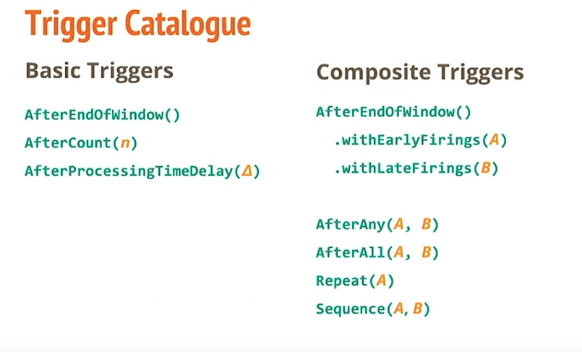

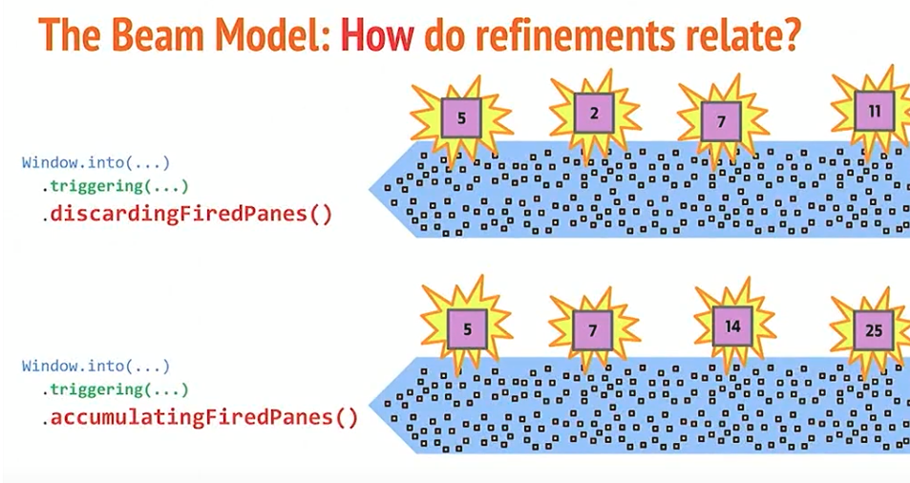

Pricing

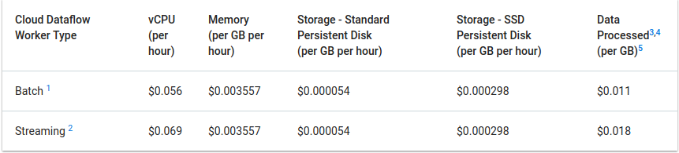

## Pub/Sub

### Basic concepts

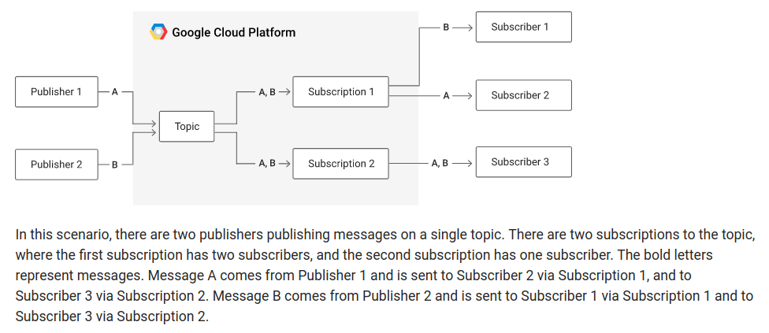

Message

A message is composed of a base-64 encoded payload (some arbitrary data), as well as an optional set of plain text attributes about the message (represented as a key-value map) that act as metadata about it.

Topic

much like topics of conversation, represent categories of information and are the resource that you publish a message to

Subscription

* Each subscription receives a distinct copy of each message sent to its topic, so consumers can access messages from a topic without stepping on the toes of others who are interested in that topic’s messages. A consumer reading a message from one subscription has no effect at all on other subscriptions.
* Each subscription sees all of the messages you send on a topic, so you can broadcast messages to a wider audience if more consumers create subscriptions to the topic. Multiple consumers can consume messages from the same subscription, so you can use subscriptions to distribute messages from a topic across multiple consumers.
* Once one consumer consumes a message from a subscription, that message is no longer available on that same topic, so the next consumer will get a different message. This arrangement ensures that no two consumers of that subscription will end up processing the same message.
* Pull vs Push subscriptions: the difference is whether the subscription waits for a consumer to ask for messages (pull) or actively sends a request to a specific URL when a new message arrives (push)
* Acknowledge deadline: This deadline, measured in seconds, acts as a timer of how long to wait before assuming that something has gone wrong with the consumer.

**Message order**

Cloud Pub/Sub provides a highly-available, scalable message delivery service. The tradeoff for having these properties is that the **order** in which messages are received by subscribers is **not guaranteed.**

Suggestion for use cases where order matters:

Use case 1: Final results order

1- Include order information in the publishers’ message. The order information could be a timestamp (though it has to be a timestamp that all servers get from the same source in order to avoid issues of clock drift), or a sequence number (acquired from a single source with ACID guarantees).

2- make the subscriber store the messages in some underlying data store (such as [Cloud Datastore](https://cloud.google.com/datastore/)) that allows storage or retrieval by the sorted timestamp.

Use case 2: Processing time order (example: transactional data where you should ensure the order of processing) - More complex.

1- Include attributes in the message that are useful to ensure order and completion (Example: Transaction id, total messages, message sequence: {transactionId: 123445, messageCount: 5, messageSequence: 1 } So logic in subscriber must ensure that it gets the 5 messages for the transaction and put all of them in order before processing.

2- Include logic in subscriber with help of a persistent storage (such as Datastore).

## 

## DataPrep

### Basic Concepts

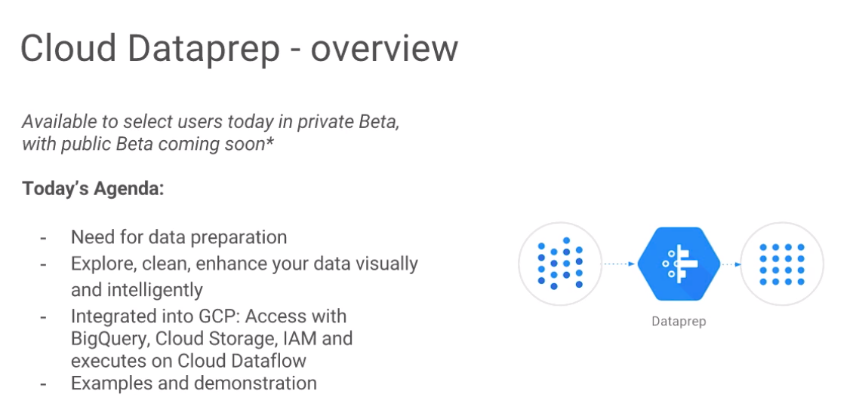

Helps to prepare data from raw to structured

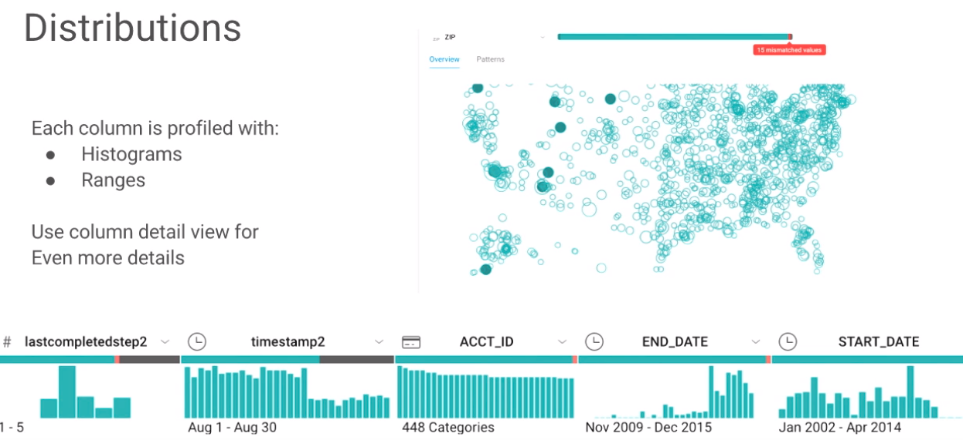

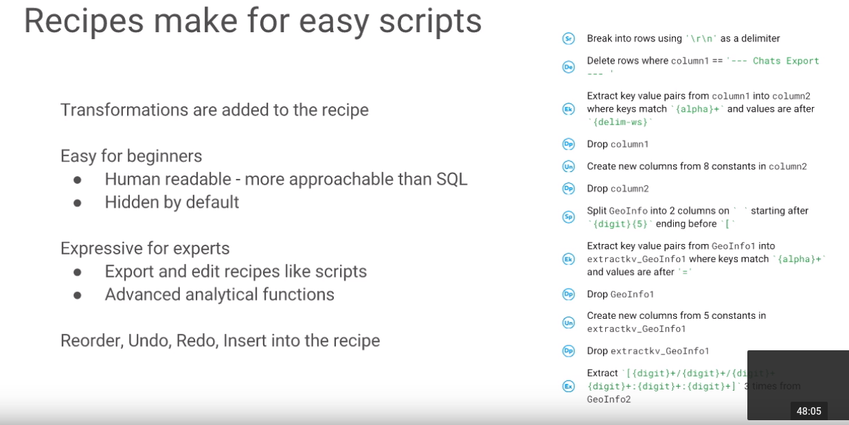

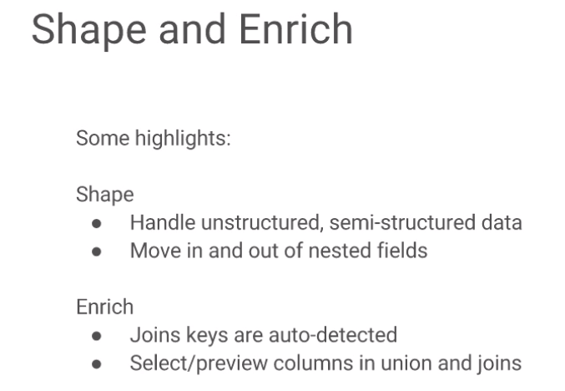

How does it in scale?

It is backed by **Google Cloud Dataflow, it will create an Apache Beam pipeline.**

**So basically when the job runs, what it runs it is actually a dataflow pipeline.**

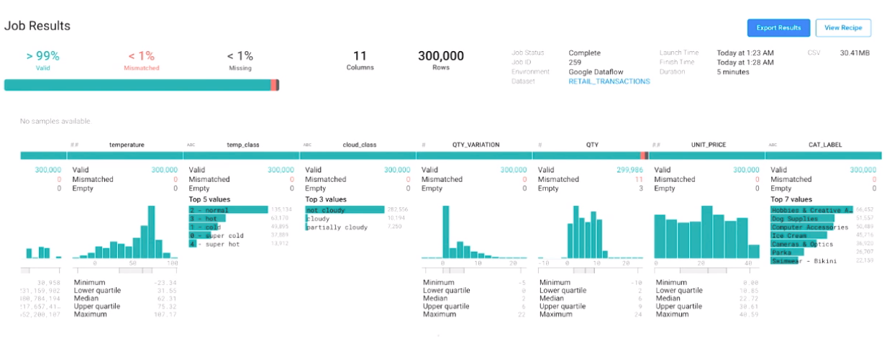

Source: <https://www.youtube.com/watch?v=Q5GuTIgmt98>

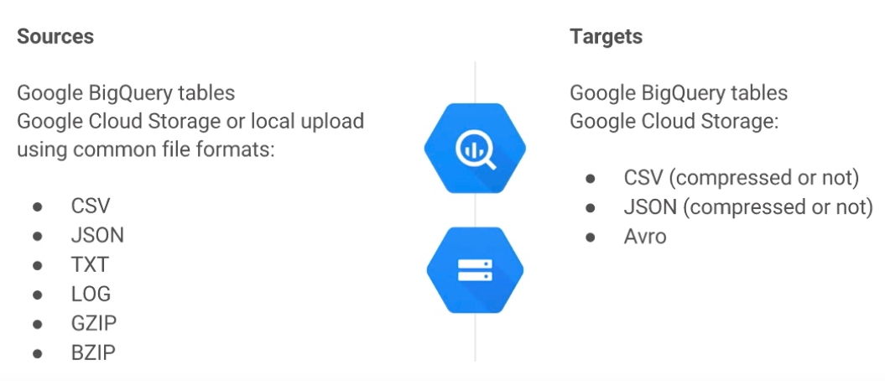

## IAM and security

### Service Accounts

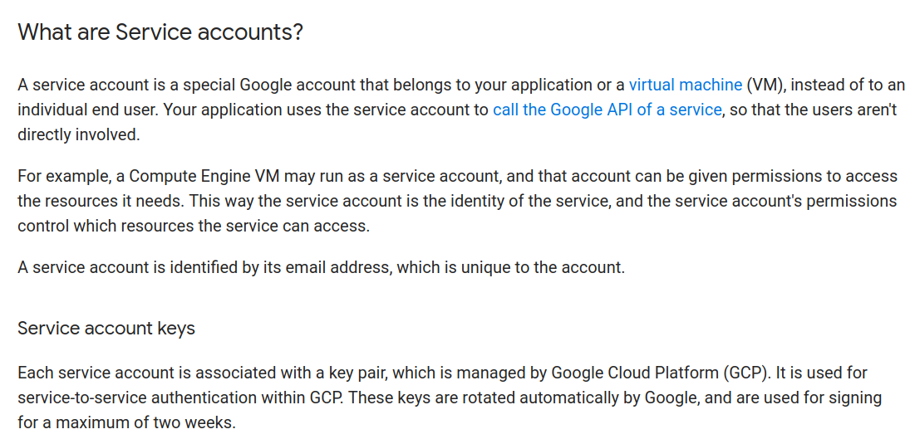

User managed service accounts

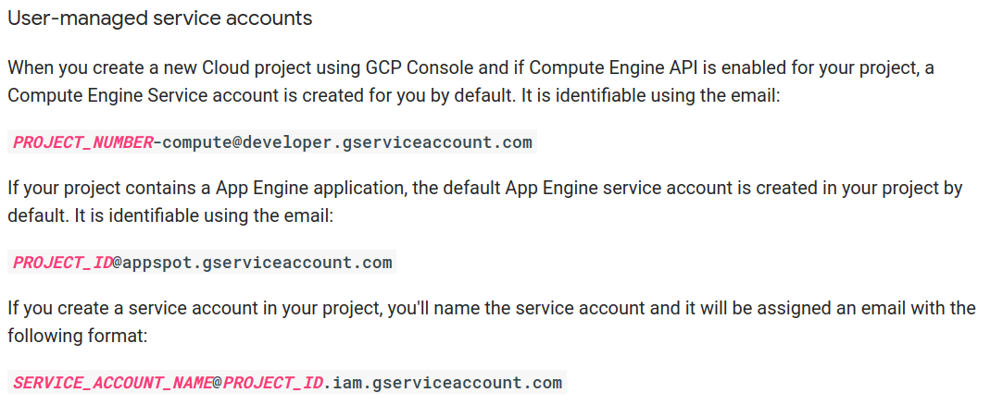

Google-managed service accounts

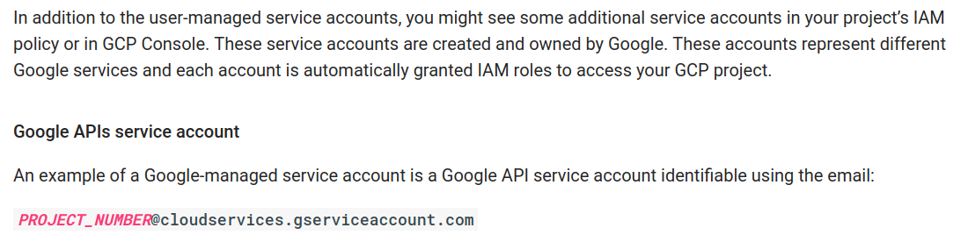

Service account permissions

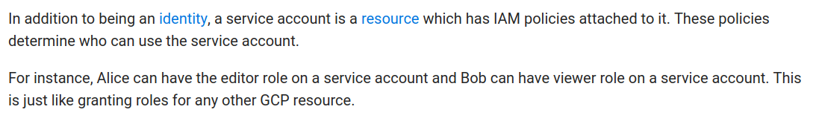

You can grant roles to a certain service account, a role is a set of permissions. Example: I can create the service account:

[spanner-tvc-test@tvc-test-187621.iam.gserviceaccount.com](mailto:spanner-tvc-test@tvc-test-187621.iam.gserviceaccount.com) and grant the following roles:

Cloud Spanner Admin, Cloud Spanner Database Admin

In Cloud IAM, you grant access to **members**. Members can be of following types:

* Google account: A Google account represents a developer, an administrator, or any other person who interacts with GCP
* Service account: (See above)
* Google group: Group of google account and service accounts.
* G Suite domain: A G Suite domain represents a virtual group of all the Google accounts that have been created in an organization's G Suite account. G Suite domains represent your organization's Internet domain name (such as shoppertrak.com), and when you add a user to your G Suite domain, a new Google account is created for the user inside this virtual group (such as username@shoppertrak.com)
* Cloud Identity domain: A Cloud Identity domain is like a G Suite domain because it represents a virtual group of all Google accounts in an organization. However, Cloud Identity domain users don't have access to G Suite applications and features

Resource

You can grant access to users for a GCP resource. Some examples of resources are projects, Compute Engine instances, and Cloud Storage buckets.

Permissions

Permissions determine what operations are allowed on a resource. In the Cloud IAM world, permissions are represented in the form of <service>.<resource>.<verb>, for example pubsub.subscriptions.consume. Permissions usually, but not always, correspond 1:1 with REST methods

Roles

A role is a collection of permissions

**Primitive roles**

There are three roles that existed prior to the introduction of Cloud IAM: **Owner, Editor, and Viewer**. These roles are **concentric**; that is, the Owner role includes the permissions in the Editor role, and the Editor role includes the permissions in the Viewer role.

**Pre-defined roles**

In addition to the primitive roles, Cloud IAM provides additional predefined roles that give granular access to specific Google Cloud Platform resources and prevent unwanted access to other resources.

Examples:

BigQuery pre-defined roles: user (roles/bigquery.user), jobUser, metadataViewer, dataViewer, dataEditor, dataOwner, admin.

Dataflow: viewer, developer, worker (provides necessary permissions for a GCE service account to run any Dataflow working unit).

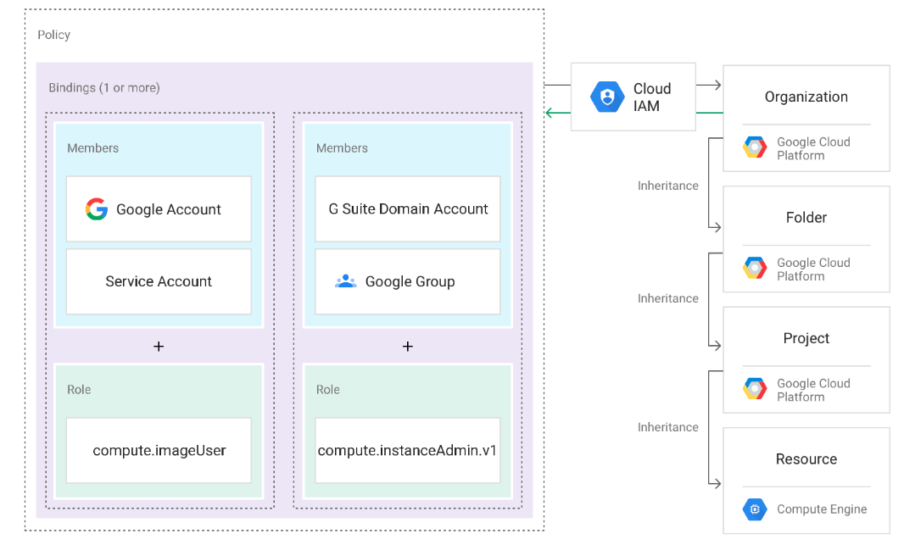

Policy hierarchy

GCP resources are organized hierarchically, where the organization node is the root node in the hierarchy, the projects are the children of the organization, and the other resources are the descendants of projects. Each resource has exactly one parent. See the Resource Manager Resource Hierarchy topic for more information.

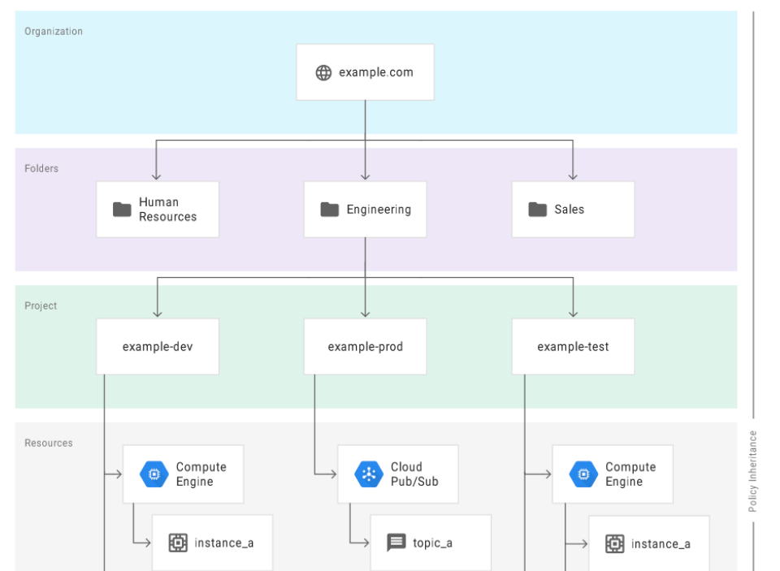

Example

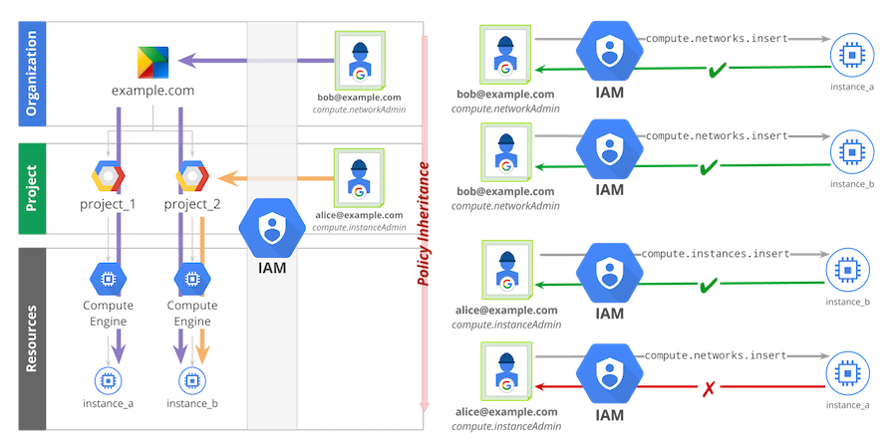

Permission granted at organization level (specially for big organizations), then project specific level (just project_2 for instance).

### Best practices

* Mirror your IAM policy hierarchy structure to your organization structure.
* Use Cloud Platform projects to group resources that share the same trust boundary..
* Set policies at the **Organization level and at the Project level** rather than at the resource level.
* Use the security principle of [**least privilege**](https://en.wikipedia.org/wiki/Principle_of_least_privilege) to grant IAM roles, that is, only give the least amount of access necessary to your resources.
* Grant roles to a **Google group** instead of to individual users when possible.
* Control the ownership of the Google group used in IAM policies.
* Grant roles at the **smallest** scope needed.
* Remember that a policy set on a child resource **cannot restrict access granted on its parent.**
* If you need to grant a role to a user or group that spans across multiple projects, set that role at the organization level instead of setting it at the project level.
* Use **labels** to annotate, group, and filter resources.
* **Audit** your policies to ensure compliance. [Cloud audit](https://cloud.google.com/logging/docs/audit/) logs contain all the calls to setiampolicy so you are able to trace when a policy has been enacted.
* Audit the ownership and the membership of the Google groups used in policies.
* If you want to limit project creation in your Organization, change the [Organization access policy](https://cloud.google.com/resource-manager/docs/access-control-org) to grant the [Project Creator role](https://cloud.google.com/iam/docs/understanding-roles) to a group that you manage.

## 

## Google Functions

Google Cloud Functions is a serverless execution environment for building and connecting cloud services. With Cloud Functions you write simple, single-purpose functions that are attached to events emitted from your cloud infrastructure and services. Your function is **triggered when an event** **being watched is fired**. Your code executes in a **fully managed environment**. There is no need to provision any infrastructure or worry about managing any servers.

**Events** are things that can happen (for example, a Cloud Storage Object is created).

**Functions** are chunks of code that run in response to events. **Triggers** are ways of coupling

a function to some events. Creating a trigger is like saying, “Make sure to run

function X whenever a new GCS Object is created.”

Although the data attached to an event depends on the type of the event, common

data types are used to minimize the learning curve. For example, HTTP events have

an Express Request object in the data field, whereas events from Cloud Storage have

the affected Cloud Storage Object in the data field

Events based on HTTP requests are **synchronous** events (the

requester is waiting for a response), whereas those coming from other services such as

Cloud Pub/Sub are **asynchronous** (they run in the background)

Example of sync function:

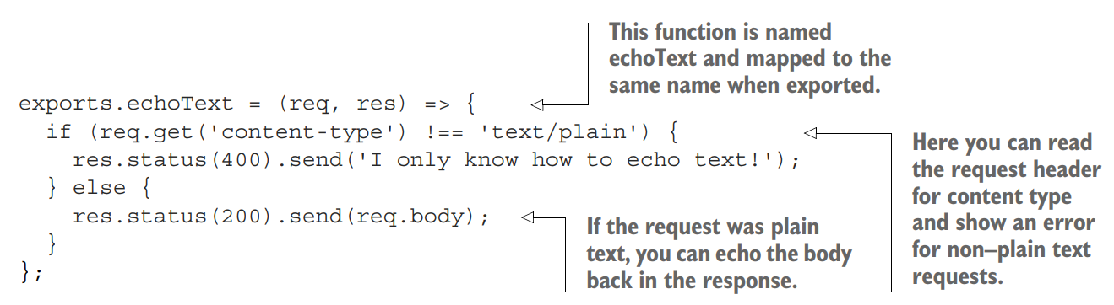

Example of async function:

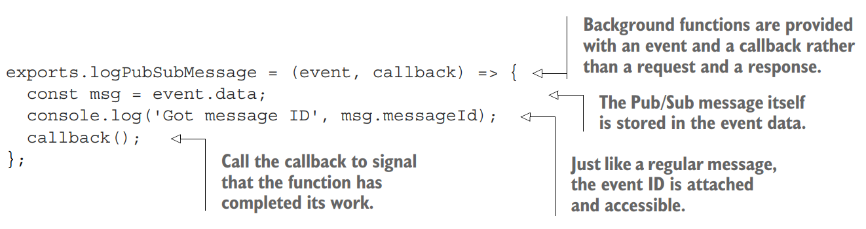

Cloud Functions can be written using **Javascript** (Node.js 6.14.0, Node.js 8.11.1) or **Python** (Python 3.7.0) runtimes

Currently, it supports **events** from following providers:

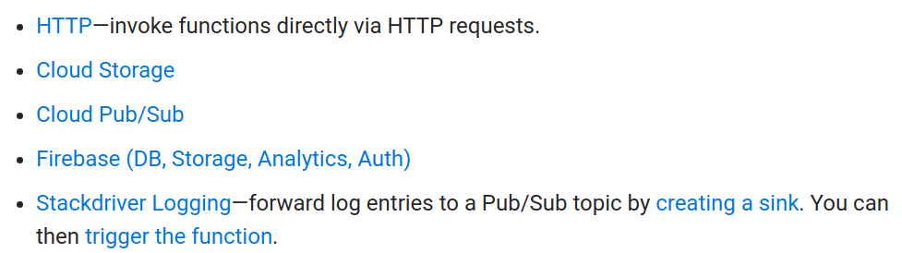

HTTP Triggers

You can invoke Cloud Functions with an HTTP request using the POST, PUT, GET, DELETE, and OPTIONS HTTP methods. To create an HTTP endpoint for your function, specify --trigger-http as the trigger type when deploying your function. From the caller's perspective, HTTP invocations are synchronous, meaning that the result of the function execution will be returned in the response to the HTTP request.

Deploy a Google Function:

1- Create the function source code locally, e.g.: a js file inside a folder

2- Create a bucket in GC Storage

3- Use the gcloud functions **deploy** command

Example (http request function)

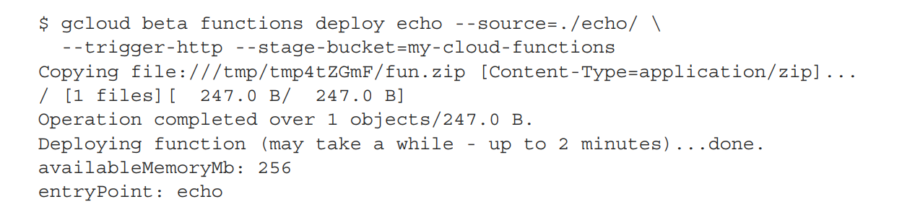

Check the function is working by using curl

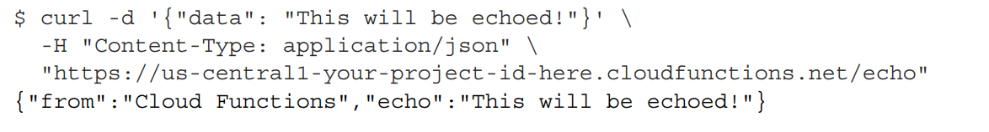

There is also a “call” command in gcloud to call a function which is not necessary triggered by a HTTP request:



Google Cloud Repository

You can store Cloud Functions in the Google Cloud Repositroy (URL will be something like <https://source.developers.google.com/projects/your-project-id-here/repos/your-repo-name>

WIll work in same way as a GitHub repo. The main advantage is that you can deploy a Google Function directly from a GC Repository:

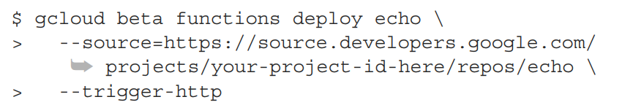

## Google Cron

Solving the problem of how to schedule tasks in a distributed system is not trivial. One solution to this problem is the [Chronos](https://github.com/mesos/chronos) framework for Apache Mesos, but this involves a significant amount of setup and management.

App Engine provides a [Cron Service](https://cloud.google.com/appengine/features/#cron). If your application runs on App Engine, you can simply write App Engine handlers, schedule events, and the Cron Service will fire events and call the corresponding event handlers for your application. To run tasks on your Compute Engine instance in response to Cron Service events, you need to relay the Cron Service events to those instances.

Suggested architecture

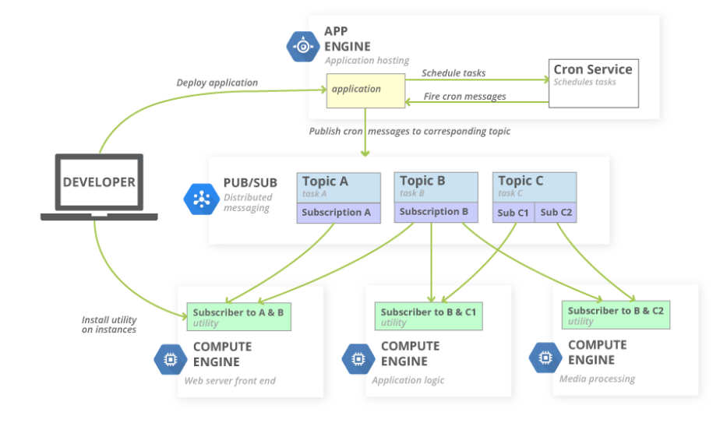

## Cloud Stackdriver

Log monitoring tool.

**Stackdriver Debugger** is a feature of the Google Cloud Platform that lets you inspect the state of a **running application**, in **real time**, without stopping or slowing it down. Your users are not impacted while you **capture the call stack and variables at any location in your source code**. You can use it to understand the behavior of your code in production, as well as analyze its state to find those hard-to-find bugs.

Stackdriver Reporting

**Stackdriver Error Reporting** counts, analyzes and aggregates the crashes in your running cloud services. A centralized error management interface displays the results with sorting and filtering capabilities. A dedicated view shows the error details: time chart, occurrences, affected user count, first- and last-seen dates and a cleaned exception stack trace. Opt in to receive email and mobile alerts on new errors.

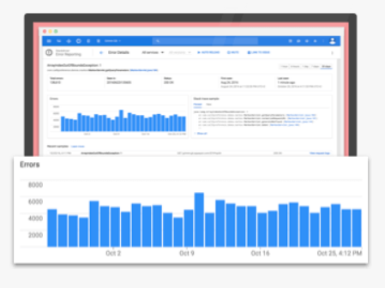

Stackdriver **Monitoring** provides visibility into the **performance**, uptime, and overall health of cloud-powered applications. Stackdriver collects metrics, events, and metadata from Google Cloud Platform, Amazon Web Services, hosted uptime probes, application instrumentation, and a variety of common application components including Cassandra, Nginx, Apache Web Server, Elasticsearch, and many others. Stackdriver ingests that data and generates insights via dashboards, charts, and alerts. Stackdriver alerting helps you collaborate by integrating with Slack, PagerDuty, HipChat, Campfire, and more

Stackdriver **Trace** is a distributed tracing system that collects **latency data** from your applications and displays it in the Google Cloud Platform Console. You can track how requests propagate through your application and receive detailed near real-time performance insights. Stackdriver Trace automatically analyzes all of your application's traces to generate in-depth latency reports to surface performance degradations, and can capture traces from all of your VMs, containers, or Google App Engine projects.

Stackdriver **Logging** provides you with the ability to f**ilter, search, and view logs** from your cloud and open source application services. Allows you to define metrics based on log contents that are incorporated into dashboards and alerts. Enables you to export logs to BigQuery, Google Cloud Storage, and Pub/Sub.

## 

## Cloud Datalab

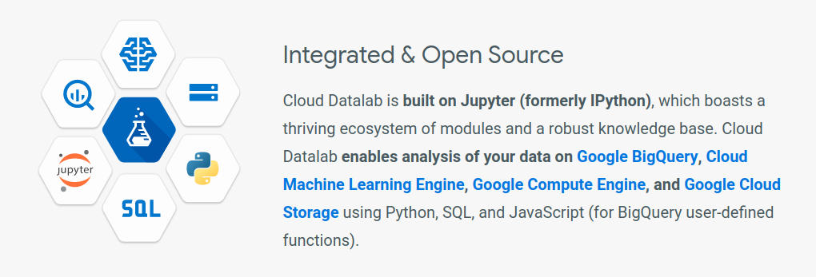

Multi-Language Support: Cloud Datalab currently supports Python, SQL, and JavaScript (for BigQuery user-defined functions).

Notebook Format: Cloud Datalab combines code, documentation, results, and visualizations together in an intuitive notebook format.

Pay-per-use Pricing: (Free). Only pay for the cloud resources you use: Google Compute Engine VMs, BigQuery, and any additional resources you decide to use, such as Cloud Storage.

Interactive Data Visualization: Use Google Charting or matplotlib for easy visualizations

Machine Learning: Supports TensorFlow-based deep ML models in addition to scikit-learn. Scales training and prediction via specialized libraries for Cloud Machine Learning Engine.

IPython Support: Datalab is based on Jupyter (formerly IPython) so you can use a large number of existing packages for statistics, machine learning etc. Learn from published notebooks and swap tips with a vibrant IPython community.

Pandas: Python library for data analysis. DataFrame is the base data object to work with. (we probably execute query first from Bigquery and then result goes into a pandas dataframe). Once data is in dataframe you can: plot, pivot, do correlation analysis, group, filter, among others, pandas runs all those operations in memory.

Open Source

## Exam Study Cases

<https://cloud.google.com/certification/guides/data-engineer/casestudy-flowlogistic>

<https://cloud.google.com/certification/guides/data-engineer/casestudy-mjtelco>

FlowLogistic overview

Flowlogistic is a leading logistics and supply chain provider. They help businesses throughout the world manage their resources and transport them to their final destination. The company has grown rapidly, expanding their offerings to include rail, truck, aircraft, and oceanic shipping.



MJTelco

MJTelco is a startup that plans to build networks in rapidly growing, underserved markets around the world. The company has patents for innovative optical communications hardware. Based on these patents, they can create many reliable, high-speed backbone links with inexpensive hardware. They need to create a distributed data infrastructure that drives real-time analysis and incorporates machine learning to continuously optimize their topologies.